Micro-Service Architecture



A technological guide for the underlying distributed design of modern systems.

Note: This guide is at the conceptual level <- biggest lie in this guide, ill change this later. It requires general knowledge of all information technology above the hardware level to be fully utilized. It does not contain step by step guides to how to set up any of the technologies mentioned.

# Systems Design in a nutshell

## Introduction

System design choices should first be influenced by the goals of the system. Different systems have different tolerances and strengths. A bank system is designed for reliability, security and consistency while a pizza chain’s system is designed for speed, efficiency and cost reduction. Consistency and security are less of a factor in a pizza chain. A wrong order is not going to cause potentially catastrophic results and a delivery man or pizza shop being robbed is not going to cause the entire chain to go bankrupt (if managed properly).

There is more than likely a software equivalent of any logistical paradigm in existence. A good way of thinking about it is for any function a human does in an organization, there will be a software equivalent doing the same function in a system.

## Design Choices

Designing a system from a high level is relatively simple. There are really only two stages.

1. Deciding what the system is required to do, and what it should be good at while doing it.
2. What technologies should be used to achieve 1.

Just to add another level of difficulty. The technological choices made should ideally be able to support expansions to the systems that have not yet been thought of or are not yet possible as well as shifts in conceptual features and requirements

It is important to keep in mind that although we will mainly be focusing on microservice design and the technologies that enable it. It is not always the case that microservices are the best design pattern for a given app, for example, there is no need to have an entire microservice architecture if we are simply building a blog.

There is no need a use a jackhammer to hammer in a nail.

# Distributed Software Architecture

Conceptually most system designs are a copy of logistic supply chains we have already figured out in the physical world. We will take a look into one of these examples analogically and also show their software equivalents.

This example describes what is known as micro service architecture. Do note that while micro services are great, people tend to go overboard and fragment too many things into too many services. There is no set guide or method on how to avoid this, it is pretty much up to the development team to be intelligent enough to design it well.

The microservice philosophy is essentially capitalism in software form. We want each citizen(service) to do one thing extremely well.

The idea of microservices actually originated from object oriented programming, within a program we usually also have services that handle specific tasks, such as a database helper which abstracts a layer up from the database connection mechanisms, so a change to the database connection code will only need to be dealt with at the database helper, no other code will (should) be affected by the changes. We just took this idea and abstracted it into components of a system instead of components of a program.

### Pizza Restaurant Chain

There can be many of each component in the following diagrams.

We will first look inside a single chain restaurant.

Note: We will look into each label technology further into the guide.





Kubernetes



Argo

Docker

Docker

Docker

Docker







Order

Communication/interactions between containers are handled by message queues, RPCs, APIs, sockets, etc.



* Services, Specialized Programs

Each worker specializes in a specific role in the restaurant.

* Container Orchestration, Kubernetes

The manager of the restaurant keeps track of everyone working in the restaurant and schedules work hours according to busy hours and employee availability.

* Workflow Orchestration, Argo

The cashier takes orders and relays them to the chefs, including different requirements for each order. Eg. no cheese, ham and tomatoes.

At a macro level, a pizza chain also represents a distributed system.



Pizza Guy

Pizza Guy

Pizza Guy

Pizza

Pizza

Pizza

Pizza

Should a restaurant in the chain burn down, the next nearest chains relative to the customer will take over service for the area. This level of abstraction one layer up from a single pizza store showcases container orchestration, should a container fail, another/several others will take over the load

The analogy can essentially be stretched forever inwards and outwards, due to the fact that systems are fractal.

That is until you get down to the unifying theory of everything and that is where we would stop

# Microservices

## Introduction

An app which employs the microservice architecture is built from lots of small specialized parts that communicate with each other and gives the illusion of a single meaningful application.

## Concerns

One way of figuring out when to create a new service is the paradigm of concerns.

For example from viewpoint of a data scientist, you may want to have a service solely responsible for querying a database and passing along the information, then have another responsible for processing the data and a third for pushing the results to a persistent data store.

In this scenario we have a total of 3 concerns:

1. Pulling data
2. Processing data
3. Pushing data

So we have 3 services.

The Microservice design pattern dictate that we should separate our concerns. This has a lot of advantages, including:

* Different teams can be responsible for each of the three containers
* Each container can be scaled independently.
* Each container can be developed and iterated independently.
* Each container can have its own release schedule.
* If one fails, the others keep chugging along.

## Example

As is so often the case, it is easier to understand by seeing than by reading. Below is an example of an e-commerce app that comprises of a few services.

Catalog Service

Logging Service

Front-End

Persistent Storage

Shopping Cart

Authentication Service

E-Commerce Site

Each of these individual services are implemented as a microservice, the benefits are that each service can be coded and cared for by separate teams of people, each service can have its own release schedule and can be scaled, patched, and tweaked independently without affecting other services.

This also allows for parallel development of each service by multiple teams, increasing the speed at which the entire site gets built/improved.

# Containers

## Introduction

Containers are an instance of an image, much like virtual machines (VM), which simulate the required environment with the use of a Linux kernel packaged in it. It is helpful to think of containers as extremely lightweight versions of VM technology.

So how does it do this? Let’s imagine that you have written a program in Python 3.7.7, your app only needs Python 3.7.7 and dependant libraries you may have used to run, everything else like a GUI is pointless overhead. So, Container Software provides a template built on the Linux Kernel with the needed dependencies of the program only and nothing else. This template is called an image.

So, if you were to fetch a Python 3.5 image from a repository and run an instance of it, you can do anything you were able to do in the host machine using a command line interface. Any mistakes or changes made in that instance is completely isolated, to start anew, just delete the instance and create a new one.

This way, your main environment remains intact in the form of an image and you can experiment and play around with the dependencies packaged in the image using containers.

There are many open source adopters of Containerd (The project that spawned containers) such as Docker, Eliot, Katacontainers, IBM Cloud Kubernetes Service, etc.

Do note that although we will be focusing on Docker, it is just a container run time. You are free to use any container run times supported by your choice of Container Orchestrator, some of which are more lightweight than docker to save resources.

## What are they literally?

The technical explanation is that there are Linux Kernel features, mainly cgroups and namespaces that allow you to isolate processes running on the same Linux Kernel. When you use these features, we call the isolated processes containers.

Your container run-time simply manages these processes for you using the same mechanics that you would use to manage cgroups and namespaces.

We will delve slightly deeper into namespaces and cgroups.

### Namespaces

On your computer you might want processes to be separated from each other. One feature Linux provides here is Namespaces.

On a normal standalone Linux machine, there are a few kinds namespaces already up by default.

* A PID Namespace - In the Linux Kernel all PID process are children of another process except the PID 1 process. These are usually processes for applications such as Firefox or Skype.
* A Networking Namespace - You can run programs on any port you want without it conflicting with what is already running on other namespaces.
* A Mount Namespace - You can mount and unmount filesystems without it affecting the host filesystem. This means you can potentially have completely different sets of devices mounted on different Mount Namespaces.

So how do we actually create a namespace? Linux provides a program called **unshare**, named after the system call of the same name. Simply use

sudo unshare --fork --pid --mount-proc bash

This creates a new PID namespace, you can see this new namespace running as a process in your default PID namespace by looking for the process with the name **htop**. To enter another namespace, you can use **nsenter**.

### Cgroups

Cgroups are what allow us to limit CPU and Memory usage of our namespaces. They are created with a program called cgcreate like so.

sudo cgcreate -a bork -g memory:mycoolgroup

This creates a directory under the following and contains files which denote what the various limits and max usages are.

ls -l /sys/fs/cgroup/memory/mycoolgroup/

-rw-r--r-- 1 bork root 0 Okt 10 23:16 memory.kmem.limit_in_bytes

-rw-r--r-- 1 bork root 0 Okt 10 23:14 memory.kmem.max_usage_in_bytes

As an example, to set a max usage of 10MB, we would do the following.

$ sudo echo 10000000 > /sys/fs/cgroup/memory/mycoolgroup/memory.limit_in_bytes

However simply doing this is not enough, we need to execute the Cgroup with **cgexec**.

sudo cgexec -g memory:mycoolgroup bash

now, if we use a bash program that uses more than 10MB of memory, it will simply run into an OS error 12, Cannot Allocate Memory.

### Seccomp-bpf

Final thing, when we isolate processes, we may want to restrict what system calls they can run. The tool Linux provides to do this is **seccomp-bpf**. For example, we may restrict a process to not have network access. When it tries to do anything with the network, the system wont allow it. This is helpful for security.

### Summary

So after learning about all these, you may think, “Wow! I could write scripts that automate all of this and have my processes run isolated from each other as pseudo VMs!”. Well 10 years ago some people thought this too and built what we know as container run times.

Of course a container is much more than just these three things, but these are the core building blocks of containers.

In the following section, we will look at how a high-level container run time known as Docker, works.

## Docker

### Introduction

Docker manages containers and images using a client-server architecture. We will take a look into its eco-system below:

* **Docker Registry** : Docker maintains all the images in the registry, they can all be pulled at any time, these are often base images of popular OS’s and software.
* **Docker Hub** : This is the repository for all your custom-built images, images can be pushed and accessed from the hub, it is essentially GitHub but for containers.
* **Docker Client** : The CLI tool used to interact with the Docker server.
* **Docker Daemon** : The Docker server process responsible for pulling, pushing, and building images. It is also used for running the container.



Images

Containers

Docker build

Docker run

Docker pull

Docker daemon

Registry

Client

DOCKER_HOST

Note: A Daemon is a background service

Host Machine

In the diagram above, you can see that the docker client asks the daemon to pull a Redis image from the registry. Also it asks the daemon to build and run the ubuntu image.

The docker client can be used to communicate with the Docker daemon present on the host machine or on any remote machine as well.

Docker provides a hello-world image that illustrates these steps, as shown in the picture below.

There are only three things the user has to keep in mind while working with Docker:

1. Images
2. Containers
3. Networks – relevant with Docker Compose

### Layers

Layers are the building blocks of docker, it works like Lego blocks literally. This can be easily illustrated by looking at an example of 2 applications written in 2 different languages.

Python App Code

Typescript App Code

Pip3 library Dependencies

Npm Modules

Node.js

Python

Linux Kernel

Linux Kernel

Each block can be used by any other image we choose to download, this eliminates the vast majority of redundant downloads, making images extremely light weight.

On the previous section, we saw that Docker pulled a single image “hello-world” using only a single layer. This could be done because the “hello-world” image was very small.

Should we pull bigger images, we would get something like this.

Notice how it pulled three layers? The reason is that whenever Docker pulls an image, it takes up a lot of space on the device. This can be seen from running “docker image ls”.

The Nginx image takes up 126MB, if images were built as a standalone image with no Component Sharing, every image would take a .iso size of memory like a VM, which is extremely inefficient.

This leads us nicely into Component Sharing, an extension of object oriented software design. It takes the object oriented concept of reusable pieces of generalized code and applies it to building images. Because each image is built on top of a Linux Kernel, there are common dependencies that can be reused by other images. Docker bundles these dependencies in one stack, these stacks are called layers.

Docker caches these intermediate layers to speed up the image building process, so no redundant downloads occur. We only download what is needed.

### Sharing Data

So far, all data is stored within the container, should the container be destroyed, all data in the container will also be gone. Therefore it is good practice to separate the data’s file system from the container’s file system.

Docker provides 2 methods to achieve this, Bind Mount and Volumes.

Bind Mount

Volume

Tmpfs mount

Docker Area

Filesystem

Memory

Container

Host

#### Bind Mount

With bind mount, the host’s file system is used and mounted on the container using the -v flag with the run command.

$docker run -it -v <absolute path>:<folder path in container> project:1.0

So if you replace <absolute path> with “/Users/YourName/Desktop/” and <folder path in container> with “/desktop” your host desktop folder will be mounted in the container as /desktop and can be accessed from within it.

#### Volume

Docker volume creates volumes in the docker space, it isolates it and makes it such that only containers can access the volumes created.

Volumes can be created and managed via the docker volume cli tool as shown

After creating a volume, we are unable to access the mount point in the picture. To access the volume, we need to mount it with docker run and the -v flag like before.

$docker run -it -v <volume name>:<folder path in container> project:1.0

#### Bind Mount vs Volume

Volumes are more reliable than bind mounts due to the fact that the host system is unable to directly access the volumes in the docker space. A user accidentally deleting a file on a host file system that is mounted and used in a container will be permanent.

### Dockerfile

This section will require some knowledge of DevOps, I will try to give a brief overview of the normal process of development pre docker below.

In the past, when a new developer would join, they would need a huge amount of time configuring their development environment, this involves pulling the code from a repository, installing the projects dependencies locally, and then dealing with any incompatibilities with their systems. The process for deployment was also the same.

Docker removes and automates these processes via a config file called Dockerfile

The example below is based on a simple javascript todolist project, the details for each command will change depending on languages, dependencies and frameworks used.

Docker isolates the code environment specified in the Dockerfile from the host machine using containers and the containers are the instances of the image that is built.

A Dockerfile is the blueprint Docker uses to build an image of your app.

#### Dockerfile Commands

Notice how every line starts with a red word in all caps? These are the commands docker have defined, we will go through the main ones, an up to date explanation for these commands can be found in their documentation.

* FROM - This tells Docker which base image to use or what should be the main platform for this image.
* WORKDIR - This sets a working directory for other Docker instructions such as RUN and CMD, if we do not specify a working directory, we would need to provide a full path for running our app while using the RUN instruction.
* ENV - This is an optional instruction used to specify various environment variables required for your app, such as when using flask, you may want to set the host to 0.0.0.0, which allows us to access the app using any IP within the container.
* COPY - The copy instruction literally copies the file from one location to another, COPY SOURCE DESTINATION is the syntax.
* RUN - This will execute any commands in a new layer on top of the current image and commit the results. The resulting committed image will be used for the next step in the Dockerfile. This command creates a new layer and runs the commands provided as arguments in that layer.
* CMD - This runs a command inside the container once a container is forked or created from an image. You can only have **one** CMD instruction in a Dockerfile. If more CMD instructions are used, only the last one will be executed.
* ENTRYPOINT - This can be used if to you want to configure your container as an executable. If you want to override CMD while running a container, use ENTRYPOINT

Eg. ENTRYPOINT[“node”,”src/index.js”]

### Building An App Image

Building an app image is straight forward once your Dockerfile is finished. All you have to do is run the Docker Build command via the Docker CLI tool.

In the example below we are building a simple flask application written in python.

Note that we tagged our image as flask_app:1.0 with the -t flag and used “.” as the command argument, the argument should be the directory the Dockerfile is residing in.

When Docker builds an image, it downloads a lot of prebuilt images from the Docker registry and stores them locally, it is therefore not advisable to build images on production servers. You can see how much space is being used by Docker by typing “docker system df”.

### Running An App Image

Running an image is also straight forward, although there are an abundance of options when using Docker run, the most important one is the -p flag.

Eg. docker run -p 5000:5000 flask_app:1.0

The option “-p 5000:5000” will create a pipe/tunnel on the host machine’s 5000 port to the container’s 5000 port/. This is known as port mapping.

### Container Logs

There are 2 ways of accessing container logs.

1. Docker attach <CONTAINER ID> - this attaches the container to the terminal, it is not advisable to use this as closing or a ctrl-c in the terminal will stop the application as well.
2. Docker logs -f <CONTAINER ID> - this will print all logs so far and listen for new activity in real time. The -f flag is what will instruct it to listen for new activity.

### Housekeeping

Docker will eventually take up quite a bit of space, to free up some of this space, docker comes with some housekeeping commands, mainly “prune”

* Docker container prune
* Docker images prune
* Docker network prune
* Docker system prune

There are other housekeeping commands like “df -h”, these will in general clean unused, stopped, and cached resources owned by docker.

### Docker Hub

Docker hub is Github, but for Docker images. It allows images to be pulled into other machines.

Images can be tagged by version number for example flask_app:1.0

Below is an example of how to tag and push an image.

To pull an image from Docker hub, simply use

“docker pull <username>/<image_name>:<version number>”

The username being the repository owner’s name.

Notice that when we run any Docker command that runs or pulls an image, it will first look locally for the image, if it does not find it, it will look at the Docker repository to see if the image exists.

This is can be seen when we run “docker run hello-world” docker will fail to find a hello-world image locally and search for it in the Docker repository, it will then pull the image, build and run it.

### Docker Networks

Docker has a built in separated network space in it’s engine to facilitate communication between containers.

The example below shows a flask app with a separate database container.

Host Port 5000

Port 5000

Flask App Container

Database Container

Docker Default Network Space

Docker Engine

Host Machine

#### Docker Network Types

Upon initial installation of Docker, the platform automatically configures three different networks that are named none, host, and bridge. 

The host and none networks cannot be removed, they are part of the network stack in Docker, but not useful since they have no external interfaces to configure.

Admins can configure the Bridge network, also known as the Docker0 network. This network automatically creates an IP subnet and gateway. All containers that belong to this network are part of the same subnet, so communication between containers in this network can occur via IP addressing.

A drawback of the default bridge network is that automatic service discovery of containers via DNS is not supported. Therefore, if you want containers that belong to the default network to be able to talk to each other, you must use the --link option to statically allow communications to occur. Communication requires port forwarding between containers.

#### Linking Containers

If you were to start two identical containers, and they both reside on the bridge network, they should be able to talk to each other right?

If you were to go into either one and check the /etc/hosts file, you would not find anything other than its own bridge IP Address

Now let’s say we want to link an application container to a database container, we would use the --link flag.

We would stop the application container and rerun it with:

Docker run --link “mysql:backenddb” -p 5000:5000 flask_app:1.0

Now when you check the /etc/hosts of the application container you should see something like the following

#### Docker Networks

Docker Networks also behave like containers, we create them via the CLI tool and connect containers to the networks. Below are a brief overview of the main Docker Network commands.

* Docker network create - create a network
* Docker network connect/disconnect - connect/disconnect a container from a network
* Docker network ls - list networks
* Docker network prune - remove all unused networks
* Docker network rm - remove one or more networks
* Docker network inspect - returns information about the network

### Docker Compose

So far, all the networking and container builds and runs have been us manually typing commands via the CLI tool, Docker has a mechanism to fully automate all these processes into a single line, Docker Compose.

Docker Compose is essentially our config file for a cluster of containers working together to provide a service. Below is an example of a docker-compose.yml file for a simple application written in Python using the Flask library and Mysql database.

Now after we set up the docker-compose.yml file, all we have to do is cd into its resident directory and run “docker-compose up --build”. In just one line, the entire project is set up and running, such is the power of docker-compose.

This is obviously a very powerful tool, we will now look into the contents of the file. The Compose file is in YAML format, if you are not familiar with YAML, it works like JSON, if you are also unfamiliar with JSON, just google it.

We will go through the file line by line and explain what they do, do note that there are far more options than in the example and all these are subject to change on future compose updates.

* Version - To keep track of versions, naming is up to the developers.
* Services - The services section defines all the different containers to be created.
* Web/database/Any_Name - The name for various services, it can be anything and the container created will be known as the name used.
* Build - this clause specifies Dockerfile Location for the application/service.
* Ports - The ports clause is used to map or expose the container ports to the host machine this is the same as the “-p 5000:5000” command previously used.
* Volumes - This is the same as the -v option used to mount volumes in the Docker CLI tool.
* Links - Links performs the same function as the --link flag, it links one service to another.
* Image - if we don’t have a Dockerfile and want to run a service directly using a prebuilt image, we can specify the image location using this clause, compose will pull the image and fork a container from it.
* Environment - Any environment variable that needs to be set up in the container can be created using this clause. It does the same thing as the -e flag when running a container.

#### Environment Variables

It is not advisable to store environment variables in the docker compose file or the code base in production environments, we do not want critical information like credentials to be stored in the codebase.

Docker compose allows us to use a .env file to store all variables used in production, a “.filename” file is hidden and therefore will not be pushed to the code base.

There are 2 ways docker allows us to use the .env file.

1. Not specifying the location of the file and simply keeping it in the same directory as docker compose, which will allows us to access variables with the ${variable_name} syntax



.env file



Docker-compose.yml file

1. Providing the full path to the .env file, which can be located in a separate directory.

Docker-compose.yml file with the same .env file in the same directory.

Note: If we define a variable in the compose file in the -environment section and also in a .env file, Compose will consider the variable declared in the Compose file from the -environment section.

#### Commands

Docker-compose should come alongside the Docker CLI Tool, for all commands just type docker-compose --help, as is the case for every single CLI tool in existence. An image of the commands is below for easy reference in the guide.

### Overview

Below is an illustration of a website, consisting of a database container, a container for backend and a container for frontend. Along with how it all links together.

Website

Docker Compose

Dockerfile

Dockerfile

Database

Backend

Frontend

Dockerfile

Linux Kernel

Linux Kernel

Postgresql

Python3

Dependencies

App Code

link

link

Exposed port 433

Linux Kernel

Node.js

Dependencies

App Code

### Security Risks & Best Practices

Docker provides obvious and tremendous benefits over traditional hypervisor virtual machine technology. However because most of its components are shared with the host kernel, if proper security measures are not taken, the host system can be at risk of compromise by an attacker.

Do note that no matter what measures you take, security can be breached at any level and no one in our current universe can totally remove the security risks of any system. We can only follow some best practices to try to close all the gates an attacker could get through.

This is obviously not a complete list of risks, new vulnerabilities are being discovered all the time, it is a general list of common risks to give you an idea of what the pitfalls usually are.

#### Risks

* Host Compromisation

Since containers use the hosts’s kenel as a shared kernel for running processes, a compromised container kernel can exploit or attack the entire host system.

* Container Breakouts

If a user is somehow able to escape the container’s namespace, it will be able to interact with the other processes on the host and can stop or kill the processes

* Max Resource utilization

Sometimes a container uses all resources of the host machine if it is not restricted. This will force other services to halt and stop the execution

* Attack using untrusted images

Docker allows us to run all images present on Docker Hub as well as a local build. So when an image from an untrusted source is run on the machine, the attacker’s malicious program may get access to the kernel or steal all the data present in the container and mounted volumes.

#### Best Practices To Mitigate Risks

* Container lifecycle management

Through the container lifecycle management process, we establish a strong framework of reviewing the process of creating, updating and deleting a container.

This is an attempt to ensure all security practices are implemented at the start while creating a container.

When a container is updated, all layers of the container should be reviewed regardless of which layer gets updated.

* Information Management

Never push any sensitive data like passwords, ssh keys, tokens, certificates in an image. It should be encrypted and kept inside a secret manager.

Access to these secrets should be explicitly provided to the services at runtime.

* No Root Access

A container should never be run with root-level access. A role-based access control system will reduce the possibility of unintentional access being granted to other processes in the same namespace.

Many organisations restrict access using the Active Directory and provide access based on user roles.

In general, we can run Linux’s inbuilt commands to create temporary user groups or users from the Dockerfile as shown below

We can also do this while running a container from the image via the CLI



This will run the container as a non-root user.

* Trusted Image Source

Check the authenticity of every image pulled from Docker Hub using Docker Content Trust (DCT), DCT is disabled by default, it provides digital signature checking which allow client-side or runtime verification of the integrity and publisher of specific image tags.

Do note that enabling DCT will make it such that you can only run signed images, it applies a filter to your local registry, you can only “see” signed image tags while all others are invisible.

To learn how to sign, activate and use docker trust, refer to the Docker documentation.

* Limit Resource Usage

One of the features of docker is the ability to assign a predefined resource usage policy for a container in the docker compose file.

Under the deploy section, we can set CPU and memory usage limits and reservations for a service.

* Vulnerability Scanning

Docker provides a scanning feature which uses a third party vulnerability scanning company called Snyk to scan images.

There are many open sourced and or official companies that provide vulnerability scanning workflow integrations.

An example of Docker Scan.

* Careful use of Docker Socket

This requires technical knowledge to understand but the breakdown is, do not bind mount the Docker daemon socket (/var/run/docker.sock) onto a container as it gives a lot of power to a container to control the daemon.

Exceptions should only be made for images from trusted sources that have signatures on them verified via the Docket Content Trust mechanism, Docker bench for Security or other verifying tools.

An example of this is the Docker Visualizer service, which requires that we bind mount the docker daemon socket to the container. Because it is an official image by Docker and it can be verified by the previous tools, it is acceptable to do so.

* Mounting Volumes as read only

One of the best practices it to mount the host filesystem as read-only if there is no data being saved by the container, to do so, we just use the ro flag for mounts while using the -v argument for readonly with the --mount argument.



# Container Orchestration

## Introduction

In Containers, we focused on things from a developer’s perspective, with container orchestration, we will take a look from an operations perspective. This is a high level explanation of cluster/swarm architecture to have a conceptual understanding of production environments capable of scaling exponentially.

Note: the term cluster and swarm are interchangeable in this context, we will use cluster due to it being the main term used in Kubernetes.

### A Short History

Containers caused a paradigm shift in how we perceived virtual machine infrastructure. This is often referred to as the “cattle vs pets” shift. We used to treat our applications like pets, we pour all our resources into 1 program and take care of them by giving them as many resources as they need, updating them consistently and monitoring their health. The shift happened when we started looking at applications like units of livestock, expendable.

This sets up a neat little analogy of container orchestration in the form of a cattle farm.

Container









As you can probably tell from the picture, this is not a literal analogy, more of a functional analogy. A livestock farmer is an expert at organising the logistics of meat production. It does not really matter what kind of meat. The farmer above could manage a veal farm or a pork farm, or all three at once if he wanted to.

It is the same for Container Orchestrators. They are farmers which excel at managing containers.

### The Cost Argument

The formal way of describing containers and the infrastructure they run on is that they are immutable - a paradigm in which containers or servers are never modified after they’re deployed. If something needs to be updated, fixed or modified in any way, new containers or clusters are built from a common image with the appropriate changes to replace the old ones.

The key idea here is Immutability. Traditional servers and even virtual machines are not treated as immutable, they are more like pets. The servers demand the constant attention of the operations team, which translates to high maintenance costs.

### Infrastructure As Code

Infrastructure as Code is one of the defining characteristics of modern infrastructure. An application can programmatically provision, configure and utilize the infrastructure it sits on to run itself, devoid of human intervention.

## What is Container orchestration?

Suppose you have an application which will interface with millions of users/endpoints. How will it be deployed efficiently without having any single point of failure to handle a large number of connections?

Managing systems at a large scale is highly complex. Millions of containers run on different machines. How can we track which container has stopped or which service is no longer running?

Furthermore we should be able to scale it up and down according to real time demand, it should self-heal when things break, and it should perform zero-downtime rolling updates and rollbacks.

Managing this cluster of containers effectively is what we call container orchestration. At the time of writing, there are three major tools available.

1. Docker Swarm
2. Kubernetes
3. Apache Mesos

For various reasons, Kubernetes has won the orchestrator wars of 2016-2017. And Is what we will be focusing on.

## Kubernetes

References to each section is in the examples/Kubernetes directory on Github.

### Introduction

Kubernetes and Docker are complementary technologies, it is common to build your applications with Docker, then use Kubernetes to orchestrate them in production

Returning to our Pizza Chain Restaurant Analogy, Docker is like an individual store in the chain, it handles day to day operations of stopping and starting containerized apps. While Kubernetes is like the Headquarters of the Pizza Chain, it takes care of the big picture decisions, such as deciding which nodes to run containers on, deciding when to scale up or down, and executing updates.



Pizza HQ

Let us move on to the second pizza chain analogy for Kubernetes architecture.

Kubernetes makes use of Kubernetes Objects/Resources/Controllers, they extend functionality on top of base objects like Pods.

For the analogy, imagine you are starting a pizza restaurant, every restaurant needs employees, the Kubernetes base Objects (Pods/Services/ConfigMaps) are like fresh graduates from pizza academy, sure they know the basics, but they do not have anything beyond that. A Pizza chef graduate will know how to make a pizza but that’s it. A cashier graduate will know how to operate the register but that’s it.

Now when we just start out that’s fine, we can make do with just having basic skills Pods/Services/ConfigMaps/etc. We can make do with just having a pizza chef, a cashier and an manager.

Your team looks like this.



After awhile, your restaurant becomes world famous, it is impossible to serve all the customers, so you expand and start another restaurant… and another… and another…

Now you find yourself at the head of a multinational pizza cooperation. Over the years you found yourself needing more and more niche expertise. Your team now comprises of graphic designers, logistics experts, farmers, data scientists, programmers, cooks, chefs, food scientists, etc.

As businesses expand, they need more and more functional components to operate effectively at scale. Applications are the same. Kubernetes Objects are just careers in a company.



CEO

Executives

Board

Service

Company Email Cashier

ReplicaSets

Store Manager

Pods

Pizza Chef

Leadership

Control Plane



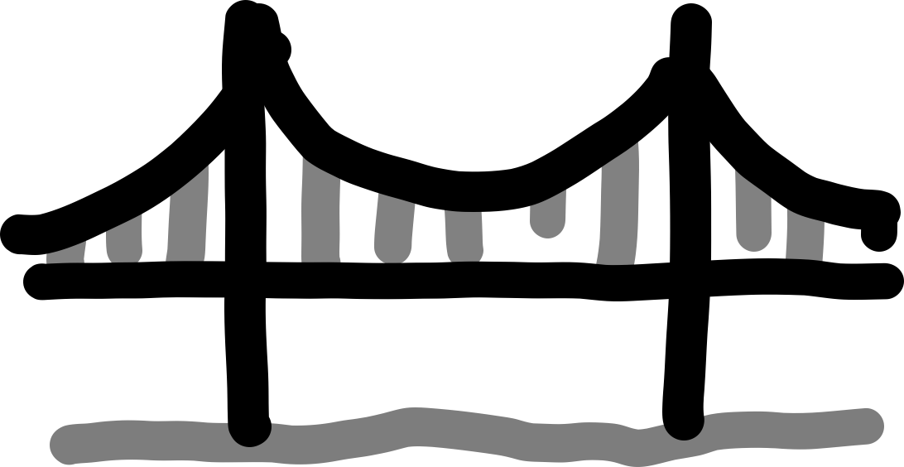

Region

Namespace

Sales Event Team

StatefulSets

Regional Partners

Ingress

Store Blueprints

ConfigMaps

Company Secrets

Secrets

Logistics

StorageClass



And many more…

Business Expansion Team

Scalers

Store Managers

ReplicaSets

Mid-Management

Deployments

Regional Managers

DaemonSets

### Diagram, text Description automatically generatedThe Declarative Model

There are two models the Declarative and Imperative. Kubernetes is built around the Declarative model.

Here are two extremely simple analogies that might help. Consider when we go to a restaurant and order a cake.

**Declarative**

I need an almond cake that will feed 10 people.

**Imperative**

Go to the kitchen, take out eggs, milk, almonds, almond flour. Turn on the oven to 350F, Mix the ingredients. Carefully place mixture in a round 12 inch baking tray. Place tray in the oven for 30 minutes. Remove tray from oven once 30 mins has elapsed. Ice cake. Serve cake.

The declarative model obviously gives the consumer tangible benefits, the complexity of baking a cake is left to the chef, all the consumer needs to do is specify the type of cake and how many people it should feed.

Kubernetes is also Cloud Agnostic, it does not care what or where your underlying hardware is, you can migrate to and from different cloud services at will. It abstracts management much like the way an OS abstracts usage and management of CPU and Memory. Kubernetes does all the heavy lifting of which server should run what on what volume with what IP, we just tell it “Hey here is an app, please deploy it with this configuration and keep it up and running.”

A quick (another) analogy, consider the process of sending a parcel through a courier service like DHL, all you have to do is package the goods in the courier’s standardized packaging, put a label on it, and hand it over to the courier. The courier is responsible for everything, the complex logistics of which planes and trucks it should go on, which highways to use and who the drivers should be to get your parcel to its destination. The courier service abstracts away the logistics of parcel delivery. All you have to do is hand them a package in their standard with a label.





It is the same for apps on Kubernetes, you package the app as a container, give it a manifest and let Kubernetes take care of deploying and keeping it running.

### Architectural Overview

The main architectural components for Kubernetes are:

* Cluster - A set of nodes with at least one master node and several worker nodes that can be virtual or physical machines.
* Kubernetes master / Control Plane - The master is in charge of scheduling and deployment of application instances across nodes in its cluster.
* Kubelet - Each Kubernetes node runs an agent process called a kubelet that is responsible for the state of the node.
* Pods - The basic scheduling unit, which consists of one or more containers.
* Deployments, DaemonSets, etc - There are types of controllers for deploying pods which add features to the pod such as autoscaling, rollbacks and backup replicas.

In the example below we assumed that each node is a physical machine for visual simplicity, just remember that they can also be virtual machines.

Cluster 1

Master Node / Control Plane

Pod

Pod

Pod

Pod

Pod

Pod

Pod

Pod

Pod

Pod

Pod

Worker Node

Worker Node

Red - Hardware

Blue - Software

Cluster 2

Master Node / Control Plane

Pod

Pod

Pod

Pod

Pod

Pod

Pod

Pod

Pod

Pod

Pod

Worker Node

Worker Node

As can be seen in the figure above, Kubernetes also supports other container technologies. It has features that abstract container runtimes that standardize the way third party container runtimes interface with Kubernetes.

### Kubernetes Objects

Kubernetes Objects are functional units that perform various types of tasks within nodes. Anything that is a Kubernetes object can and must be defined in the manifest file under the “kind” variable.

When we refer to something as a fully fledged Kubernetes object, we mean that it is configurable via the manifest file and is also an actual unit you can interact with via the kubectl CLI tool.

### Masters, Nodes

A Kubernetes cluster is made of masters and nodes. These are Linux hosts that can be Virtual Machines, bare metal servers or instance in a private or public cloud.

The master node paradigm is like the brain muscle paradigm. Our brain (Master/Control Plane) sends signals through our nervous system (API Server) to muscles (Nodes).

Master

Node

Node

Node

#### Masters (Control Plane)

A Kubernetes master is a collection of system services that make up the control plane of the cluster. The simplest setups run all master services on a single host, however this is only suitable for labs and test environments.

In a production environment, multi-master high availability (HA) is a necessity. Which is why major cloud providers implement HA masters as part of their hosted Kubernetes platforms, such as Azure Kubernetes Service(AKS), AWS Elastic Kubernetes Service(EKS), Google Kubernetes Engine(GKE).

Generally speaking, running 3-5 replicated masters in a HA configuration is enough.

It is also good practice to not run applications on master hosts, this allows master hosts to concentrate entirely on managing the cluster, minimizing the possibility of a application malfunction affecting master availability.

Now we will take a look at the components of a control plane, or the system services that it is made up of.

##### The API Server

The API Server is the central communications hub of Kubernetes. All communications, between all components, must go through this API server.

It exposes a REST API that you POST YAML config files to over HTTPS. These YAML files, which are sometimes called manifests, contain the desired state of your application.

This desired state includes:

* Which container image to use
* Which ports to expose
* How many Pod replicas to run

All requests to the API Server are subject to authentication and authorization checks , but, once these are done, the config in the YAML file is validated, persisted to the cluster store, and deployed to the cluster.

##### The Cluster Store

The cluster store is the only stateful (handles state information, like is it up down and how much load is it under, etc) part of the control plane. It persistently stores the entire configuration and state of the cluster. As such, it’s vital component of the cluster. No cluster store, no cluster.

##### The Controller Manager

The controller manager implements all of the background control loops that monitor the cluster and respond to events.

It controls controllers, meaning it spawns all of the independent control loops and monitors them. Think of it as middle management in a company where you are the CEO.

There are many control loops, but the main idea behind all of them is this.

1. Obtain Desired State
2. Monitor Current State
3. Determine Differences
4. Resolve Differences

##### The Scheduler

At a high level the scheduler watches the API server for new work tasks and assigns them to the appropriate healthy nodes in the cluster, how it figures out which nodes to give the tasks to is complex and there is a ranking system based on various conditions which we will not go into, but the node with the highest ranking score is selected to run the task

##### The Cloud Controller Manager

If you are running tour cluster on supported public cloud platforms like AWS, Azure, GCP, DO, IBM Cloud, etc. your control plane will be running a cloud controller manager responsible for managing integrations with the underlying cloud services and technologies, such as instances load balancers, and storage.

An example is if your application asks for an internet facing load balancer, the cloud controller manager is involved in provisioning an appropriate load balancer on your cloud platform.

##### Summary

Kubernetes master run all the cluster’s control plane services. It is where all scheduling and control decisions are made.



#### Nodes

Nodes are the workers of a Kubernetes cluster. At a high level, they do three things:

1. Watch the API Server for new work assignments
2. Execute new work assignments
3. Report back to the control plane via the API Server

They are more simple than masters as can be seen below

As you can see there are three major parts of a node.

##### Kubelet

The Kubelet is the star of the show on every node. It’s the main Kubernetes agent, and it runs on every node in the cluster, the terms node and Kubelet are commonly used interchangeably

When you join a new node to a cluster, the process installs the Kubelet onto the node, it acts as an agent for the node. It is responsible for registering the node with the cluster. Registration effectively pools the node’s resources into the wider cluster pool.

One of the main jobs of the Kubelet is to watch the API server for new work assignments. Any time it sees an assignment, it executes the task and maintains a reporting channel back to the control plane via the API server.

If a Kubelet cannot a particular task, it reports back to the master and lets the control plane decide what actions to take. The Kubelet does not make decisions.

##### Container Runtime

The kublet needs a container runtime to perform container-related tasks like pulling images, stopping and starting containers.

In the early days, Kubernetes had native support for a few container runtimes like Docker. However it has moved on to providing a Container Runtime Interface (CRI) provides a standardized and documented interface for third party container runtimes to plug into.

##### Kube-Proxy

The Kube-Proxy runs on every node in the cluster and is responsible for local cluster networking. It ensures each node gets its own unique IP address and implements local IPTABLES or IPVS rules to handle routing and load-balancing of traffic on the Pod network.

### Diagram Description automatically generatedKubernetes DNS

As well as the various control plane and node components, every Kubernetes cluster has an internal DNS service that is vital to operations.

The cluster’s DNS service has a static IP address that is hard-coded into every Pod on the cluster, meaning all containers and Pods know how to find it. Every new service is automatically registered with the cluster’s DNS so that all components in the cluster can find every service by name. There are other components registered with the cluster DNS, but for the sake of simplicity we will not go into them.

#### DNS as an analogy

The most common analogy for what DNS’s are is the phone book, but keeping with the theme of this guide, we will use a restaurant instead.

Service = Menu Item

Chef = Server

Waiter = DNS

Steak Chef, Yulia



Tom, two omelettes. Table 3

Omelette Chef, Tom

Two omelettes please.



Waiter

Pastry Chef, Alice

Waiter

The waiter knows which chef to ask for an omelette and where to find him at that moment in time. The DNS knows what the IP address of the requested Service is and which node to find them in.

### Pods

If you are familiar with VMware, the atomic unit of scheduling is the Virtual Machine (VM). In the Docker world, it is the container. In the Kubernetes world, it’s the Pod.

While it is true that Kubernetes runs containerized apps, you cannot directly run a container on a Kubernetes cluster. Containers must **always** run inside of Pods.

#### Pods & Containers

A very helpful thing to understand is that the term Pod comes from a pod of whales, how we describe a group of whales in English. Notice how the Docker logo looks like a whale?

It makes sense that we call a group of containers a Pod in Kubernetes doesn’t it?

The simplest model is to run a single container per Pod. However, it is possible to run multiple containers inside a single Pod. These multi-container Pods are only used in certain situations like if you have Web containers supported by a helper container that pulls the latest content from another microservice.



The point of all this imagery and analogy is that a Kubernetes Pod is a construct for running one or more containers.

#### Pod Anatomy

At the highest level, a pod is a sandbox for hosting containers. You ring off an area in the Host OS, build a network stack, create a bunch of kernel namespaces, and run one or more containers in it. This has some interesting and critical implications.

When you run multiple containers in a single Pod, they share the **same Pod environment**. This includes things like IPC namespace, shared memory, volumes, and network stack. What do these words mean? One end result of these is that all containers in the pod share the same IP Address (the Pod’s IP). This is shown in the figure below.

You may be wondering if this is the case, how do the containers in the pod talk to each other? Well they communicate by using the ports on the Pod’s localhost interface.

When should we employ multi-container Pods? Multi-container Pods are ideal when you need tightly coupled containers that may need to share memory and storage. However if you don’t need to tightly couple your containers, you should put them in their own Pods and loosely couple them over the network. This keeps things clean from a Microserve standpoint, each Pod is dedicated to a single task.

#### Pod Lifecycle

Pods are mortal, they are born, they live and they die. If they die unexpectedly, they, much like humans, are unable to be revived, we replace them with a brand new Pod, with a shiny new ID and IP address.

This has implications on how we design our applications. Don’t design them so that they are tightly coupled to a particular instance of a Pod. Instead, design them such that when a Pod fails, another one can just pop up into existence and take over seamlessly with a new ID and IP Address.

At the technical level:

1. We POST our manifest file to the API server
2. Once there, the contents of the manifest get persisted to the cluster store as a record of the desired state, and the Pod is scheduled to a healthy node with enough resources.
3. Once it’s scheduled to a node, it enters a Pending state, which happens until the container runtime on the node finishes downloading images and starts the containers.
4. 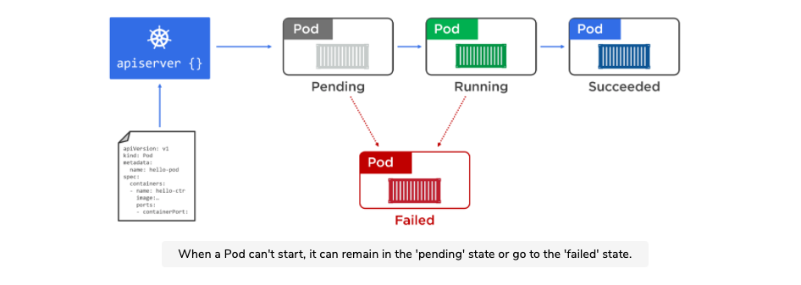Once everything is up and ready, the Pod enters the Running state.

Pods that are deployed via Pod manifest files are not managed by a controller that might add features like auto-scaling and self-healing. For this reason, we almost always deploy Pods via higher-level controllers such as Deployments and DaemonSets.

The key takeaway is that Pods are mortal. It is imperative we do not store states in Pods. It’s also why we should not rely on Pod IPs.

#### When to use Multi-Container Pods

The decision to make a multi-container Pod stems from the concept concerns as described in the Microservices section at the beginning.

Lets say we have two clear concerns:

1. Serving a web page
2. Making sure the content is up to date

Now we are faced with a question. Do we keep these two concerns in a single container or two separate container?

Microservice design patterns dictate that we should separate concerns, so we will have two containers. One for the web service, and another for the file sync service.

In cases like these where the two services have to have a shared memory or volume, it is acceptable to keep them in the same pod.

As seen above, the two containers will have a shared volume, which will store the web pages to be served.

### Packaging Apps for Kubernetes

For an application to run on a Kubernetes cluster, it needs to fulfil a few conditions:

1. Being packaged as a container
2. Being wrapped in a Pod
3. Being deployed via a declarative manifest file

Now going back to our previously defined Docker workflows, we will add the above steps to the process.

1. Write your app in the language of your choice
2. Build it into a Container Image
3. Store it in a registry

At this point, your app is containerized.

1. Define a Kubernetes Pod to run the containerized application
2. Deploy pod to cluster

### Image Repositories

We store images in registries which can either be public or private. Each registry is divided into one or more repositories, and we actually store the images in the repositories.

Public registries are on the internet and are the easiest way to download images and run containers. However it is important to understand that it’s a wild west. They host a mixture of official images and community images.

Official images are images provided by the product vendors and have undergone a vetting process to ensure certain levels of qualities. Typically official images will implement best practices, be scanned for known vulnerabilities, contain up-to-date code, and be supported by the product vendor. This is not the case for community images. Yes there are some good community images, but practice extreme caution when using them.

With all this in mind, it is important that a standard way for developers to obtain and consume images in your environments be setup. It is also vital that any such process be as frictionless as possible for developers. This is because by nature of being developers, if something is too annoying, they will find ways to bypass them.

Some of the things that will help with this are:

* Using approved base images

Since images are made up of multiple layers that build on top of each other to form a useful image. There is always a base layer which contains the core OS and filesystem components that applications need in order to run.

It is common for an organisation to have a small number of pre-approved base images for everyone to build on top of. This has multiple advantages including long term security, reducing software sprawl, making testing easier, making updates easier and making troubleshooting easier.

* Nonstandard base images

As many benefits using approved base images is, there are occasions when an application needs something different. This means you will need processes in place that:

* + Identify why an existing approved image cannot be used
  + Determine whether an existing approved base image can be updated to meet requirements, and if its worth the effort
  + Determine the support implications of bringing an entirely new image into the environment.

Generally speaking, it is better to just update an existing base image instead of introducing an entirely new image.

* Control access to images

There are various options for this. The most secure and practical option is to host your own private registry within your own firewall. This allows your organization to manage how the registry is deployed, how it is replicated, and how it is patched. It also integrates permissions with existing identity management providers, such as Active Directory, and allows you to create repositories that fit your organizational structure.

If you do not have the means for a dedicated private registry, you can host your images in private repositories on public registries such as Docker Hub. This is not as secure.

Away from the registry itself, you should also:

* + Restrict which cluster nodes have internet access, your image registry may be on the internet
  + Configure access controls that only allow authorized users/nodes can push to repositories

Expanding on this, you will probably need to grant your worker nodes access to the internet so they can pull images. In this situation, the best practice is to limit internet access to the addresses and ports of any registries you use. Strong RBAC rules should also be implemented so that you can maintain control over who is pushing and pulling images from which repositories.

### Kubernetes Objects / Controllers / Resources

Important Note: All examples under this section are not production grade examples, they are just intended to demonstrate the way objects work. Also, this is just a fraction of Kubernetes Objects, other parts of the guide will introduce other types of Objects when relevant.

These refer to functional components that possess various characteristics in the Kubernetes cluster. We think and refer to these as entities that we can configure via manifests. There are third party open source Kubernetes Resources such as Argo and OpenEBS that provide unique functionality and capabilities, you can also write your own resource if you wish.

You can see a full list of all Kubernetes objects by using the kubectl CLI tool. Simply type kubectl api-resources and a list of all Kubernetes objects your version supports.

It is possible to run a stand-alone Pod on a Kubernetes cluster, but the preferred model is to deploy all Pods via higher-level controllers. The most common controller is the Deployment. It offers scalability, self-healing, and rolling updates. You can define Deployments in YAML manifest files that specify things like which image to use and how many replicas to deploy.

Once everything is defined in the Deployment YAML manifest file, you POST it to the API server as the desired state of the application and let Kubernetes implement it.

Most of the time you’ll deploy Pods indirectly via a higher-level controllers, some of which are:

1. Deployments
2. DaemonSets
3. StatefulSets
4. Cron Jobs

Each has features and are wrappers around pods. For example, a Deployment is a higher-level Kubernetes object that wraps around a particular Pod and adds features such as scaling, zero-downtime updates, and versioned rollbacks.

Under the hood, Deployments, DaemonSets and StatefulSets all implement a controller and a watch loop that is constantly observing the cluster making sure that the current state matches the desired state.

#### Deployments

Up till now, we have only seen Pods being used, the problem with pods is that they do not self-heal, auto scale or allow for easy updates or rollbacks. As a result, we almost always deploy Pods via the Deployment controller.

A single Deployment Object can only manage a single Pod template. For example if you have an application with a Pod template for the Web Backend, and another Pod template for the Catalog Service, you will need two Deployment Objects.

Catalog

Catalog Replica

Catalog Replica

Deployment Controller/Object

Web Backend

Web Backend Replica

Web Backend Replica

Deployment Controller/Object

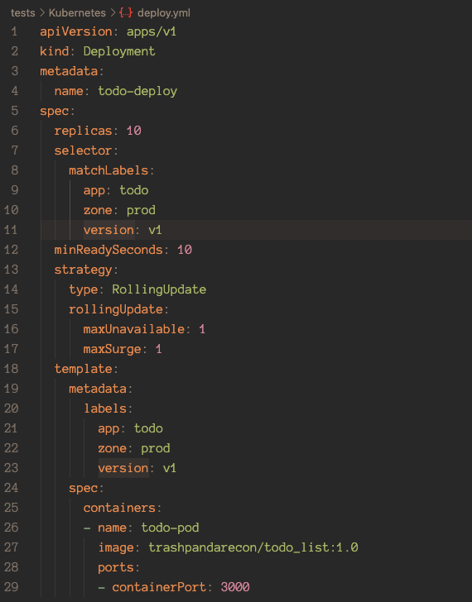

On the right is an example of a Deployment manifest.

Simply use Kubectl apply -f <filename> to deploy this file.

##### Rolling Updates

Rolling updates allow us to update our images with zero downtime to the application.

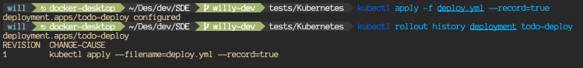The actual way to deploy the update is just to amend the original manifest file with the updated version number of the image and or any other changes you would like to make, then use the kubectl apply -f <deploy filename> --record=true. --record=true will record the update in the object’s history.

This may be a reason why you would use the record flag.

We can use the kubectl rollout command to roll back the application to REVISION 1 above using kubectl rollout undo deployment todo-deploy --to-revision=1.

When we roll back or roll up deployment versions, their ReplicaSets do not get deleted. The previous versions still exist which enables us to easily switch between revisions. This can be seen using kubectl get rs

Note that the operation of rolling between ReplicaSet configs is an imperative operations and will not change your YAML Manifest file. It is good practice to manually update the Manifest after doing a rollback with the config of the current active ReplicaSet configuration.

#### Service

Pods are unreliable, this statement is a result of a lot of technical details like how scaling pods cause a lot of IP churn, etc. As a result, Kubernetes has Service objects. Each Service Object has its own stable IP address, its own stable DNS name and its own stable port.

##### Internal

If we do a simulation, assuming that we have a microservices app with a bunch of Pods performing video rendering. How will this work if other parts of the app that need to use the rendering service cannot rely on pods being there when they are required?

This is where Service come into play. Services provide reliable networking for a set of Pods.

The Kubernetes Service is providing a reliable name and IP and is load balancing requests to the two renderer Pods behind it.

Services are fully fledged objects in Kubernetes API, like Pods and Deployments, they have a front end that consists of a stable DNS name, IP address, and port. On the back end, they load balance across a dynamic set of Pods, as Pods are born and die, the Service sees this and updates itself accordingly while continuing to provide that stable endpoint for other pods to access the renderers.

##### External

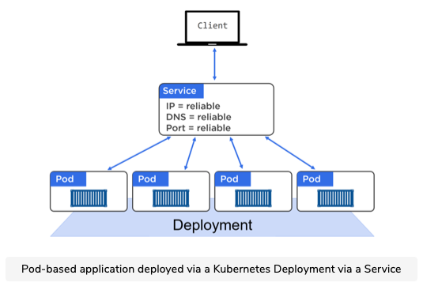It is not a good idea to talk directly to a Pod because that Pod could disappear at any point. Therefore we put a Service Object in front of a set of Pods as a medium for the client to interact through.

The service object maintains a list of healthy Pods throughout Pod rollbacks, scaling, and updating operations. These are all transparent.

##### Connecting Pods to Services

Services use labels and a label selector to know which set of Pods to load-balance traffic to. The service has a label selector that is a list of all the labels a Pod must possess in order for it to receive traffic from the Service.

The figure below shows a Service configured to send traffic to all pods on the cluster tagged with the following three labels.



* zone-prod
* env=be
* ver=1.3



An important note is that ALL labels have to match. A single different or missing label will result in it not being selected by the Service Object.

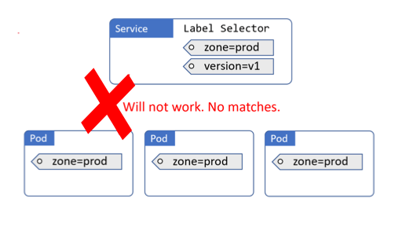

##### Service Types

* ClusterIP

This is the default option and gives the Service a stable IP address internally within the cluster. It does not make the Service available outside the cluster.

* NodePort

This builds on top of ClusterIP and adds a cluster-wide stable TCP or UDP port available outside the cluster on a stable port.

*** NodePort by design punches a gaping hole into Kubernetes security. It bypasses almost all Kubernetes Network Security and exposes an upper range of Ports not commonly used. This has the added effect of pissing off everyone using your service because the upper range of Ports may be blocked by Admins through firewalls. If you are building an External internet facing application. Look at Ingress instead.

* LoadBalancer

This builds on top of NodePort and integrates with cloud-based load-balancers.

* ExternalName

This is used to direct traffic to services that exist outside of the cluster.

##### Endpoints Objects

Every service gets its own Endpoints Object with the same name as the Service. The Endpoints Object holds a list of all the Pods the Service matches and is dynamically updated as matching Pods live and die. You can see Endpoints with the normal kubectl commands as well.

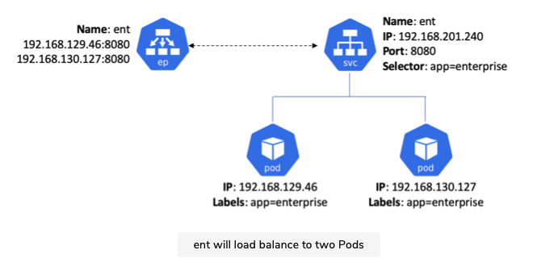The figure below shows a service named “ent”. It will load balance to two Pods. It also shows the Endpoints Object with the Ips of the two Pods that match the Service’s label selector

The kube-proxy on every node that sees the new Service and Endpoints objects will create IPVS (Linux IP Virtual Server) rules to redirect traffic to the Service’s ClusterIP to one of the Pods that match its label selector.

It is at this point that the Service is fully registered and ready to be discovered.

##### Diagram Description automatically generatedCluster DNS

As well as the various control plane and node components, every Kubernetes cluster has an internal DNS service that is vital to operations.

The cluster’s DNS service has a static IP address that is hard-coded into every Pod on the cluster, meaning all containers and Pods know how to find it. Every new Service Object is automatically registered with the cluster’s DNS so that all components in the cluster can find every service by name. There are other components registered with the cluster DNS, but for the sake of simplicity we will not go into them.

Services, not pods register with the Cluster DNS.

###### DNS as an analogy

The most common analogy for what DNS’s are is the phone book, but keeping with the theme of this guide, we will use a restaurant instead.

Menu Item = Service ( like gmail login )

Chef = Server

Waiter = DNS

Steak Chef, Yulia



Tom, two omelettes. Table 3

Omelette Chef, Tom

Two omelettes please.



Waiter

Pastry Chef, Alice

Waiter

The waiter knows which chef to ask for an omelette and where to find him at that moment in time. The DNS knows what the IP address of the requested Service is and which node to find them in.

##### Service Registration Summary

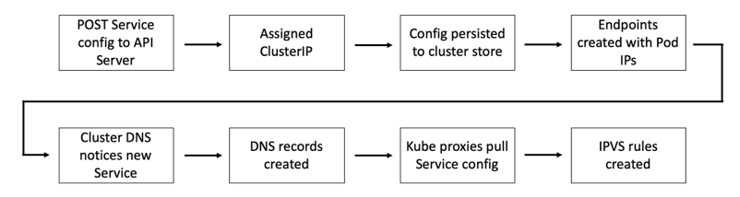To summarize Service Objects in Docker, here is a big picture overview of how it is created.

##### Service Discovery

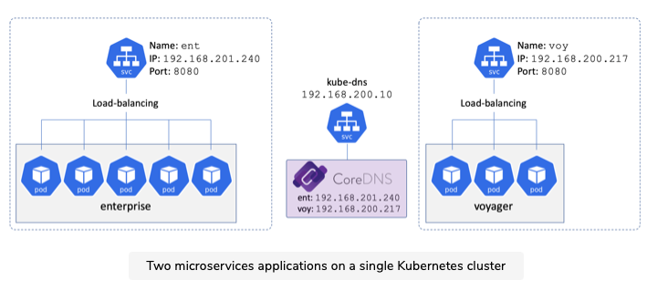Lets assume we have two microservices on a single cluster - enterprise and voyager. Both are registered according to the figure below.

For service discovery to happen, each microservice needs to know two things:

1. The name of the remote microservice they want to connect to
2. How to convert that name into an IP Address

Kubernetes automatically hardcodes a nameserver mapping in every container by adding it to their /etc/resolv.conf file. As well as any search domains that should be appended to unqualified names.

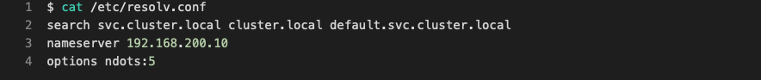Note: An “Unqualified name” is a short name such as ent. Appending a search domain converts an unqualified name into a fully qualified domain name (FQDN) such as ent.svc.cluster.local .

Nameserver being the ip address of the Cluster DNS.

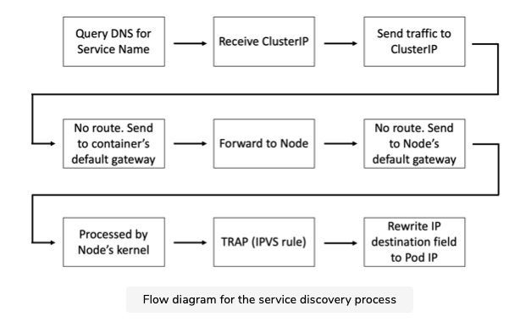For the sake of sanity, we will not delve deep into exactly how the traffic gets routed. Instead, we will just look at this flow diagram of the Service Discovery process.

##### A Production Use Case

This is all fine and interesting, but how does this actually bring tangible benefits to a business/application? Let’s take a look at a real world use case for this, updating applications with immediate no downtime rollbacks.

Updating applications is a fact of life, to achieve true no downtime updates and or rollbacks, we could use the Deployment type, but it does not provide true no downtime updates, it slowly replaces current old pods with new pods. One thing we could do is to take advantage of the Service label selector and its constant watch loop.

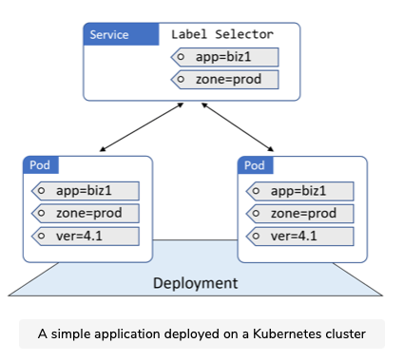Imagine that you have this setup below.

Now, assume you need to push a new version without causing any downtime or overlap. To do this, you can add Pods running the new version of the app, at which point the Service will load balance across both versions.

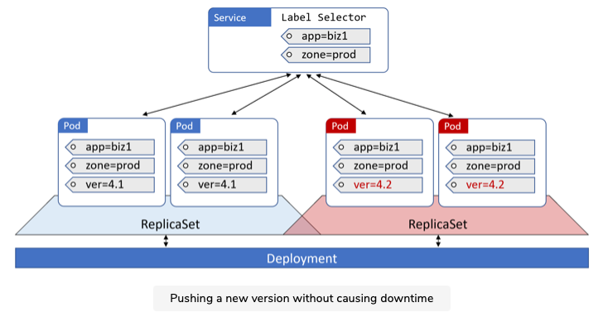

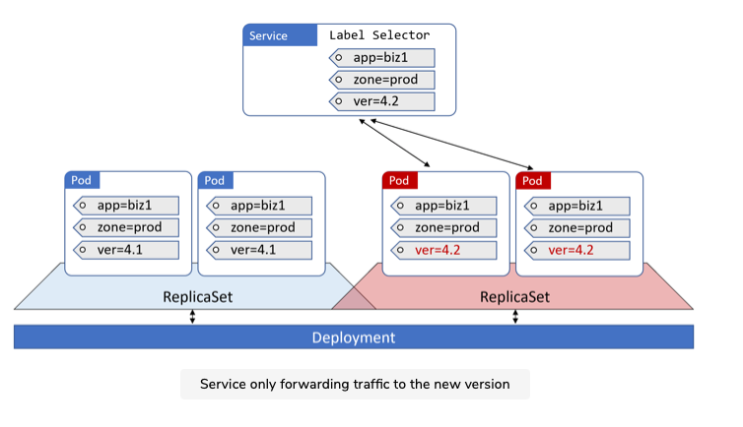Once you are happy with the updated version, you can force ALL traffic to use the newer version by simply updating the Service’s label selector to include version=4.2. Suddenly the old version no longer match and the Service sends all traffic to the new version.

Assuming we have two Deployments going on here, one for the current version and one for the previous version. The previous version will not disappear, it sits in the cluster waiting.

Now, why in the world could you possibly want old version Pods just sitting in your cluster being useless? The answer is simple, imagine there is a fatal error in the updated Pods that causes it to crash constantly on users. Imagine you are in charge of Amazon’s commercial sales site, any downtime causing inconvenience to customers is catastrophic to your reputation and every second the site is down will literally cost millions of dollars. The moment we are made aware of the error, all we have to do is change the label selector of the Service Object to 4.1 and business will proceed as usual within seconds, albeit at reduced capacity. While the dev team gets fired, you get praised for saving operations and literal millions for the company.

Obviously this only applies in extremely high stakes scenarios where seconds will bleed an inordinate amount of money from the business. Otherwise it is perfectly fine and preferable to use a single Deployment.

#### Ingress

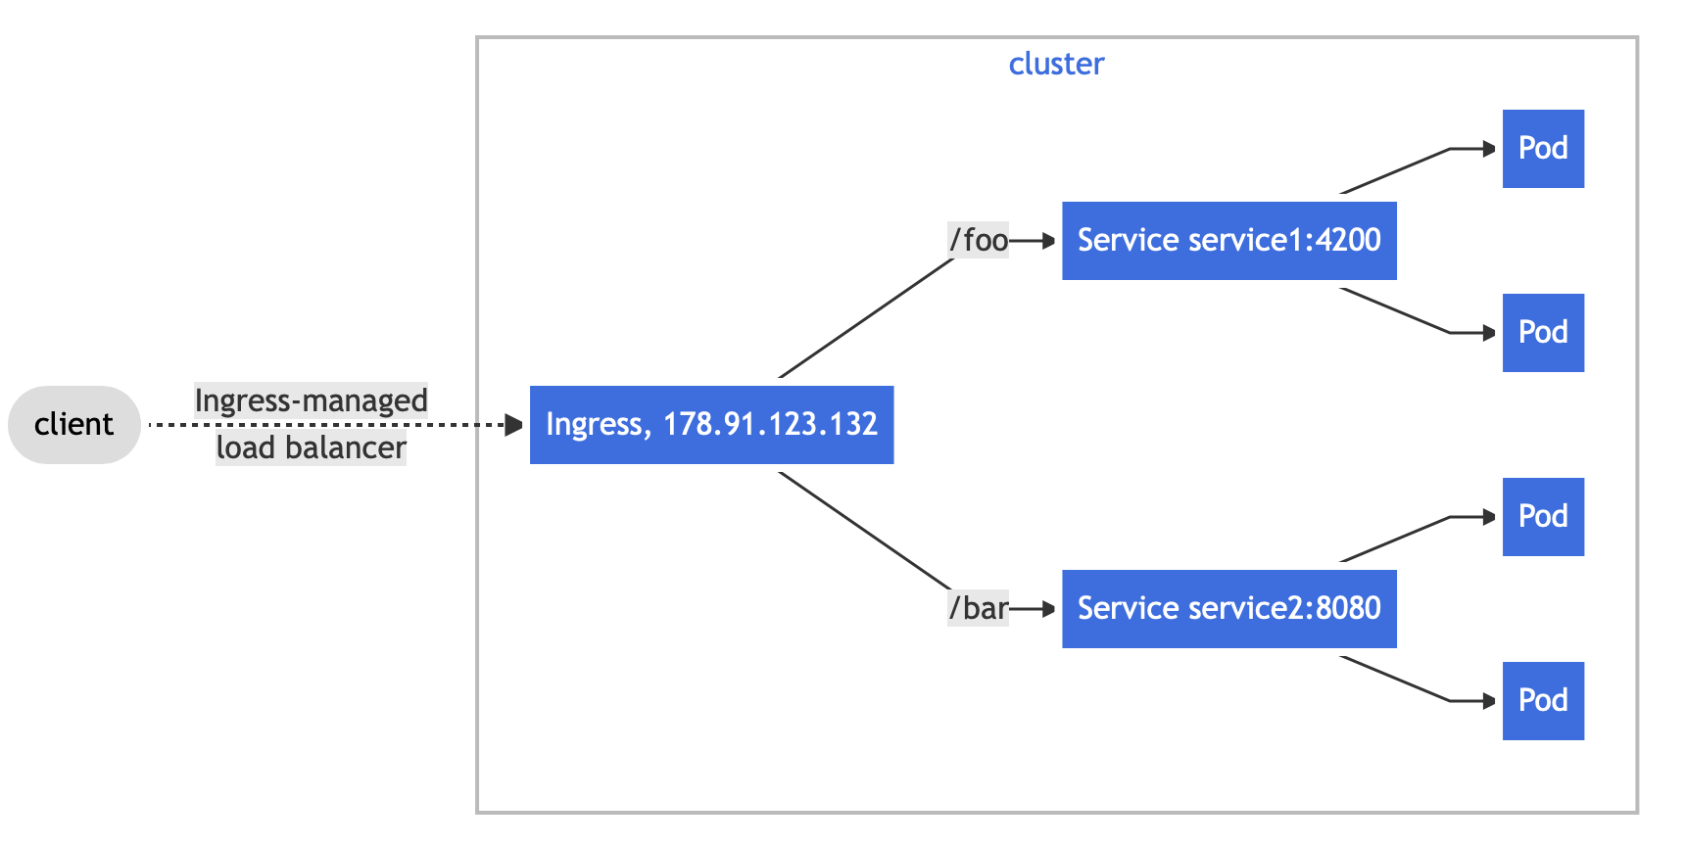The Ingress object type can be seen as having a one to many relationship with Service object types.

There are 3 ways of exposing a service object externally.

1. NodePort - As previously stated, this is really not a good idea in terms of security.
2. LoadBalancer - This is able to load balance to a single service in a one to one relationship, it may be sufficient on the small scale, but as you can imagine, it is an unscalable solution
3. Ingress - The optimal solution. It is able to expose many services by various configurable names all in a single object.

Ingress objects are quite unique in that they do not actually work by themselves. If you were to simply deploy an Ingress object by itself, nothing would happen. For the Ingress object to work, you will need to deploy an ingress controller onto the cluster.

There are multiple third party ingress controllers you can use, a list of them can be found in the Kubernetes documentation. Any number of ingress controller types can be deployed onto a cluster. To choose which one your ingress object uses, an annotation needs to be added. In the case of the NGINX Ingress controller, it can be done like so. ( This is a general rule, some ingress controller implementations may be different. )

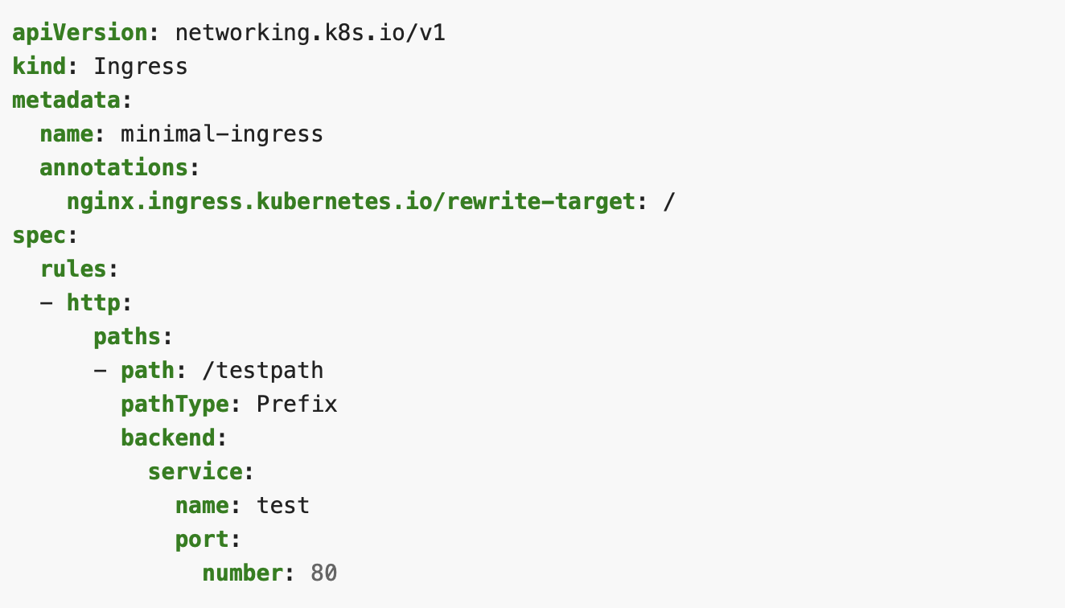Note: This is a minimal example.

##### Ingress rules

Each HTTP rule contains the following information:

* An optional host. In this example, no host is specified, so the rule applies to all inbound HTTP traffic through the IP address specified. If a host is provided (for example, foo.bar.com), the rules apply to that host.
* A list of paths (for example, /testpath), each of which has an associated backend defined with a service.name and a service.port.name or service.port.number. Both the host and path must match the content of an incoming request before the load balancer directs traffic to the referenced Service.
* A backend is a combination of Service and port names or a custom resource backend by way of a [CRD](https://kubernetes.io/docs/tasks/extend-kubernetes/custom-resources/custom-resource-definitions/). HTTP (and HTTPS) requests to the Ingress that matches the host and path of the rule are sent to the listed backend.

###### Default Backend

A default backend is usually configured in your ingress controller, any request that does not match any of your ingress rules will be routed to this backend.

###### Resource Backends

A Resource backend is an ObjectRef to another Kubernetes resource within the same namespace as the Ingress object. A Resource is a mutually exclusive setting with Service, and will fail validation if both are specified. You may want to use this to expose Storage Objects via a specific route.

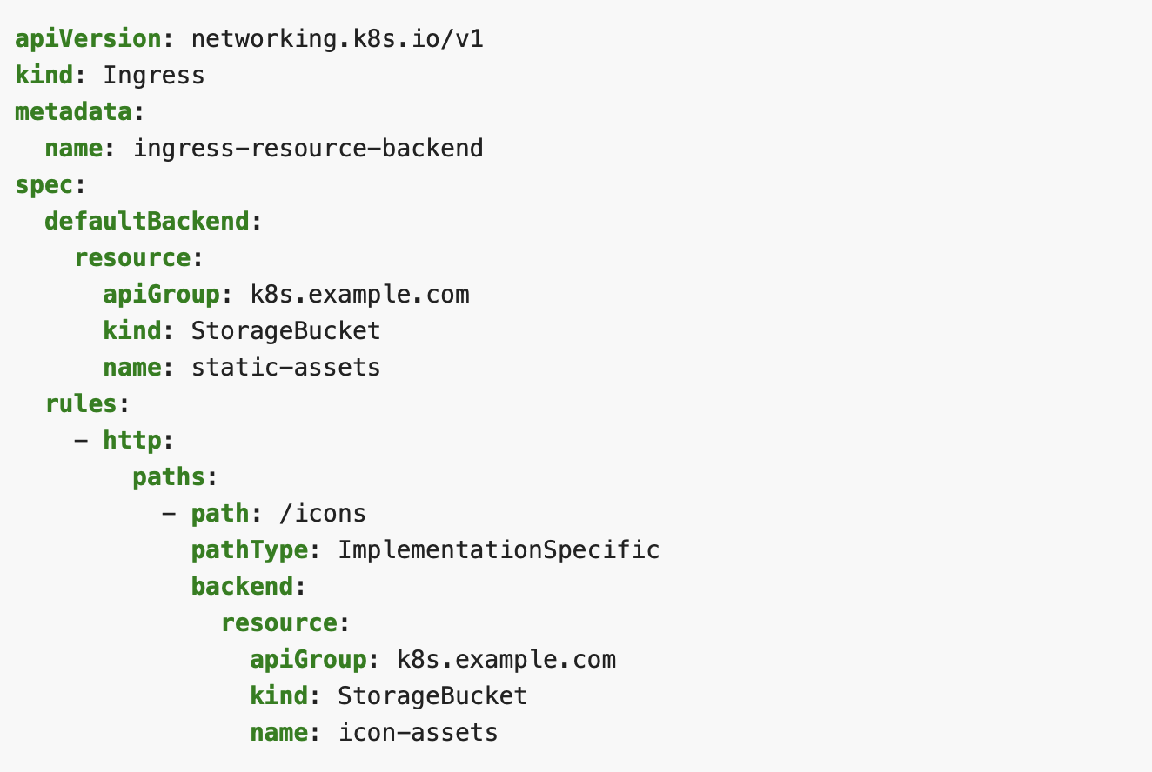

Here is one such example from the Kubernetes Docs.

###### Path Types

Each path in an Ingress is required to have a corresponding path type. Paths that do not include an explicit pathType will fail validation. There are three supported path types:

* ImplementationSpecific: With this path type, matching is up to the IngressClass. Implementations can treat this as a separate pathType or treat it identically to Prefix or Exact path types.
* Exact: Matches the URL path exactly and with case sensitivity.
* Prefix: Matches based on a URL path prefix split by /. Matching is case sensitive and done on a path element by element basis. A path element refers to the list of labels in the path split by the / separator. A request is a match for path p if every p is an element-wise prefix of p of the request path.

In some cases, multiple paths within an Ingress will match a request. In those cases precedence will be given first to the longest matching path. If two paths are still equally matched, precedence will be given to paths with an exact path type over prefix path type.

A list of specific matching examples can be found in the Kubernetes.

###### Hostname

Hosts can be precise matches (for example “foo.bar.com”) or a wildcard (for example “*.foo.com”). Precise matches require that the HTTP host header matches the host field. Wildcard matches require the HTTP host header is equal to the suffix of the wildcard rule.

###### Name Based Virtual Hosting

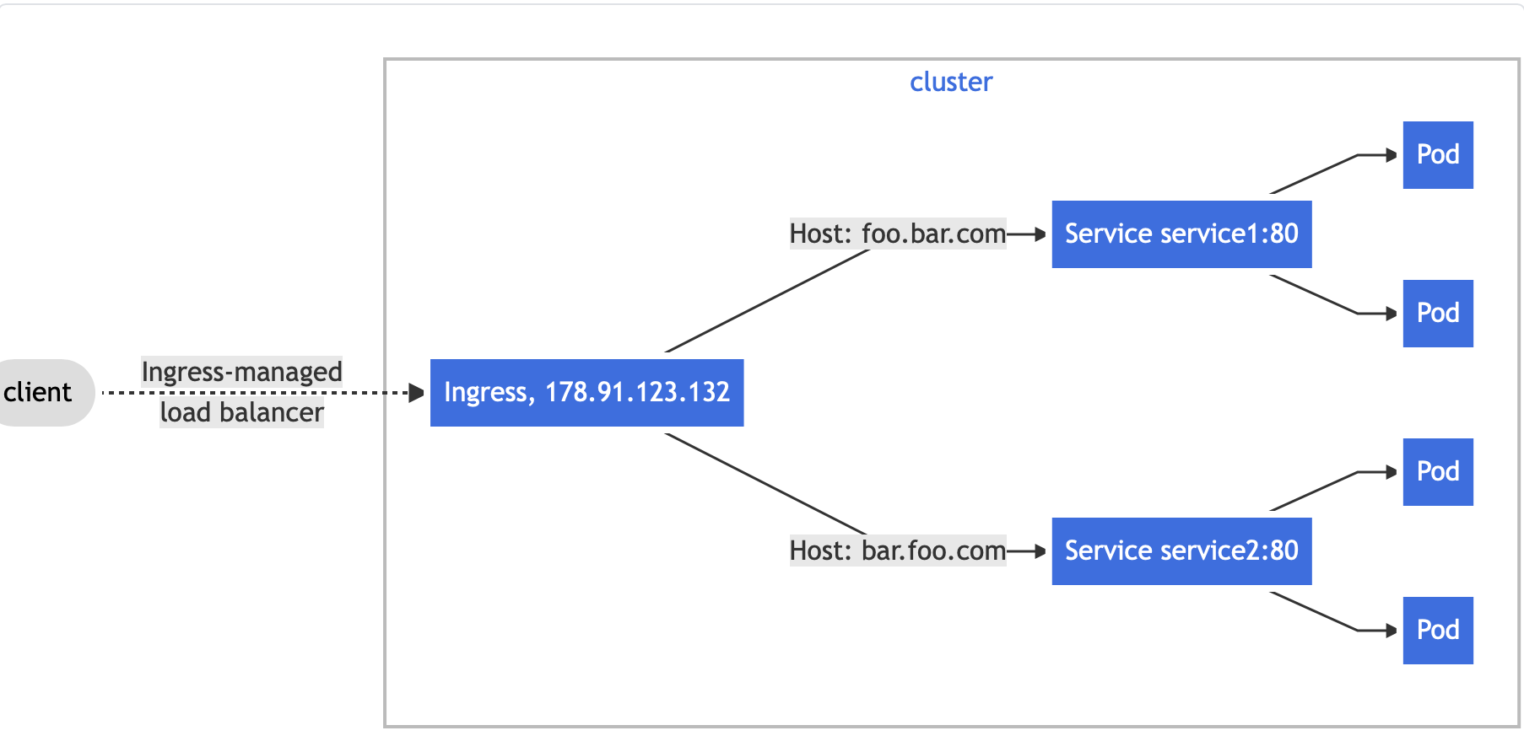Named based virtual hosts allow us to route HTTP traffic to multiple host names at a single IP address like so.

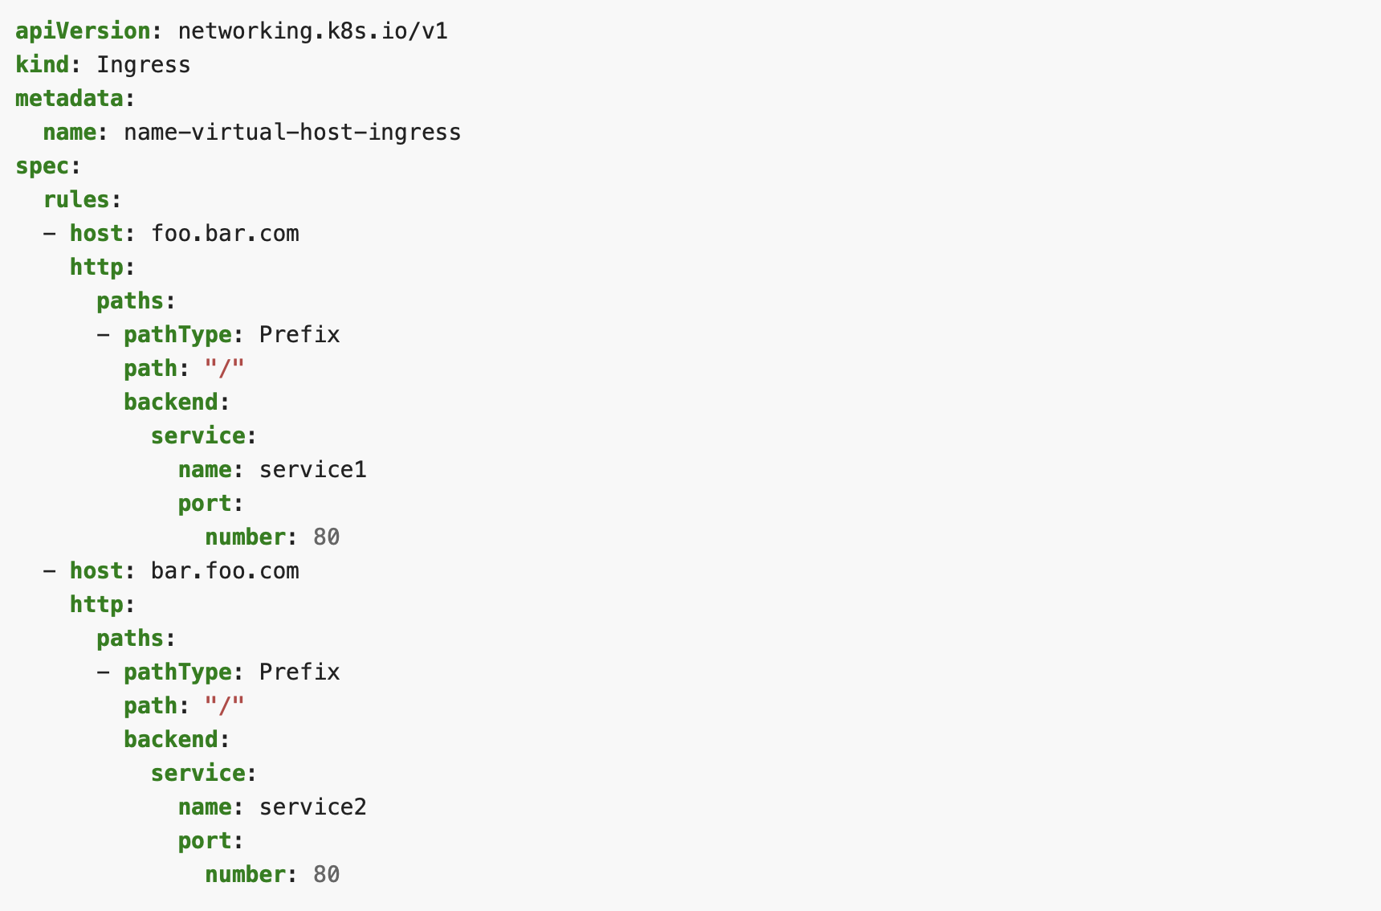This is done with the hosts header.

##### TLS

You can secure an Ingress by specifying a Secret that contains a TLS private key and certificate. The Ingress resource only supports a single TLS port, 443, and assumes TLS termination at the ingress point (traffic to the Service and its Pods is in plaintext). If the TLS configuration section in an Ingress specifies different hosts, they are multiplexed on the same port according to the hostname specified through the SNI TLS extension (provided the Ingress controller supports SNI). The TLS secret must contain keys named tls.crt and tls.key that contain the certificate and private key to use for TLS. For example:

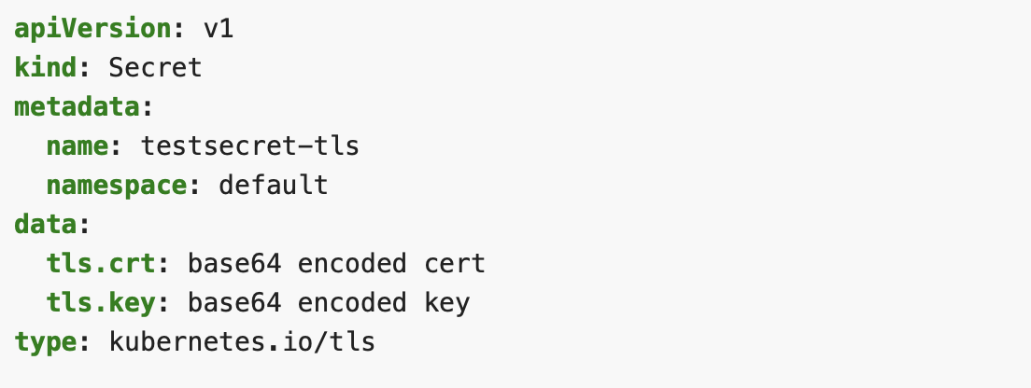

Referencing this secret in an Ingress tells the Ingress controller to secure the channel from the client to the load balancer using TLS. You need to make sure the TLS secret you created came from a certificate that contains a Common Name (CN), also known as a Fully Qualified Domain Name (FQDN) for https-example.foo.com.

**TLS features are different between each ingress controller, refer to their documentations for more information.

Note that this will not work on a default rule because the certificate would have to be issued to all possible subdomains. Therefore hosts in the TLS section must explicitly match the hosts in the rules section.

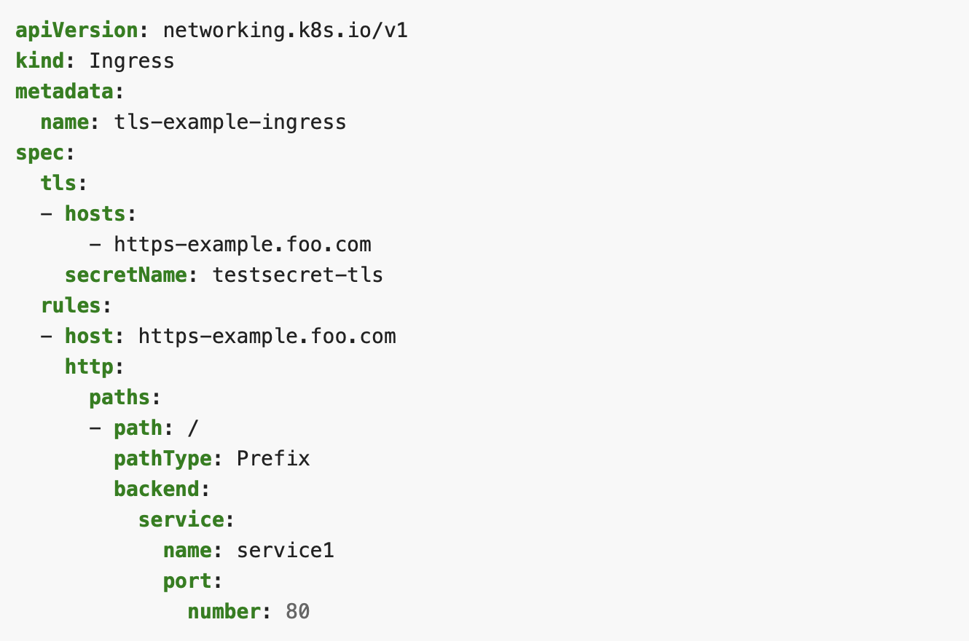

#### Namespaces

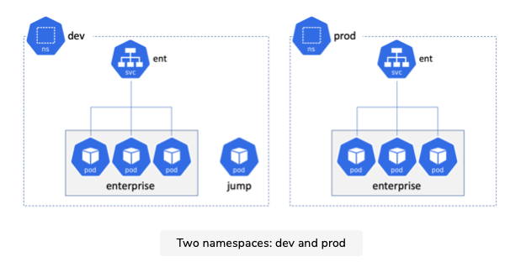If you don’t know what namespaces are, it is similar to the idea of context. Lets take a look at the figure below where we have two namespaces, dev and prod.

Notice how they both have an ent Service? With namespaces, we can have identical names but in different contexts.

Pods can access the ent services in either namespace in a couple of ways, you can directly use the IP of the services, or use domain names. The most reliable way of using domain names to access the services is by using the FQDN. For example, ent.prod.svc.cluster.local:8080 to access the prod ent service. You can also just access it via ent:8080, but it will depend on how the /etc/resolv.conf file was set up, the container will automatically append either prod.svc.cluster.local or ent.svc.cluster.local to the ent name depending on what namespace it is in.

#### Storage Objects

Kubernetes has a feature-rich storage subsystem called the persistent volume subsystem which consists of three objects:

* PersistentVolume ( PV )
* StorageClass ( SC )
* PersistentVolumeClaim ( PVC )

Kubenetes supports many types of storage from a variety of places.

For example:

* iSCSI
* SMB
* NFS
* Object Storage Blobs

Note: Some obvious restrictions apply. For example, you cannot use AWSElasticBlockStore if your Kubernetes cluster is running in Microsoft Azure.

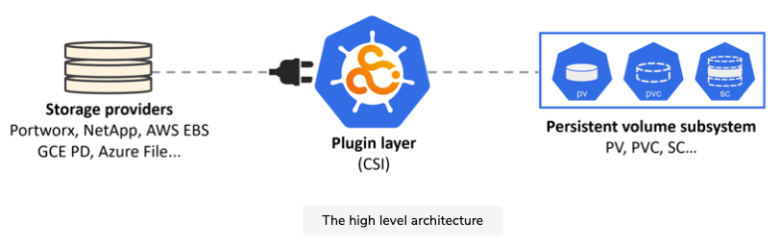These are all external storage systems that can be in the cloud or in your on-premises data center. However no matter what type of storage you choose to employ, or where it comes from, when it’s exposed on your Kubernetes cluster, it’s called a volume.

As can be seen above, no matter what store you are using, all you need is a plugin layer that allows their storage resources to be surfaced as volumes in Kubernetes.

On the right are the various components of the Kubernetes persistent volume subsystem. These are a set of API objects that allow applications to consume storage.

At a high level:

* PersistentVolumes (PV)

How external storage is mapped onto the cluster.

* PersistentVolumeClaims (PVC)

PVCs are like tickets that authorize applications (Pods) to use a PV.

* Storage Classes (SC)

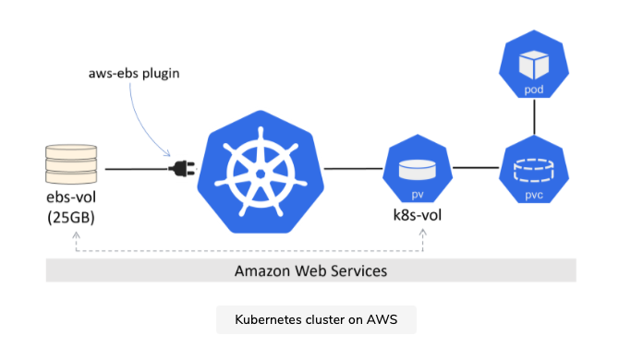

It is worth noting that a single external storage volume can only be used by a single PV. For example, you cannot have a 90GB external volume that has two 45GB PVs, each using half of it.

##### The Kubernetes Persistent Volume Subsystem

Before we can use the PV Subsystem, a volume that is visible by the CSI plugin is needed. This can be achieved in multiple ways, the easiest of which is to use a cloud provider. You can also use Local Persistent Volumes which we will go into later in the guide.

For the following examples, we assume we have a CSI plugin visible volume already made.

The Kubernetes steps for starting a Persistent Volume looks like this:

1. Create the PV
2. Create the PVC
3. Define the volume into a PodSpec
4. Mount it into a container

An important PV property is the .spec.accessMode policy.

There are three options:

* ReadWriteOnce (RWO)

Defines a PV that can only be mounted/bound as R/W by a single PVC. Attempts from multiple PVCs to bind(claim) it will fail.

* ReadWriteMany (RWM)

Defines a PV that can be bound as R/W by multiple PVCs. This mode is usually only supported by file and object storage, such as NFS. Block storage usually only supports RWO.

* ReadOnlyMany (ROM)

Defines a PV that can be bound by multiple PVCs as R/O

There are a few things worth nothing, a PV can only be opened in one mode - it is not possible for a single PV to have a PVC bound to it in ROM mode and another PVC bound to the same PV in RWM mode.

A Pod does not interact directly with a PV, it interacts with the PVC object bound to the PV.

Another property to note is the spec.persistentVolumeReclaimPolicy. This tells Kubernetes what to do with a PV when its PVC has been released. Two policies current exist:

* Delete

Delete is extremely dangerous. It is the default for PCs that are created dynamically via storage classes. This policy will delete the PV and associated resource on the external storage system, which will result in data loss. Use with caution.

* Retain

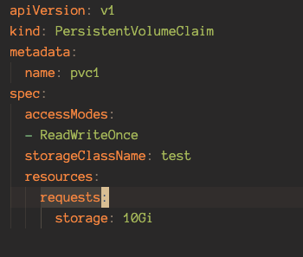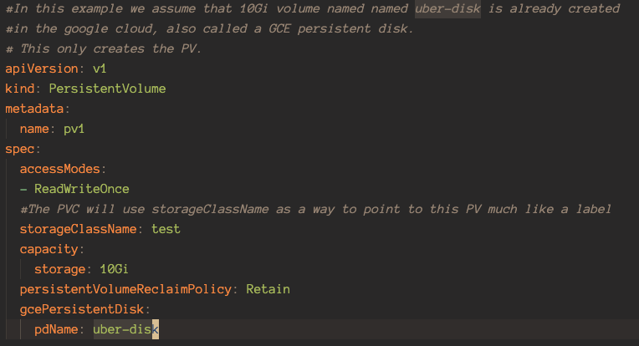Retain will keep the associated PV object on the cluster as well as any data stored on the associated external asset. However, it will prevent another PVC from using the PV in the future.

Above we see a side by side view of a PVC and a PV. Some things to note are that the PVC can claim less space than is stated on the PV. For example, the PVC above can also specify less than 10Gi at the storage setting.

##### Storage Classes & Dynamic Provisioning

So far, everything we have went through concerns manual creation of Kubernetes storage. But it doesn’t scale - there’s no way someone managing a large Kubernetes environment can manually create and maintain large numbers of PVs and PVCs. We need something more dynamic, which is where storage classes come in.

Extremely Important Note: Kubernetes does NOT natively support local PV dynamic provisioning via storage classes, take a look at OpenEBS and its equivalents in order to dynamically provision local storage.

Storage classes allow you to define different classes, or tiers, of storage. How you define classes is completely up to you, but it will depend on the types of storage you have access to.

For example we may want to define 3 types of classes:

* A Fast Class

Quick storage, SSDs

* A Slow Class

Slow storage, HDDs

* An Encrypted Class

Encrypted storage

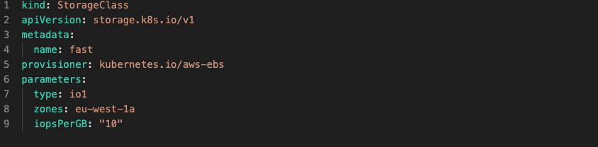At this point in time, storage classes are defined as resources in the storage.K8s.io/v1 API group. The resource type is StorageClass, a simple example is shown below.

A few quick things worth nothing:

* StorageClass Objects are immutable - this means you cannot modify them once deployed.
* Metadata.name should be meaningful as it’s how other objects will refer to the class.
* The terms provisioner and plugin are used interchangeably
* The parameters section is for plugin-specific values
* You can also add allowVolumeExpansion: true to allow the provisioner to expand volume capacity as needed

A short side note on IOPs and what it means:

* **0.25 IOPS per GB**

designed for workloads with low I/O intensity. These workloads are typically characterized by having a large percentage of data inactive at any time. Example applications include storing mailboxes or departmental level file shares.

* **2 IOPS per GB**

designed for most general-purpose usage. Example applications include hosting small databases that are backing web applications or VM disk images for a hypervisor.

* **4 IOPS per GB**

designed for higher-intensity workloads. These workloads are typically characterized by having a high percentage of data active at any time. Example applications include transactional and other performance-sensitive databases.

* **10 IOPS per GB**

Designed for the most demanding workloads such as those created by NoSQL databases, and data processing for Analytics. This tier is available for storage that is provisioned up to 4 TB in most data centres.

The configurations for storage classes are highly dependent on your storage provider. Read their documentation before writing one.

##### Implementation

The basic workflow for deploying and using a StorageClass on your cluster is as follows:

1. Create your own Kubernetes cluster with a storage backend.
2. Ensure the plugin for the storage backend is available.
3. Create a StorageClass Object.
4. Create a PVC Object that references the StorageClass by name.
5. Deploy a pod that uses volume based on the PVC.

Notice how the workflow does not include creating a PV? This is because storage classes create PVs dynamically. Although if you are using local storage, a PV is necessary.

We will now look at a simple example of how to use a PVC and PV with a Pod. Note that we are only using a single Pod to keep things simple. Pods deployed like this are usually called Singletons and are not recommended for production because they do not provide self healing or high availability. For production, look at Stateful sets or Deployments.

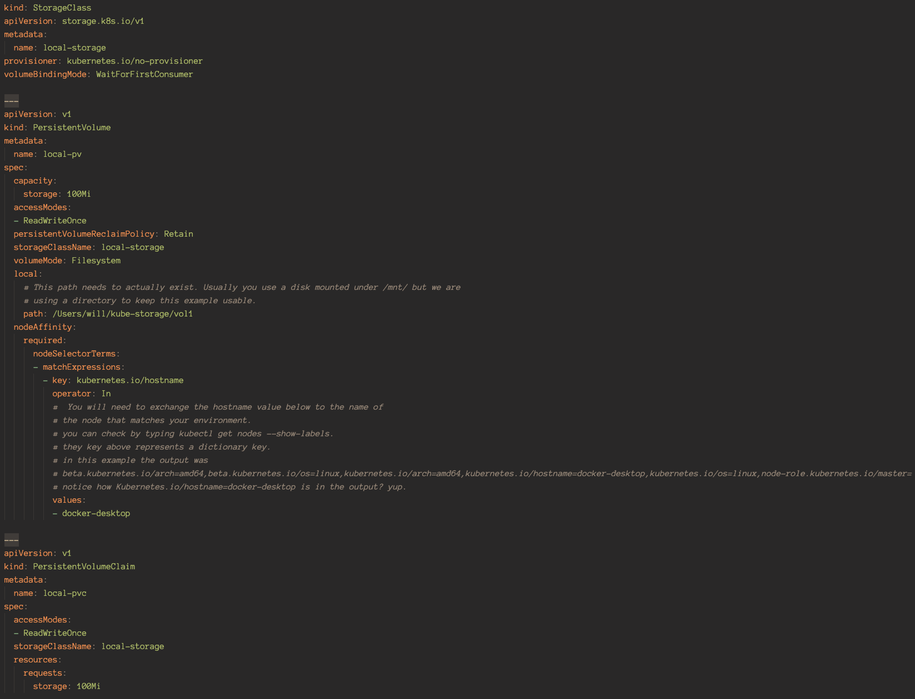Note: for the example below we are using local storage, which is why a persistent volume is defined.

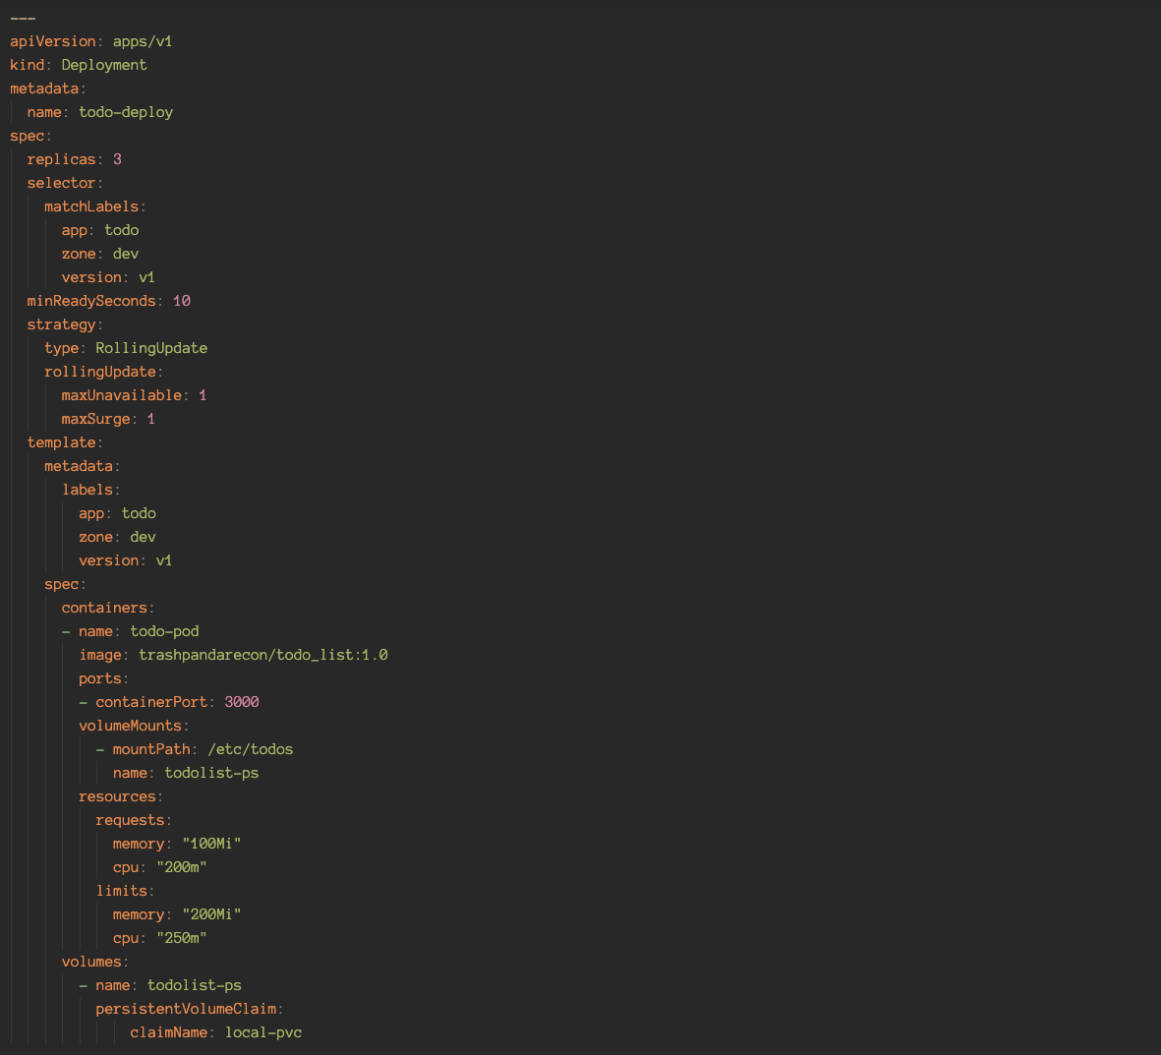

You can configure as many StorageClass objects as you need. However, each one relates to a single provisioner. For example, If you have a Kubernetes cluster with StorageOS and Portworx storage back ends, you will need at least two StorageClass objects. That said, each back end can offer multiple classes/tiers of storage, each of which can have its own StorageClass.

For example you can have the following two StorageClass objects for different classes of storage from the same back end:

1. “fast-secure” for high performance encrypted volumes
2. “fast” for high-performance unencrypted volumes

#### ConfigMaps & Secrets

Most applications are composed of two main parts:

* The application binary
* A configuration

A simple example is a web server, such as NGINX or Apache. Neither are very useful without a configuration.

In the past, we coupled the application and the configuration into a single unit. As we moved into the early days of cloud-native microservice applications, we brought this model with us. However, it’s an anti-pattern. It goes against the very idea of decoupling.

In comes ConfigMaps, it decouples the configuration from the image, which brings some tangible benefits such as:

* Reusable application images
* Simpler testing
* Simpler and fewer disruptive changes

Here is a quick example to demonstrate the above benefits.

Lets say you are a company that deploys modern applications to Kubernetes, and you have three distinct environments:

* Dev
* Test
* Prod

Your dev team write and update applications. Initial testing is performed in the dev environment; further testing is done in the test environment, where more stringent rules and the likes are applied. Finally, stable components graduate to the prod environment.

Each environment has subtle differences, such as number of nodes, configuration of nodes, network and security policies, and are different sets of credentials and certificates.

Currently, you are doing things the old way, baking each configuration for each microservice into the container. With this in mind, you have to perform all of the following for every application:

* Build three distinct images
* Store the images in three distinct repositories
* Run each version of the image in a specific environment

Every time you make a change to an application configuration, you need to create an entirely new image and perform a rolling update to the entire app - regardless of the impact of the change.

This is obviously insane, so lets take a look at what decoupling will bring to this workflow.

This time, your application and its configuration is decoupled. You new workflow for now looks like this.

* You build a single image that is shared across all three environments
* You store a single image in a single repository
* You run a single version of each image in all environments.

To make this work you build your application images as generically as possible, with no embedded configuration. You then create and store configurations in separate objects and apply a configuration to the application when you run it. For example, you have a single copy of a web server that you can deploy to all three environments. When you deploy it to prod you apply the prod configuration to it. When you run it in dev, you apply the dev configuration to it.

In this model, you create and test a single version of each application image that you store in a single repository. All staff can have access to the image repository as there is no sensitive data stored in the images. Finally, you can easily push changes to the application and its configuration independent of each other.

Now that we have established that this is the way to go. Kubernetes provides an object, called a ConfigMap (CM), that lets you store configuration data outside of a Pod. It also lets you dynamically inject the data into a Pod at runtime.

ConfigMaps are typically used to store non-sensitive configuration data like:

* Environment variable values
* Entire configuration files ( things like database and webserver configs)
* Hostnames
* Service ports
* Account names

You should NOT use ConfigMaps to store sensitive data, such as certificates and passwords. Kubernetes provides a different Object, called a Secret, for storing sensitive data. The difference is that Kubernetes takes steps to obscure data stored in Secrets. It makes no such efforts in ConfigMaps.

##### How Do They Work?

Behind the scenes, ConfigMaps are a map of key-value pairs, and we call each key-value pair an entry.

* Keys are an arbitrary name that can be created from alphanumerics, dashes, dots, and underscores.
* Values can contain anything, including carriage returns.
* We separate keys and values with a colon - key:value

Some simple examples can be:

* dbPort:3005
* hostname: test-env-1

More complex examples can store entire configuration files like this one

Key: conf

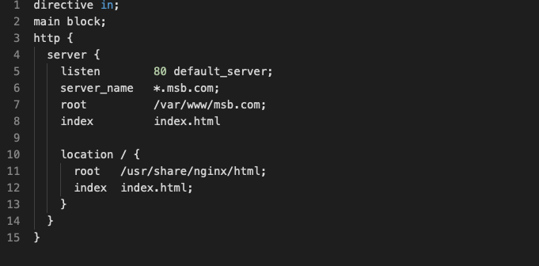Value:

All methods work seamlessly with existing applications. In fact, all an application sees is its configuration data either in an environment variable, an argument to a startup command, or a file in a filesystem. The application is unaware that the data originally came from a ConfigMap.

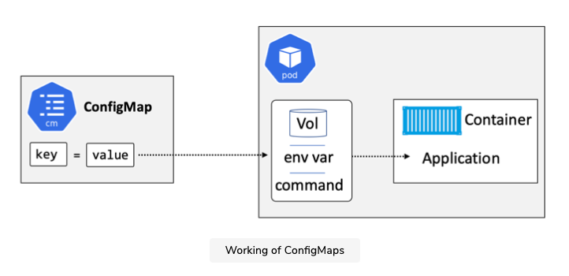The figure below shows how the pieces connect.

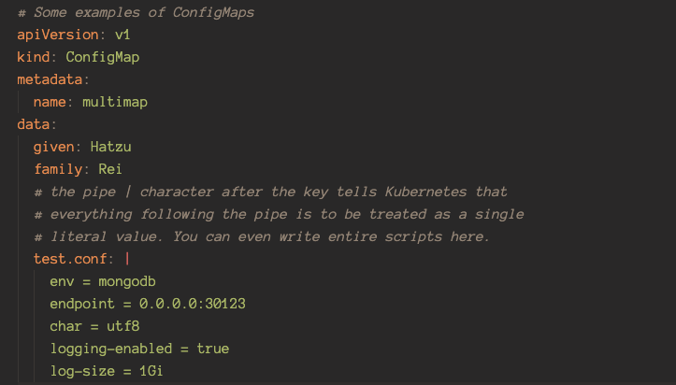The figure below shows an example of a map manifest.

Once data is stored in a ConfigMap, it can be injected into containers at runtime via three methods in the next sub sections.

With ConfigMaps out of the way, we can now take a look at Secrets. There are two choices when it comes to writing our Secrets, we can use predefined Secret types or write a custom type, which is referred to as Opaque. Predefined Secret types are usually used to write configurations for underlying common infrastructure separate from your business logic such as docker configs and ssh auths.

For a full list of each Secret type, refer to the Kubernetes documentation. In this guide, we will focus on Opaque Secret types, due to them being more relevant when writing scripts on a consistent basis.

There are two main methods of storing Secret data in manifest files, you can either use data, or stringData. The differences are listed below.

* Data

Data assumes the values are base64 encoded with no newlines (\n). This is especially important to keep in mind as various methods of encoding strings in base64 may split long lines with newlines, which will cause failure when actually using the data in the container. This is really difficult to debug if you are not aware of it.

* stringData

stringData assumes that the values are just plaintext.

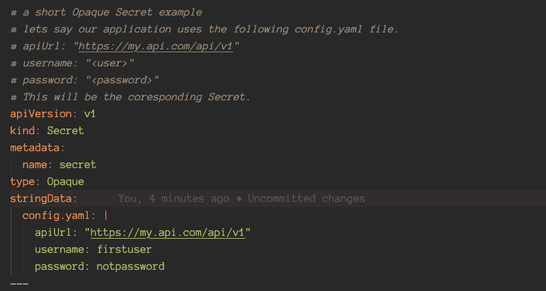Secret data values are obscured by Kubernetes even if they are written in plain text in the manifest. We will go through a quick example below.

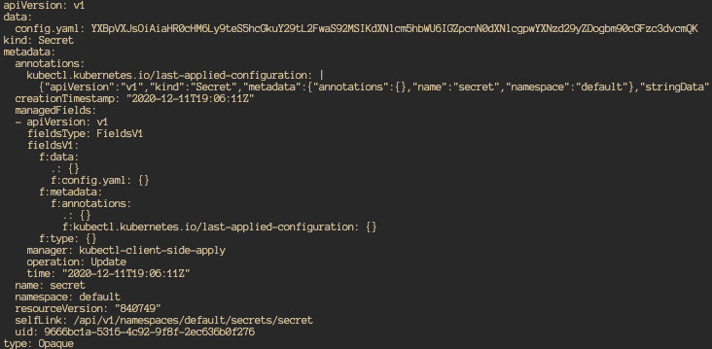After deploying, you can see that the values are obscured when retrieved by running kubectl get secret secretmap -o yaml

###### Environment variables & Startup Arguements

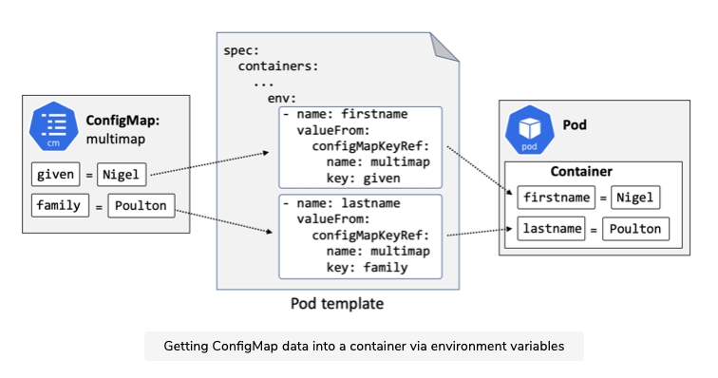This is a common way to get ConfigMap data into a container. You create the ConfigMap, then you map its entries into environment variables in the container section of a Pod template.

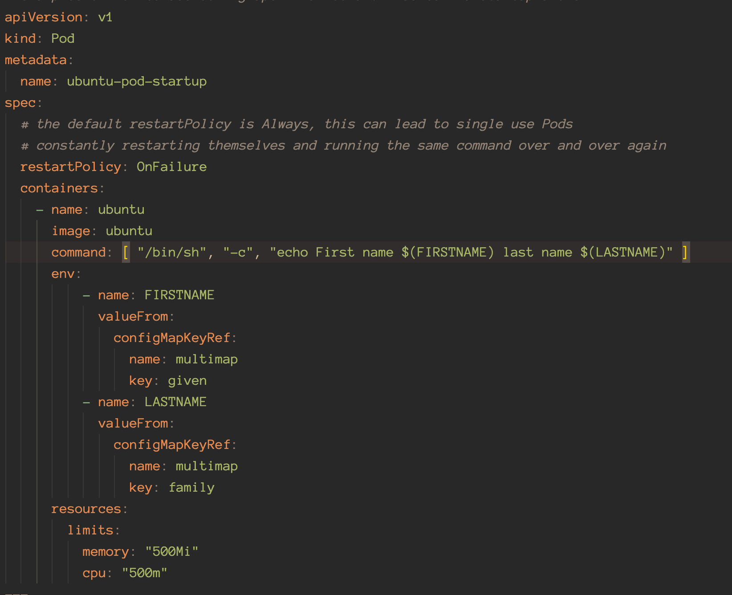

As can be seen above, the env variables are declared under the env block. They reference the multimap ConfigMap

###### Files in a volume

ConfigMaps with volumes is the most flexible option out of the three. You can reference entire configuration files as well as make updates to the ConfigMap and have them reflected in the running containers in real time.

The high level process for exposing ConfigMap data via a volume looks like this:

1. Create ConfigMap
2. Create ConfigMap volume in the Pod template
3. Mount the ConfigMap volume into the container
4. 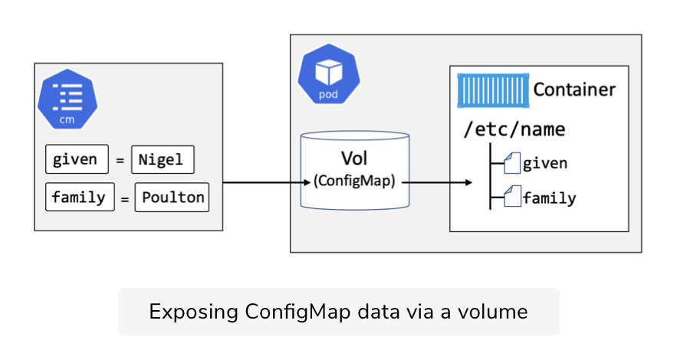Entries in the ConfigMap will appear in the container as individual files

The above figure shows the process. The figure shows that you have a ConfigMap with two values.

* Given = Nigel
* Family = Poulton

They are mounted into the container under the /etc/name directory with their keys as the file names and the values as the file contents.

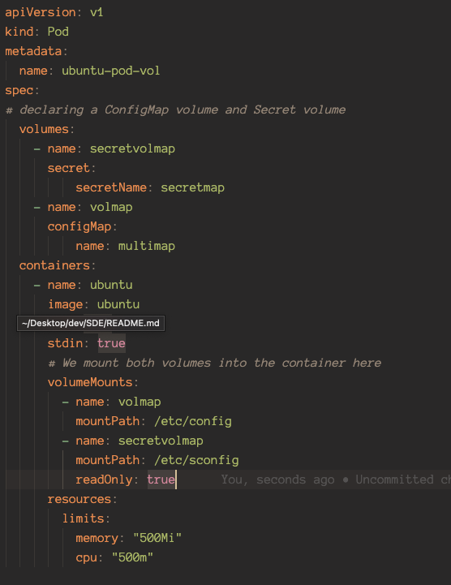Below is the Pod spec in the Github ConfigMap_Secrets directory example.

As you can see above, the volumes block creates a special type of volume called a ConfigMap volume as well as a Secrets volume.

We mount the volumes under the volumeMounts block in containers. With the mountPath /etc/config and /etc/configs. This means that four files will appear in the container.

* /etc/config/given
* /etc/config/family
* /etc/config/test.conf
* /etc/sconfig/config.yaml

The format of these files will always be consistent. The file name will be the key and the contents of the file will be the value. Therefore you can hardcode the configuration locations and filenames in your application code to import them.

You can even write entire scripts by making the key’s value the appropriate format. For example you could write a python script as a value and set the key as “program.py”, then you can run the file in the container like a normal python script.

Important Notes: The Secrets volume does not behave like the ConfigMaps volume. When mounting a ConfigMaps volume, it will not overwrite directories - Should you mount the volume into a directory that already has files in it. The ConfigMap volume files will simply be added into the directory.

This is NOT the case with Secrets volumes. A secret volume, when mounted, will populate the target directory only with secret volume files, removing any files that were previously in the directory. Should you need to bypass this quirk, you can use a postStart lifecycle hook to copy it into place after the container starts up.

#### StatefulSets

Before we get into StatefulSets, do note that StatefulSets are only a framework. Applications need to be written in ways to take advantage of the way StatefulSets behave.

It is useful to compare StatefulSets with Deployments. Both are first class objects in the Kubernetes API and follow the typical Kubernetes controller architecture. They both support self-healing, scaling, updates, and more.

They vital differences are that StatefulSets guarantee:

* Predictable and persistent Pod names
* Predictable and persistent DNS hostnames
* Predictable and persistent volume bindings

These three properties form the state of a Pod, sometimes referred to as the Pods sticky ID, this state/sticky ID is persisted across failures, scaling and other scheduling operations, making StatefulSets ideal for applications where Pods are a little bit unique and not interchangeable. IE Databases.

A quick example of just how sticky these three IDs are. Failed Pods managed by a StatefulSet will be replaced by new Pods with the exact same three properties. This is true even if the replacement Pod is started on a different cluster Node.

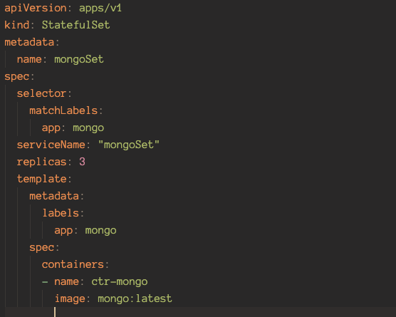The following snippet shows some of the fields in a typical StatefulSet manifest.

This snippet defines a StatefulSet named mongoSet and it defines three Pod replicas running the mongo:latest image .

The format of StatefulSet Pod names is <StatefulSetName>-<Integer>. The integer is a number starting from 0 up to the number of pods in the order they are created.

Be aware that StatefulSet names need to be valid DNS names, so no weird characters.

##### Creation Process

StatefulSets create one Pod at a time and always wait for previous Pods to be running and ready before creating the next. This is different from Deployments which is built on top of the ReplicaSet controller that starts all Pods at the same time, potentially causing race conditions.

##### Deletion Process

Deleting StatefulSets does not terminate Pods in order. Due to this, you may want to scale a StatefulSet to 0 replicas before deleting it.

You can also use terminationGracePeriodSeconds to further control the way Pods are terminated. It’s common to set this to at least 10 seconds to give the applications running in Pods a chance to flush local buffers and safely commit any writes that are still in flight.

##### Scaling Process

Scaling operations are also governed by Creation Process rules. This also applies to scaling down, which follows the rules in reverse - the controller terminates the pods from highest number to lowest until the desired state is reached.

##### Volumes

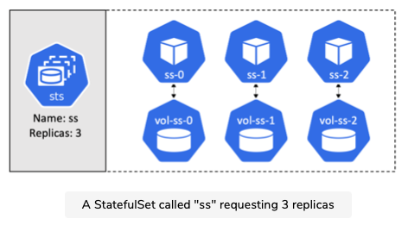When a StatefulSet Pod is created, any volumes it needs are created at the same time and named in a way to connect them to the right Pod. This can be seen in the figure below.

You can see above how each volume(PVC) is created and how the names connect volumes to Pods.

##### Handling Failures

The StatefulSet controller will replace a failed pod with a replacement Pod with the same name and attach it to the same volumes.

However, if a failed Pod recovers after Kubernetes has replaced it, you’ll have two identical Pods on the network writing to the same volumes. This can result in data corruption. With this in mind, the StatefulSet controller is extremely careful with how it handles failures.

Potential Node failures are especially troublesome to deal with. For example, if Kubernetes loses contact with a Node, how does it know if the Node is down and will never recover, or if it’s a temporary glitch such as a network partition or a crashed kubelet, or if the Node is just rebooting? To make matters worse, the controller cant even force the Pod to terminate, as the kubelet may never receive the instruction. Due to all these potential problems, manual intervention is needed before Kubernetes will replace Pods on failed Nodes.

##### Networks and Headless Services

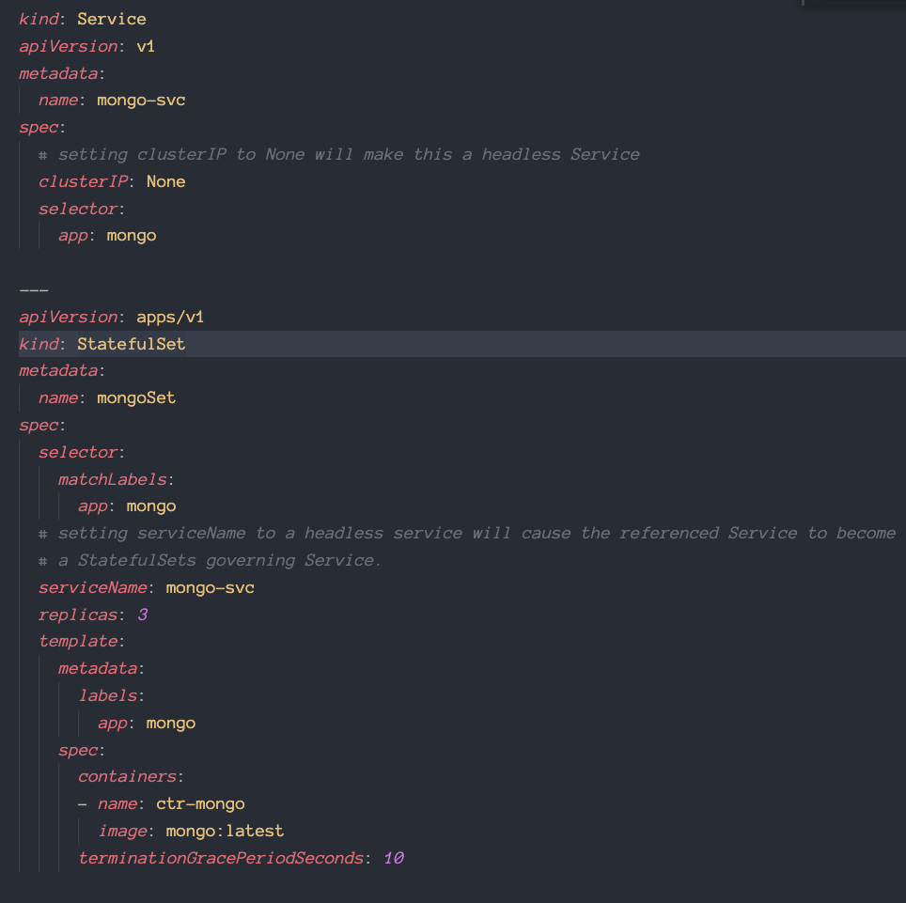Stateful sets use a headless Service to create predictable DNS hostnames for every Pod replica. A headless Service is just a regular Kubernetes Service object with the spec.ClusterIP set to None. It becomes a StatefulSets governing Service when you list it in the StatefulSet manifest under spec.service name like below.

By combining the objects like this, the Service will create DNS SRV records for each Pod replica matching the label selector of the headless Service. Other pods can then find members of the StatefulSet by performing DNS lookups against the name of the headless Service.

##### Using Stateful Sets

To deploy a working StatefulSet we need a minimum of three objects:

1. A StorageClass
2. A headless Service
3. A StatefulSet

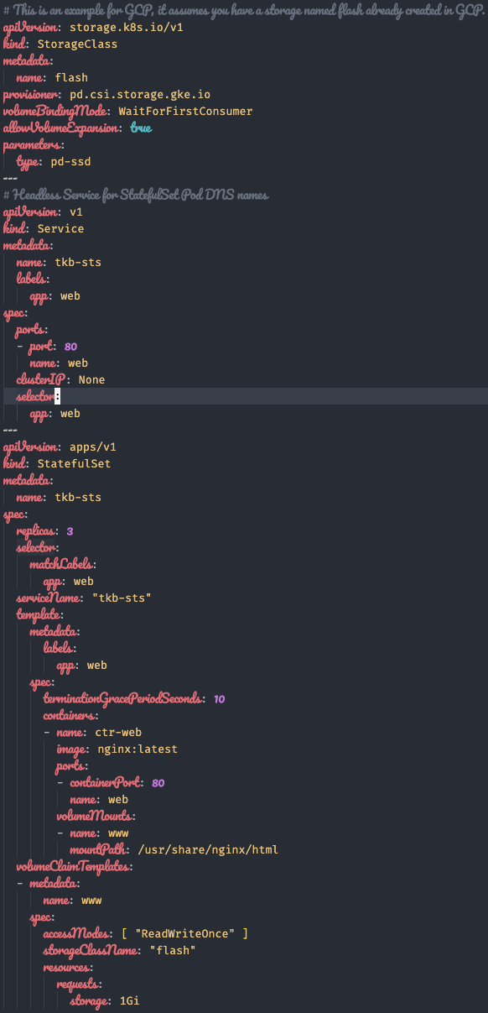Due to its reliance on dynamically provisioned storage via a StorageClass, the example is for Google Cloud in order to keep these examples as standalone as possible.

As mentioned earlier in the Storage section of the guide, should you need to use local storage, other solutions are needed on top of Kubernetes.

The volumeClaimTemplate is Kubernete’s solution to PVCs being single use.

Scaling down and deleting Pod replicas does NOT delete the associated PVC.

Scaling down will be put on hold if any of the Pods are in a failed state. This behaviour is to protect the resiliency of the app and integrity of its data.

It is possible to control the starting and stopping of Pods via the StatefulSet’s spec.podManagementPolicy property.

#### DaemonSets

DaemonSets are useful when you need a replica of a particular Pod running on every node in the cluster. Some examples include monitoring and logging Pods that you need to run on every node in the cluster.

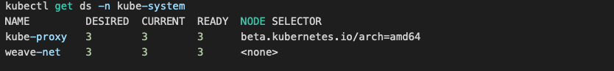The following command shows two DaemonSets in the kube-system namespace that exist on a 3-node cluster.

Notice that the desired state is 3 for each DaemonSet. You do not need to specify this in the Daemonset manifest. It is automatically implied based on the number of nodes in the cluster.

Beyond the default behaviour of running one Pod replica on every cluster node, you can also run DaemonSets against subsets of nodes.

DaemonSets are really similar to Pods and Deployments, if you already understand those these are simple.

#### CronJobs and Jobs

Jobs, a.k.a batch jobs, are useful when you need to run a specific number of a particular Pod, and you need to guarantee that they’ll all successfully complete.

Some subtleties of jobs that are worth noting:

1. Jobs do not have a concept of desired state.
2. Pods that are part of a Job are short-lived, once the job is done, they die.

These make jobs very different from other objects. Jobs manage a specified number of a certain Pod and make sure they complete and exit successfully.

If a Pod that the Job object spawns fails, the Job will create another in its place. Once all Pods managed by the Job complete, the Job itself completes.

Jobs can be useful even if you only need to run a single Pod through completion. Basically, if you need to run one or more short-lived Pods, and you need to guarantee that they complete successfully, Jobs are your friend.

Cronjobs are just Jobs that run against a time-based schedule.

#### Scalers

Up till now you may have noticed that scaling happens manually. Which is less than ideal.

As such, Kubernetes offers several auto-scaling technologies.

* Horizontal Pod Autoscaler (HPA)

HPAs are a stable resource you can configure via a manifest. Its job is to scale the number of replicas in a Deployment based on observed CPU metrics.

It works like this:

1. You define a Deployment that makes use of Pod resource requests.
2. You deploy these to the cluster
3. You also create an HPA object that targets that Deployment and has a rule that says something like: if any Pod in this Deployment uses more than 60% of its requested CPU, spin up an additional Pod.
4. You deploy this to the cluster as well, once these two are deployed together, the HPA will work its magic and scaling will become automatic.

One thing worth noting is that HPAs update the .spec.replicas field of the targeted Deployment. Due to this, it can become the case that your Deployment manifest becomes out of sync with what is currently observed on the cluster.

Note that at the time of writing, a new version of autoscaling is being worked on to allow scaling based on more than just CPU usage.

* Cluster Autoscaler (CA)

CAs are all about resizing your Kubernetes cluster. At a high level, they increase and decrease the number of Nodes in your cluster based on demand.

CAs periodically check Kubernetes for any Pods that are in the Pending state due to a lack of node resources. If it finds any, it adds nodes to the cluster so that pending Pods can be scheduled to.

Note that this requires integrations with your cluster’s underlying infrastructure platform via a public API that allows Kubrenetes to add or remove nodes ( cloud instances ). The major cloud platforms implement Cluster Autoscaler with varying levels of support. Refer to their documentation for the latest support info.

* Vertical Pod Autoscaler (VPA)

This scales resource limits instead of pods.

When configured, it will set the requests automatically based on usage and thus allow proper scheduling onto nodes so that appropriate resource amount is available for each pod. It will also maintain ratios between limits and requests that were specified in initial containers configuration.

It can both down-scale pods that are over-requesting resources, and also up-scale pods that are under-requesting resources based on their usage over time.

It should be noted that VPA and HPA should not be used on memory or CPU together at this moment. There are workarounds, but they involve custom external metrics.

VPA is less used due to it being not really making sense if you are designing and building microservices, the only real use case is maybe for StatefulSets.

#### ServiceAccounts

When you interact with Kubernetes, using kubectl for example, what you are using is a user account. When processes in pods need to interact with Kubernetes, they use a service account, which describes the set of permissions they have within Kubernetes.

Out of the box, all Pods are given the default service account. Unless an administrator has changed the default service account, the permissions are limited. If you run kubectl from inside a container on a node, it will automatically know where to find the cluster that it’s running on.

Refer to the example in the github for more information.

It is good practice to have separate serviceAccounts for every service.

### Working with Kubernetes

There are many ways to get a Kubernetes Cluster, the easiest way is to use a Hosted Kubernetes cluster, they are the closest you will get to zero effort production grade Kubernetes. Google Kubernetes Engine (GKE) lets you deploy a production-grade Kubernetes cluster with just a few clicks. Other clouds offer similar services as well.

* AWS: Elastic Kubernetes Service
* Azure: Azure Kubernetes Service
* Linode: Linode Kubernetes Engine
* DigitalOcean: DigitalOcean Kubernetes
* IBM Cloud: IBM Cloud Kubernetes Service
* Google Cloud Platform: Google Kubernetes Engine

For the purpose of experience with the software, we will use Docker Desktop. Keep in mind that there are quite literally over a hundred ways to get a Kubernetes Cluster.

#### Docker Desktop

Docker Desktop lets us get a local development cluster on our Mac/Windows machine. With a few easy steps, we can get a single-node Kubernetes cluster that we can develop and test with.

It works by creating a VM on your laptop and starting a single-node Kubernetes cluster inside that VM. It also configures a Kubectl client with context that allows it to talk to the cluster in the VM. There is also a simple GUI that lets us perform basic operations such as switching between all of our Kubectl contexts.

Docker Desktop can be downloaded from the Docker website, a login may be required but rest assured that the account is free and so is the product. If you already have Docker Desktop installed, the option to enable Kubernetes is under Preferences.

The commands we will go through should work on other Kubernetes cluster services as well.

#### Kubectl

Kubectl is the main Kubernetes CLI Tool and is what we will use for day to day Kubernetes management.

At a high level, Kubectl converts user-friendly commands into JSON payloads required by the API server in Master. It uses a config file to know which cluster and API server endpoint to POST commands to.

The kubectl config file is called config and lives in the $HOME/.kube/ directory.code config

As seen above, it contains definitions for:

* Clusters
* User Credentials
* Contexts

#### Pod Manifest File

Manifest Files are excellent sources of documentation. By keeping documentation for the basic functions and requirements of an application in the manifest file, new members can immediately see the configuration for the app and what it requires.

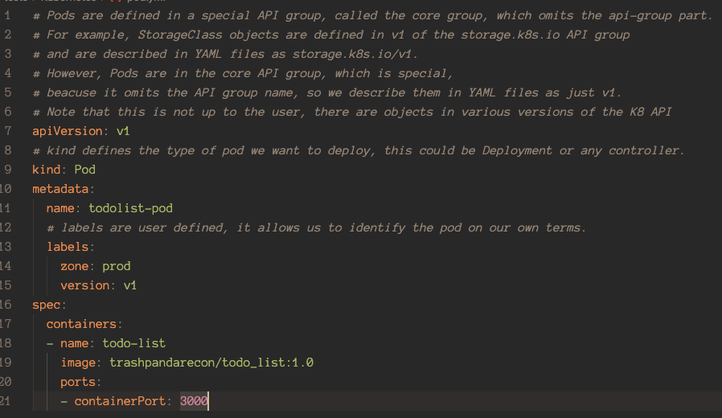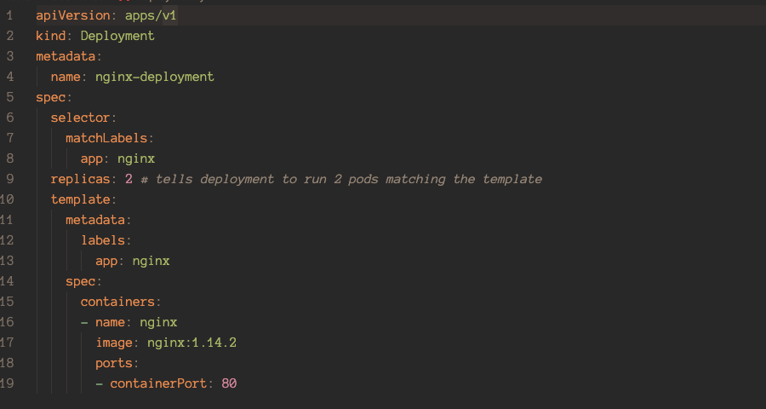Examples of Manifest Files, for a list of all possible parameters, refer to Kubernetes Documentation.

#### General Commands

These are really basic commands, for a full list of commands, look at the Kubectl documentation.

To POST a manifest file you can either use kubectl create -f <filename> or kubectl apply -f <filename>

To get a general information about an object, use kubectl get. Do note that this only searches objects in the default namespace by default, to view all namespaces use -A or use -n <namespace> to look at specific namespaces.

To delete objects, simply use kubectl delete, this is also namespace specific.

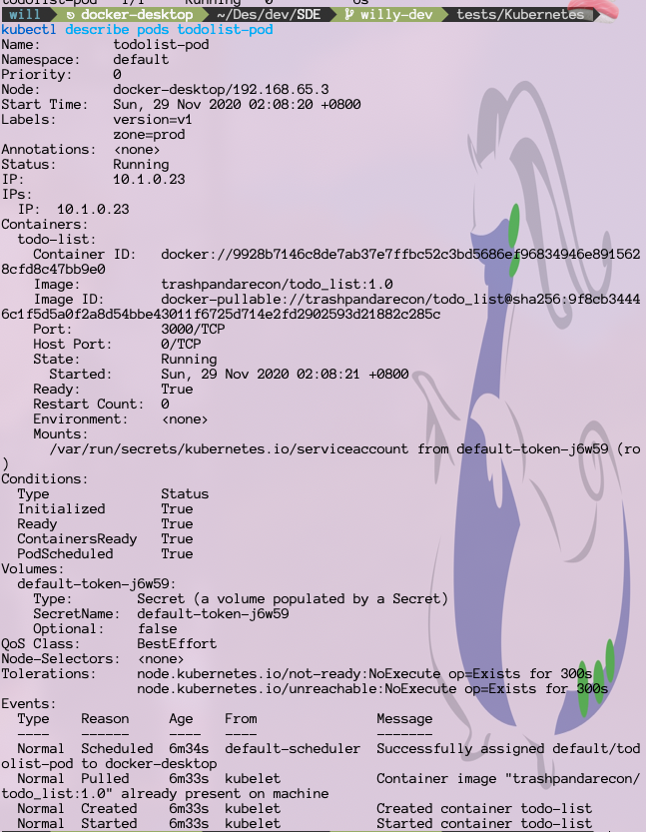We can see a detailed description of objects via the kubectl describe command

#### Interacting with Pods

K8s has a similar mechanic to Docker when it comes to interacting with running pods named kubectl exec

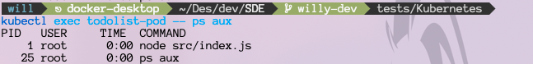You can run a single command like this.

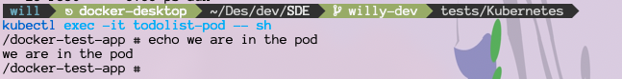Or run an interactive shell like this.

### Security

Security is fundamental and affects everything at every level. Kubernetes is no exception. There are a lot of things that can be done to secure Kubernetes, but first we will perform some threat modelling.

Disclaimer that this is by no means an exhaustive list of security measures, it just serves to give you an idea of possible attack vectors.

The Cloud Native Computing Foundation commissions third-party security audits of Kubernetes. Reading the audit reports is also a good way to learn more about Kubernetes and how the internals work.

#### Threat Modelling Kubernetes

Threat modelling is the process of identifying vulnerabilities so that we can put measures in place and mitigate them.

##### Spoofing

###### Securing Communications with the API server.

Kubernetes is composed of many small components that work together that all communicate over the network. As such, Kubernetes implements a security model that requires components to authenticate via mutual TLS (mTLS).

This requires both parties to authenticate each other via cryptographically signed certificates. However, it’s vital that the following things be considered:

1. A typical Kubernetes installation will auto-generate a self-signed Certificate Authority during a bootstrap process. This is the CA that will issue certificates to all cluster components. Its better than nothing, but on its own, it probably isn’t enough for your production environment.
2. Mutual TLS is only as secure as the CA that issued the cerficiates.

A good practice is to ensure that certificates issued by Kubernetes internal CA are only used and trusted within the cluster. This requires careful approval of certificate signing requests, as well as making sure the Kubernetes CA is not added as a trusted CA for any components outside of Kubernetes.

As mentioned above, all interaction via the API server is subject to authentication and authorization checks. This is true for both internal and external components. A good way of doing it is to have two trusted key pairs: one for internal components and one for external components.

To accomplish this, Kubernetes leverages an internal self-signed CA to issue keys to internal components as well as one or more trusted third-party CAs to issue keys to external components (Kubernetes needs configuring to trust third-party CAs).

###### Securing Pod Communications

As well as spoofing access to the cluster, there is also the threat of spoofing an application for app-to-app communications. This is when one Pod spoofs another. Fortunately we can leverage Kubernetes Secrets to mount certificates into Pods that can then be used to authenticate Pod identity.

While on the topic of Pods, every Pod has an associated ServiceAccount that is used to provide an identity for the Pod within the cluster. This is achieved by automatically mounting a service account token into every Pod as a Secret. Two points to note:

1. The service account token allows access to the API server.
2. Most Pods probably don’t need access to the API server.

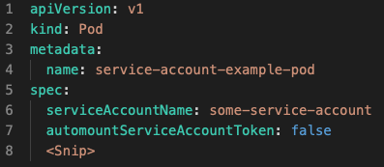Due to these two points, it is recommended to set automountServiceAccountToken to false for Pods that do not need to communicate with the API server. The following snippet shows how to do this

If the service account token needs to be mounted, there are some non-default configurations that are worth looking at. These include:

* expirationSeconds
* audience

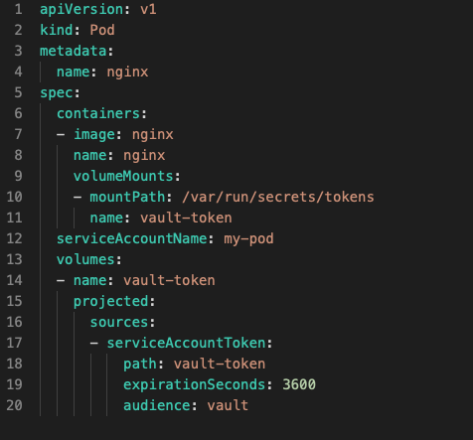These let you force a time when the token will expire as well as restrict it to only working with subsets of entities.

Kubernetes has various ways of refreshing these tokens. However the application is still responsible for reloading the token when it rotates. Periodic reloading once every 5 minutes should be sufficient for most use cases.

Note that audience refers to ServiceAccounts, you can specify more than one.

##### Tampering

###### Tampering with Kubernetes Components

All of the following Kubernetes components, if tampered with, can cause harm:

* Etcd
* Configuration files for the API server, controller-manager, scheduler, etcd, and kubelets
* Container runtime binaries
* Container images
* Kubernetes binaries

Tampering happens either in transit or at rest.

* In Transit

TLS is a great tool for protecting against in transit tampering.

* At Rest
* Restrict access to the servers that are running Kubernetes components
* Restrict access to repositories that store Kubernetes Configuration files
* Only perform remote bootstrapping over SSH
* Always perform SHA-<current acceptable standard> checksums on downloaded binaries
* Restrict access to your image registry and associated repositories

###### Tampering with Applications

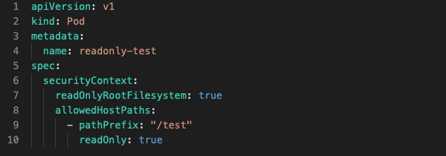A good way to prevent a live Pods from being tampered with is by setting its filesystems to read-only. This can be done like so in the figure below.

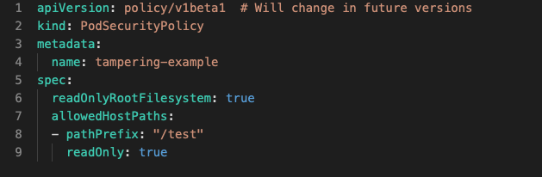PodSecurityPolicy Objects are a relatively new Kubernetes Object that allows you to force security settings on all Pods in a cluster or on a subset of Pods. They are a good way to enforce security policies without developers and operations staff having to remember to do it for every single Pod.

##### Repudiation

Repudiation is casting doubt on something. Non-repudation is proving certain actions were carried out by certain individuals.

Basically, auditing.

Kubernetes API server events can help us audit the history of the cluster, you may need to manually enable auditing on your API server.

Although the API server is the central hub of Kubernetes, it is also important to collect audit logs from container runtimes, kubelets, and the applications running on your cluster. This is without even mentioning network firewalls and the likes.

Once you start auditing multiple components, it quickly requires you to have a centralized location to store and correlate events. A common way of doing this is by deploying an agent to all nodes via a DaemonSet. The agent collects logs and ships them to a secure central location.

After the logs are in a central location, it is then required for them to be secured. If the security of the central log store is compromised, the logs become worthless.

To provide non-repudiation relative to tampering with binaries and config files, you might want to consider having an audit daemon that watches for write actions on certain files and directories on your Kubernetes masters and nodes.

##### Information Disclosure

###### Protecting cluster data

Now if you recall, the cluster store is central to Kubernetes. Which also means that the cluster store is a prime target for information disclosure attacks.

As a minimum, you should limit and audit access to the nodes hosting the cluster store. As will be seen in the next paragraph, gaining access to a cluster node can allow the logged-on user to bypass some of the security layers.

Kubernetes 1.7 introduced encryption of Secrets but doesn’t enable it by default. Even when this does become default, the data encryption key (DEK) is stored on the same node as the Secret. This means that gaining access to a node allows you to bypass encryption. This is especially worrying on master nodes that host the cluster store.

Fortunately, Kubernetes 1.11 enabled a beta feature that lets you store *key encryption keys (KEK)* outside of the Kubernetes cluster. These types of keys are used to encrypt and decrypt data encryption keys and should be safely guarded. You should seriously consider Hardware Security Modules (HSM) or cloud-based Key Management Stores (KMS) for storing your key encryption keys.

Capabilities will be added so keeping an eye on updates is a good idea.

###### Protecting data in Pods

Just store everything that needs secrecy in Secrets Objects.

##### Denial of Service

If you don’t know what this is, imagine the system is a juggler. Now imagine that u take a machine gun and load it with balls, then shoot the juggler with infinite ammo. The juggler would at the very least be overloaded and at the very best be killed.

###### Protecting cluster resources against DoS

It’s a timer-honored best practice to replicate essential control plane services on multiple nodes for a high avability (HA). Kubernetes is no different, and you should run multiple master nodes in an HA configuration for your production environment. Doing this will prevent a single master from becoming a single point of failure. This would also cause the attacker to potentially need to attack more than one master at a time to have any actual impact.

You should also consider replicating control plane nodes across multiple availability zones. This may prevent a DoS attack on the network of a particular zone affecting you.

The same principle applies to worker nodes, have many over many availability zones.

You should also configure appropriate limits for the following resources:

1. Memory
2. CPU
3. Storage
4. Kubernetes Objects

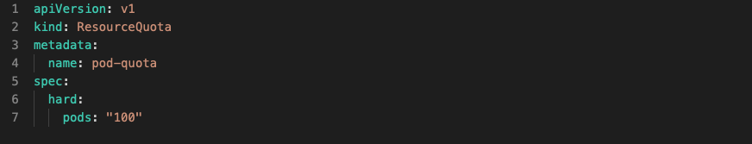Limiting Kubernetes objects includes things like limiting the number of ReplicaSets, Pods, Services, Secrets and ConfigMaps in a particular Namespace.

ResourceQuota objects are a nifty tool to prevent resources from being starved by limiting them.

Once the podsPidLimit is exhausted, a Pod will typically be restarted.

This also ensures that a single Pod doesn’t exhaust the PID range for all the other Pods on the node, including the kubelet. One thing to note is that setting the correct value requires a good estimate of how many Pods will run simultaneously on each node. Without a ballpark estimate, the admin may end up over or underallocating PIDs to each pod.

Side Info: A Node has a maximum number of PIDs, each pod takes up a certain amount. If your Node reaches the maximum number of PIDs, no further Processes can be created and everything will probably end up freezing on your Node. This is true for every OS. Which is why the Fork Bomb attack exists.

###### Protecting the API server against DoS

All communications in Kubernetes goes through the API server. The API server exposes a RESTful interface over a TCP socket, making it susceptible to botnet-based DoS attacks.

The following may be helpful in either preventing or mitigating such attacks.

* High availability masters. Having multiple API server replicas running on multiple nodes across multiple availability zones
* Monitoring and alerting of API server requests ( these are based on sane thresholds )
* Not exposing the API server to the internet ( firewall rules, etc )

###### Protecting the cluster store against DoS

Cluster configuration is stored in etcd, making it vital that etcd be secure and available.

The following recommendations help accomplish this:

* Configure an HA etcd cluster with either 3 or 5 nodes ( at least )
* Configure monitoring and alerting of requests to etcd
* Isolate etcd at the network level so that only members of the control plane can interact with it

A default installation of Kubernetes will install etcd on the same servers as the rest of the control plane. This is fine for development and testing; however, large production clusters should consider a dedicated etcd cluster simply due to how integral it is to the entire operation of Kubernetes. This will provide better performance and resilience.

###### Protecting application components against DoS

Most Pods expose their main service on the network, and without proper controls in place, anyone with access to the network can perform DoS attacks on the Pod. Kubernetes provides Pod resource request limits to prevent such attacks from exhausting the Pod and node resources.

The following will be helpful in this:

* Define Kubernetes Network Policies that restrict Pod-to-Pod and Pod-to-external communications
* Utilize manual TLS and API token-based authentication for application-level authentication ( reject any unauthenticated requests )

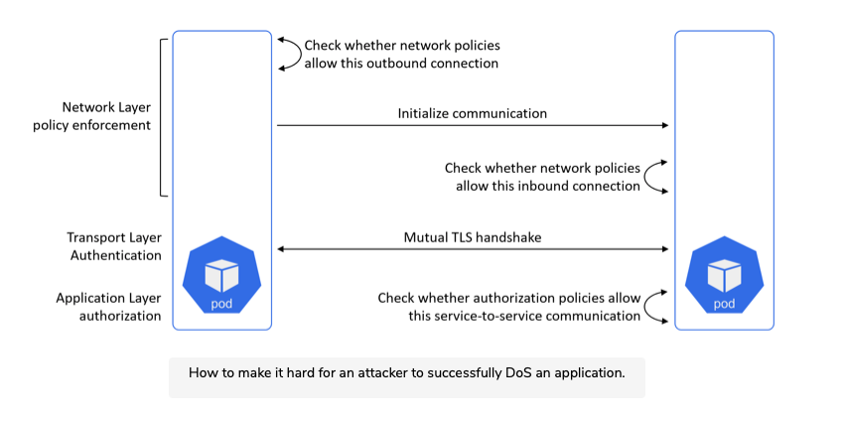This figure is helpful. It goes top down.

##### Privilege Escalation

Kubernetes offers several authorization modes that help safeguard access to the API server.

These include:

* Role-based Access Control (RBAC)
* Webhook
* Node

You should run multiple authorizers at the same time. For example, a common best practice is to always have RBAC and node enabled.

###### Role-based Access Control (RBAC)

RBAC mode lets you restrict API operations to a subset of users. These users can be regular user accounts as well as system services.

The idea is that all requests to the API server must be authenticated and authorized.

RBAC is extremely configurable and you should use it to implement a least-privileged model for users accessing the API server. When implemented it is a deny by default system that requires you to specifically grant individual permissions.

###### Webhook

Webhook mode lets you offload authorization to an external REST-based policy engine. However, it requires additional effort to actually build and maintain the external engine. It also makes the external engine a potential single point of failure for every request to the API server.

###### Node

Node authorization is all about authorizing API requests made by kubelets. The type of requests made to the API server by nodes are different from regular user requests, the node authorizer is designed to help with this.

##### Protecting Pods

This section will take a look at a few technologies in Kubernetes that help to reduce the risk of privilege escalation attacks against Pods and containers.

###### Do NOT run processes as root

The root user is the most powerful user on a Linux system and is always User ID 0 (UID 0). Therefore, running application processes as root is almost always a bad idea as it grants the application process full access to the container. This is made even worse by the fact that the root user of the container often has unrestricted root access on the node as well. The short of it is, be extremely afraid of giving anything root access.

Fortunately, Kubernetes lets us force container processes to run as unprivileged non-root users.

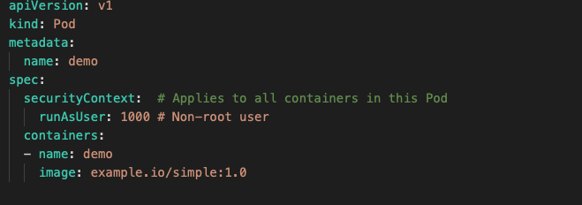The following shows how, It forces all containers that are part of the Pod to run processes as UID 1000.

This is all fine but multiple containers running with the same UID means that they also probably have access to the same resources. This can be a problem. For example, two different containers with R/W access to the same host directory can cause data corruption via not coordinating write operations. Shared security context also increase the possibility of a compromised container tampering with a dataset it should not have access to.

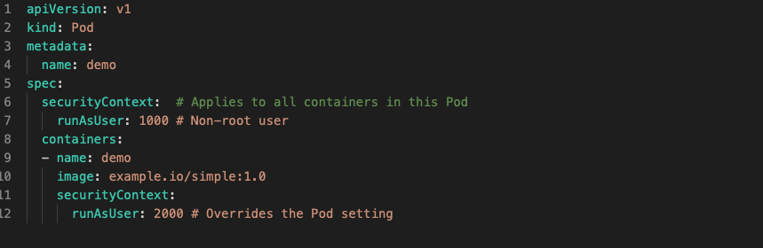With this in mind, it is possible to use the runAsUser property at the container level instead of at the Pod level like so.

This example sets the UID to 1000 at the Pod level but overrides it at the container level so that processes in the demo container run with UID 2000. Unless otherwise specified, all other containers in the Pod will use the Pod level UID.

Other ways of getting around this issue are:

1. Enabling user namespaces

User namespaces is a Linux kernel technology that allows a process to run as root within a container but run as a different user outside of the container. For example, UID 0 (root) in the container gets mapped to UID 1000 on the host. This can be a good solution for processes that need to run as root inside the container, but you should check whether it has full support from your container runtime and Kubernetes version.

1. Maintaining a map of UID usage

This is a clunky way of preventing multiple Pods and containers from using overlapping UIDs. It is a hacky method and requires strict adherence to a gated release process for releasing Pods into production.

Just to be clear, the hacky part is the UID map itself as well as the fact that you are introducing an external dependency and complicating releases and troubleshooting.

###### Drop Capabilities

While user namespaces allow container processes to run as root inside the container but not on the host machine, the simple fact remains that most processes do not need all of the privileges that the root has. However, it is also equally true that many processes require more privileges than the typical non-root user has.

Kubernetes solves this by using Capabilities.

The root user has the most power in a linux system, but this power is not a single entity. It is made up of a lot of small privileges that we call Capabilities. For example, the SYS_TIME capability allows a user to set the system clock, whereas the NET_ADMIN capability allows a user to perform network-related operations such as modifying the local routing table and configuring local interfaces.

There are at the time of writing over 30 capabilities. With this is mind, an out of the box Docker runtime drops over half of them by default. This is a sensibledefault that is designed to allow most processes to run without leaving the keys in the front door. While sensible defaults like these are better than nothing, they will usually not be enough for a lot of production environments.

A common way to find the absolute minimum set of capabilities an application requires is to run it in a test environment with all the capabilities dropped. This will cause the application to fail and log messages about the missing permissions. Which you can then add by mapping those permissions to capabilities, then adding them to the application’s Pod manifest, then running the application again. Rinse and repeat until the application runs properly with the minimum set of capabilities.

As good as this is, it requires seriously extensive testing of your application. The last thing we want is a production edge case that you hadn’t accounted for in your test environment. This is true throughout the process of testing.

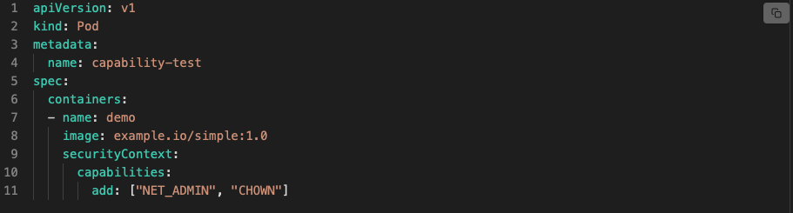Below is an example of adding NET_ADMIN and CHOWN capabilities to a container.

###### Filter syscalls

Seccomp is similar in concept to capabilities but works on syscalls rather than capabilities.

The way that Linux processes ask the kernel to perform an operation is by issuing a syscall to the kernel. Seccomp lets you configure which syscalls a particular container can make to the host kernel. As with capabilities and every other security related paradigm, a least-privilege model is preferred, in which the only syscalls a container is allowed to make are the ones it needs in order to run.

Be extremely careful with this; Linux has over 300 syscalls and seccomp is an alpha feature at the time of writing. Also check support from your container runtime.

###### Preventing Privlege escalation by containers

The only way to create a new process in Linux is for one process to clone itself and then load new instructions onto the new process. This is an oversimplification but the original process is called the parent process, and the copy is called the child.

By default, Linux allows a child process to claim more privileges than its parent. This is usually a bad idea. In fact, you will often want a child process to have the same or less privileges than its parents. This is especially true for containers, as their security configurations are defined against their initial configurations, and not against potentially escalated privileges.

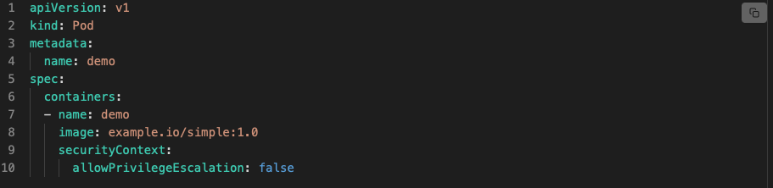Fortunately Kubernetes lets us disable this with a single property as seen below.

#### Pod Security Policies

We can enable security policies on a per-Pod basis by setting security context attributes in individual Pod manifest files. However, this approach doesn’t scale. It requires developers and operators to remember to do this for every Pod, and is prone to errors. Pod Security Policies offer a better solution.

Pod Security Policies are a relatively new feature that allows us to define security settings at the cluster level. We can then apply these to targeted sets of Pods as part of the deployment process. As such, this solution scales better, requires less work from everyone involved, and is less error prone. It also lends itself to situations where you have a team of people dedicated to securing apps in production.

Pod Security Policies are implemented as an admission controller, and, in order to use them, a Pod’s serviceAccount must be authorized to use it. Once this is done, their policies are applied to new requests to create Pods as they pass through the API admission chain.

An example of a Pod Security Policy object can be found in the examples/Kubernetes directory in the Github.

There is no doubt that configuring effective security policies is both important and incredibly difficult. But a step by step approach where we start from the maximally restrictive policy and tweak as needed makes it a lot easier. It is also probably a good idea to configure several Pod Security Policies that vary in how restrictive they are and then allow your development teams to work with cluster admins to see which one best fits their applications.

#### Cluster-level workload isolation

Kubernetes does not support secure multi-tenant clusters. The only cluster-level security boundary in Kubernetes is the cluster itself.

What does this actually mean? It means that if you need to have strongly separated workloads, the only way is to put these workloads on separate clusters.

Strongly separated workloads - For example you might have sensitive or secret projects happening, probably not a good idea to put that in the same cluster as the production workloads. Due to the lack of security controls at the cluster level.

Kubernetes has a dedicated group working on implementing multitenancy models. This means that future releases of Kubernetes may support this.

#### Node level isolation

There are times when individual applications require nonstandard privileges as we have established previously. Isolating them within a cluster might be overkill, but the increased risk of collateral damage would probably justify running them on ring-fenced subset of worker nodes. In this case, if one Pod is compromised it can only impact other Pods on the same nodes.

Kubernetes offers several technologies such as labels, affinity and anti-affinity rules and taints, to help target subsets of nodes.

#### Runtime Isolation

This is a very deep subject but I will try to give a high level overview.

When it comes to runtime isolation, Virtual Machines beat Containers hand down.

However, it is becoming easier and more common to augment containers with additional kernel-level isolation technologies, such as apparmor and SELinux, seccomp, capabilities, and user namespaces. Unfortunately, these add significant complexity to the setup and are less secure than a Virtual Machine.

There are also projects that enable Kubernetes to orchestrate other workloads, such as virtual machines and functions.

As a summary, the following workload isolation options exist:

1. Virtual Machines - Every workload gets its own virtual machine and kernel. This provides excellent isolation but is slow and heavy.
2. Traditional namespaced containers: Every workload gets its own container but shares a common kernel. Not the best solution, but it’s fast and lightweight.
3. Run every container in its own virtual machine - this option attempts to combine the versatility of containers with the security of VMs by running every container in its own dedicated VM. Despite using specialized lightweight VMs, this is kinda pointless.
4. Use appropriate runtime classes - This is very new but has a lot of potential. All workloads can run as containers, but workloads requiring stronger isolation are targeted to a class of container runtime that provides appropriate isolation ( gVisor, Kata Containers, etc. ) . Runtime classes are currently an alpha feature in Kubernetes.

Obviously running virtual machines can complicate things when it comes to patching OSes. Also running a mix of containers and virtual machines will increase network complexity

#### Network Isolation

Firewalls are an integral part of any layered information security system. They simply have a set of rules that either allow or deny system to system communication.

Kubernetes does not implement the internal Pod network, instead, it implements a plugin model, called the Container Network Interface (CNI). Vendors and the community are responsible for writing the CNI plugins that actually provide the Pod network.

There are loads of plugins available and the networking options they support fall into one of two categories:

1. Overlay
2. BGP

##### Overlay Networking

The most common way to build the Pod network is as an overlay network. In the Kubernetes world overlay networking allows us to build simple flat Pod networks that hide any complexity that might exist between the nodes in the cluster.

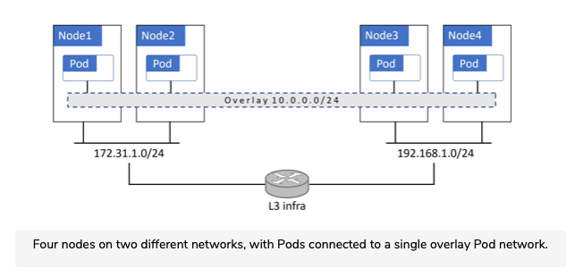For example, you might have your cluster deployed across two different networks but have all Pods on a single flat Pod network. In this scenario, the Pods only know about the flat overlay Pod network and have zero knowledge of the networks the nodes are on.

Just as a warning, this is going to get ridiculously technical, feel free to skip this part.

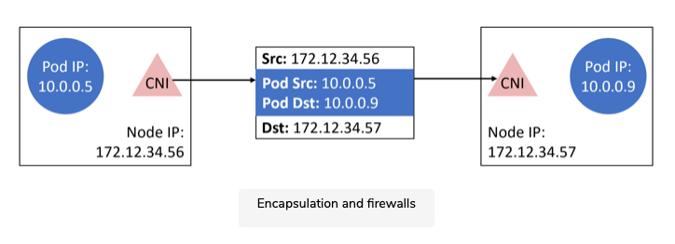Overlay networks encapsulates packets for transmission over VXLAN tunnels. In this model, the overlay network is a virtual Layer 2 network operating on top of the existing Layer 3 infrastructure. Traffic is encapsulated in order to pass between Pods on different nodes. This simplifies implementation, but poses problems for some firewalls as can be seen below

##### Border Gateway Protocol BGP

BGP is the protocol that literally powers the internet. At its core, it’s a simple and scalable protocol that creates peer relationships that are used to share routes and perform routing.

The following analogy might help. Imagine you want to send a birthday card to a friend who you lost contact with and no longer have their address. However, your child has a friend at school whose parents are still in touch with your old friend. In this situation, you give the card to your child and ask them to give it to their friend at school. This friend then gives it to their parents, who deliver it to your friend.

This is similar to BGP. BGP routing happens through a network of peers that help each other find a route for packets to go from one Pod to another.

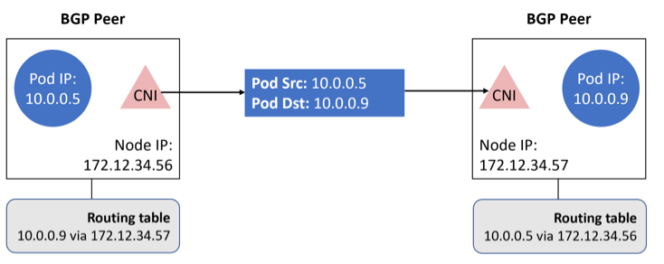BGP does NOT encapsulate packets, making life a lot easier for firewalls as can be seen below.

##### How this impacts firewalls

The difference is really just encapsulation. If your firewall does not perform deep packet inspection, choose a BGP based Pod network. If your firewalls do, you can just choose either.

Also consider deploying physical firewalls and host-based firewalls in combination. All these decisions are tied to your organisation so make sure you talk this out with your infrastructure team.

Keep in mind that Pod/Container Ips are dynamic due to them being ephemeral, this causes a lot of IP churn and reduces how useful IP addresses are in identifying systems and workloads. With this in mind, the ability to associate Ips with Kubernetes specific identifiers like service aliases, Pod IDs and container IDs, when performing things like packet capturing is extremely useful.

#### Identity and Access Management, IMS

Controlling user access to Kubernetes is important in any environment. Kubernetes has a robust RBAC subsystem that integrates with existing IMS providers, such as Active Directory and other LDAP systems.

Most organisations already have a centralized IMS provider, such as Active directory, that is integrated with company HR systems to simplify employee lifecycle management.

Because of this, Kubernetes leverages existing IMS providers instead of implementing its own. For example, a new employee joining the company will automatically get an identity in Active Directory, which integrates with Kubernetes RBAC to automatically grant that user certain access to Kubernetes. When an employee leaves the company, the reverse happens.

It is highly recommended that you leverage RBAC.

##### Rules Based Access Control, RBAC

Kubernetes implements a least privilege RBAC subsystem. When enabled, it locks down a cluster and allows you to grant permissions based on specific users and groups.

The model is based on three major components:

* Subjects

These refer to the users and groups, and these must be managed outside of Kubernetes.

* Operations

Operations refer to what the subjects are allowed to do.

* Resources

Resources are objects on the cluster.

Put these three together and you have an RBAC rule. For example, Alex (subject) is allowed to create (operation) Services (resource) on this cluster A.

RBAC leverages on two other objects in its API group Roles and RoleBindings. The Role is how the resource and operation you want to allow is defined, and the RoleBinding connects it with a subject.

##### Managing SSH Access to Cluster Nodes

Almost all Kubernetes administration is done via the API server. This means that it should be rare that someone needs SSH access to the cluster nodes. SSH access should only be required in the following instances:

* Performing node management activities that cannot be performed via the Kubernetes API
* Break the Glass - OH MY GOD ITS ALL BURNING, situations such as when the API server is down
* Deep troubleshooting.

You should have tight controls over who has remote access to the control plane nodes.

###### Multi-factor authentication

All admin access to the API server and pretty much anything with root access should be protected with MFA, they are simply too powerful to not implement this.

#### Auditing and Security Monitoring

No system is 100% secure, you should plan for the eventuality that your systems will be breached. When breaches happen, it is vital that you do at least two things:

1. Recognize that a breach has occurred
2. Build a detailed timeline of events that cannot be repudiated

Auditing is key to both of these requirements, and the ability to build a reliable timeline helps answer post-event questions. In a surprising amount of circumstances information like this will be called upon in court.

Good auditing and monitoring solutions also help to identify vulnerabilities in your security systems.

With these points in mind, you should ensure that reliable auditing and monitoring is high on your list of priorities, and you should not go to live in production without them.

##### Secure Configurations

There are various tools and checks that can be useful in ensuring your Kubernetes environment is provisioned according to the best practices and in line with company policies.

The Center for Information Security (CIS) has published an industry-standard benchmark for Kubernetes security, and Aqua Security has written an easy to use tool, called kube-bench, to implement the CIS tests. In its most basic form, you run kube-bench against each node in your cluster and get a report outling which tests passed or failed.

Many organizations consider it best practice to run kube-bench on all production nodes as part of the node provisioning process. Then, depending on your risk appetite, you can pass or fail provisioning tasks based on the results.

Kube-bench repots can also serve as valuable baselines in the aftermath of an incident. In situations like this, you run an additional kube-bench after a breach and compare the results with the initial baseline to determine if and where the configuration has changed.

##### Logging

The long and short of it is, just log everything. If you can log it, log it. This extends to your hardware right up to your code there is no such thing as too many logs.

This may cause a ridiculous amount of logs, and work is being done to help with analyzing this including machine learning, but at this time, there is no easy solution.

#### Migrating Existing Apps to Kubernetes

Every business has a mis of apps, some more critical than others. With this in mind, it is important to adopt a careful and planned approach to migrating apps to Kubernetes.

One such approach is the crawl, walk, run strategy:

1. Crawl - Threat modeling your existing apps to help you understand the current security posture of those applications.
2. Walk - When moving to Kubernetes, ensure the security posture of these apps remain unchanged.
3. Run - Start improving the security posture after the migration is successful. Start with the least critical apps and move to the most critical apps.

#### Service Meshes

After reading the Security section, you are probably thinking, sure I know securing traffic between microservices is important, but how?

At the highest level, a service mesh is a form of intelligent network that can do things like:

* Automatically encrypt traffic between microservices
* Provide extensive application network telemetry and observability
* Provide advanced traffic control, such as circuit breaking, latency-aware loa balancing, fault injection, retries, etc.

There are many service mesh implementations, but two leading technologies are Istio and Linkerd. They both build on top of something called an envoy proxy and are implemented in a similar way. However, they have slightly different scopes. Istio has a broader scope, at the expense of complexity. Linkerd has a smaller scope and is arguably easier to implement and run.

Both are implemented as Kubernetes-native applications and run their own control plane on your cluster.

Once deployed on your cluster, they are injected into your applications as sidecar containers. This involves injecting a service mesh container into any application Pod that you want to be on the service mesh.

The service mesh sidecar container is based on the envoy proxy and sets up rules to intercept all network traffic entering and exiting the Pod. This allows the service mesh to do things like:

* Automatically encrypt all Pod-to-Pod communication
* Send detailed telemetry to a central location
* Implement circuit breaking, A/B loading, etc.

There can be a small performance overhead, but the cost is worth it.

The way the sidecar containers are injected into Pods is via an admissions controller. The Admissions controller inspect all objects being deployed to the cluster and can implement policies such as injecting service mesh sidecars.

One example might be a policy that injects service mesh sidecars into every Pod being deployed to the production Namespace.

Service mesh technologies are relatively new and can sometimes be hard to configure and work with. Many public cloud providers that offer hosted Kubernetes services allow you to deploy a service mesh as part of the hosted service. This gives us a very simple way to deploy a service mesh, but they only work on the hosted platform.

### Helm

Helm is the de facto Kubernetes package manager and greatly simplifies the installation and management of Kubernetes applications.

Helm was accepted into the Cloud Native Computing Foundation (CNCF) in 2018 as an official top level project. Which means it sits beside Kubernetes gRPC and others.

As a package manager it is like apt for ubuntu and brew for Mac. It serves to hide all the complexity of things like Deployments, Pods, and Persistent Volumes in construct called a chart. Think of a chart as the Helm equivalent of packages. As such, you can install, update and delete Kubernetes applications via the application’s Helm chart.

### Summary

As you probably realise at this point, Kubernetes is a behemoth. We have not even covered close to half of it. The idea of this rough guide is to give you a clear picture of what Kubernetes is and some of the other technologies that come with it.

Hopefully you now know what is possible and what is not possible, if you think something is possible, someone has probably already been working on it for years, a quick google will yield answers.

# Workflow Orchestrators

## Introduction

Note: this will be in the context of Kubernetes

Workflow orchestrators are extensions of Kubernetes functionality. The one we will be focusing on, Argo. Which is just a Kubernetes Resource.

Other options to Workflow orchestration are Prefect or Airflow.

Argo, and also other orchestrators, work using a Discrete Acyclic Graph paradigm, it works like a decision tree. There are steps in a DAG called “tasks” and each tasks is an amount of work. All the tasks added up together make up some larger piece of work.

You may see the term CRD after looking around, this stands for Custom Resource Definition. Which are just applications that build directly on top of Kubernetes as Resources.

### The Mandatory Pizza Analogy

Continuing from the Kubernetes Pizza analogy, you are now the CEO of an international Pizza Organisation. But the world has moved on to data driven business, what that means you don’t know, you are just a Pizza executive, versed in the ways of the pie. Now you may be thinking about building up your own data team, training them and such. But once you start looking into it, the amount of work and resources it work take seems prohibitive.

Then a company specializing in big data workflows comes along and offers to help you tool your pizza empire to be more data driven for a reasonable cost. That company? Argo.

That was a long winded explanation to say that Argo is a third party entity that retools existing Kubernetes resources to be used for data workflows.

## Argo

Argo is a code agnostic, Kubernetes native workflow orchestrator.

Since Argo is a Kubernetes resource, we are able to interact with Argo through it’s CLI tool or through Kubernetes manifest yaml files.

Side Note: The Argo CLI tool is just a wrapper around Kubectl.

Argo is actually a set of projects, we will mainly be looking at Argo Workflows, but Argo Events is also extremely useful. Argo Events is a flexible event system for Kubernetes that you can use to trigger workflows.

Just an exciting note on Argo Events: it has event sensors that can interact with workflows. So you could set it up such that you simply have a slack channel for running workflows. Send a command via the slack channel, and you will immediately:

* Have the workflow run
* Notify your team
* keep an easy to see history of workflows.

You can also trigger workflows on github events. I’ll leave it to you to imagine the possibilities

#### Core Concepts

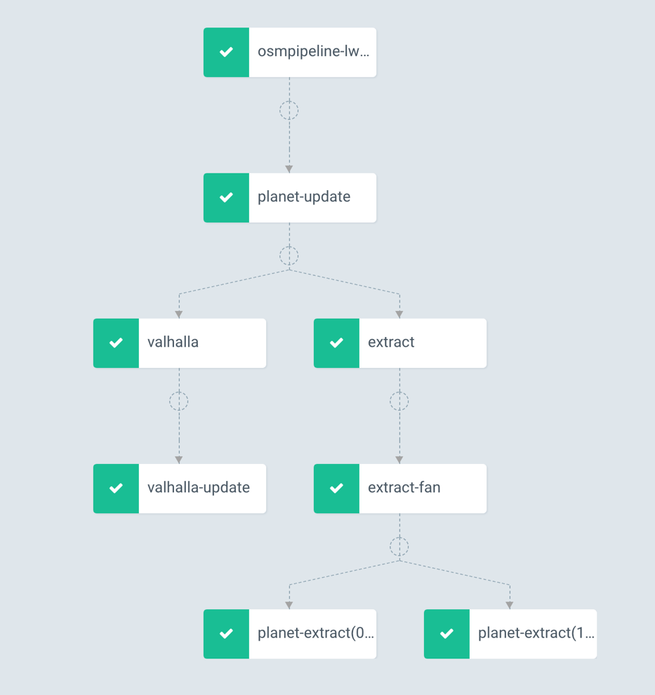

As can be seen above, Argo Workflows is pretty close in structure to a tree. It has some terminology unique to Argo which are listed below.

* Workflow - a named Kubernetes resource defining the execution of one or more templates.
* Template - a step, steps or DAG
* Step - a single step of a workflow, typically run a container based on inputs and capture the outputs
* Steps - a list of steps
* Entrypoint - the first step to execute when running a workflow
* Node - a step
* Directed Acyclic Graph (DAG): a set of steps/nodes and the dependencies/edges between them
* Workflow Template - a Kubernetes resource defining a reusable workflow for a cluster
* Cluster Workflow template - a Kubernetes resource defining a reusable workflow for a cluster
* Inputs - parameters and artifacts passed to a step/node
* Outputs - parameters and artifacts produced by a step/node
* Parameters - objects, strings, booleans, arrays
* Artifacts - files saved by a container
* Artifact Repository - a place where artifacts are stored
* Executor - the method to execute a container (container run time)
* Workflow Service Account - the service account that a workflow is executed as

### Anatomy

A workflow looks just like a Kubernetes Object manifest yaml definition, because well, it is.

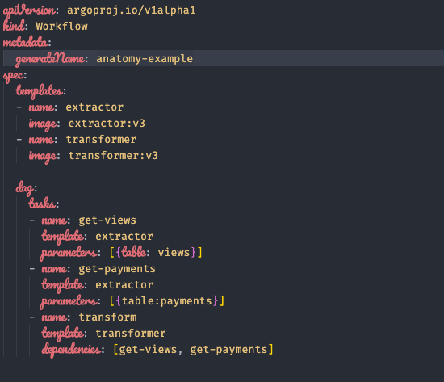We will look at a rough example below

Argo uses declarative DAGs, which means all you need to do is declare dependencies and it will take care of the rest.

The templates are just container images and the way those containers work in this hypothetical example is that you simple pass in the table name you want to extract and it does it.

Each tasks is a step in the DAG and there are various configurations you can do, this is just an extremely simple example.

### Workflow Spec Structure

The basic structure of a workflow spec, as can be seen in the previous section. Follows this basic structure.

* Kubernetes header including metadata
* Spec body
* Entrypoint invocation with optional arguments
* List of template definitions
* For each template definition
* Name of the template
* Optional list of inputs
* Optional list of outputs
* Container invocation (leaf template) or a list of steps
* For each step, a template invocation

### Features

To keep this section short, examples are in the github along with explanations in their respective README.md files.

Argo has some advanced features such as:

* Parameter Passing

Where the output of one task is passed on as an argument for another task.

* 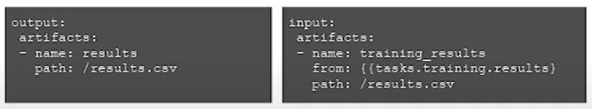Artifacts

You can output artifacts in a variety of formats and then use those outputs as inputs in other tasks.

You can output these artifacts Artifact stores like min.io or S3.

* Memoized Resubmit

If your workflow fails you can resubmit and let it run from the point of failure and not rerun from the steps before failure.

* Suspend & Resume

Suspend and resume workflows for whatever reason. You can also suspend workflows within the task definition in the manifest.

* Sidecars

You can have multiple containers running in each tasks, although keeping it to one container simplifies things.

* Daemon Containers

Containers that are alive for the duration of your task.

For example you may want all your tasks to write to a database, so you could use a database container as a Daemon that will be alive for the duration of the tasks for them to write to.

* DAG things

There are a lot of DAG related stuff like conditional tasks, sub-DAGs, generated DAGs, loops, recursive DAGs. But they make things complex so unless there is a real need to use them, probably not a good idea to just use it for the sake of using it.

* Post-run Hooks

Run stuff after the the workflow finishes, like maybe send a Slack message or email to alert you.

* Creating K8 resources as a task

You can create pods or any resources as a task if you want.

### Argo UI

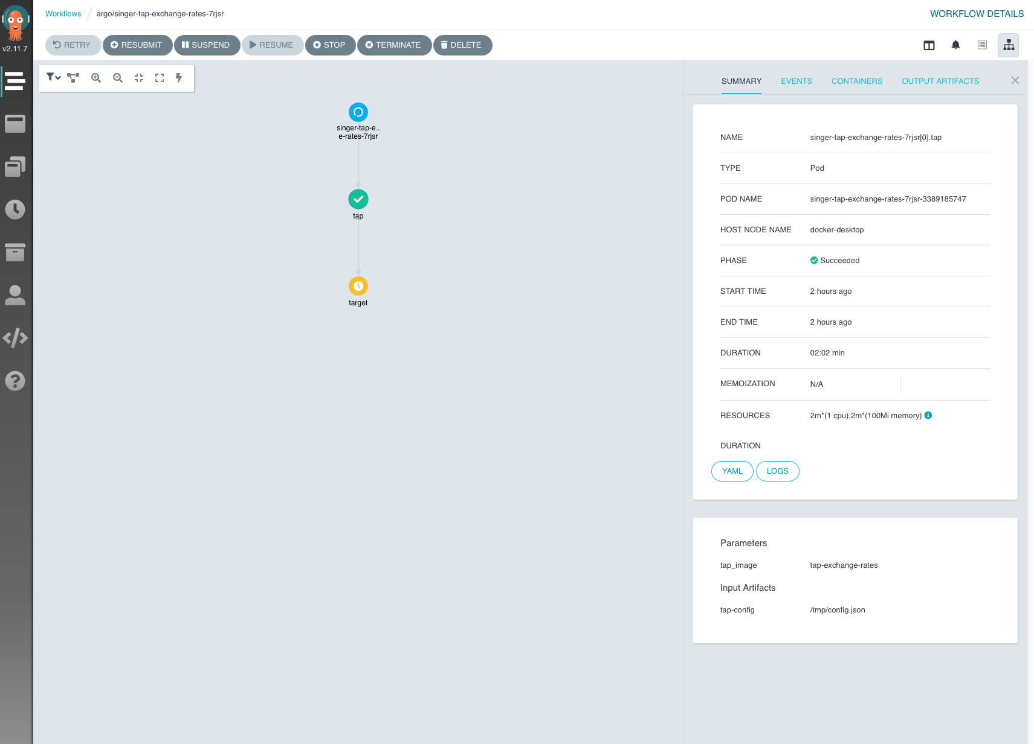Argo is constantly working on the UI, so it is not fully fledged yet, but it is pretty useful for a visual representation for all your workflows and their states. You can also kick off workflows from the UI itself which is nice.

### Packaging & Deployments

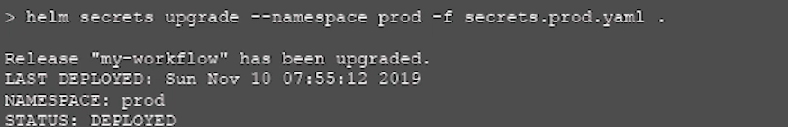Because Workflows and Events are K8s resources, you can use helm ( the Kubernetes package manager ) to deploy and/or upgrade workflows.

One nice thing about this mechanism is that if you have a workflow already running and you upgrade it via helm, the workflow will continue running to completion unimpeded and unaffected by the upgrade.

You can also package your workflows as helms and deploy them via helm.

# NoSQL Databases

## Introduction

Before we begin with this introduction, we assume that you already have some knowledge of relational databases like mysql.

Here is a fun fact, 90% of all data on the internet has been created in the last several years, and that number is only increasing at an accelerating rate. Keep this in mind as we go along this introduction.

Relational databases have dominated the world for the last two decades. Why? Here is a list.

* They are close to how we view the world and how we traditionally kept records. We used to book keep in physical **record** books in **table** form. Relationships between these different tables are then created based on the relationships that exist between the various entities in the application.
* Relational databases also have a strong consistency, meaning that once a change is made to some of the records, it can be seen by every application in that domain. This made relational databases an ideal integration mechanism, with multiple applications sharing a common data store and by extension, data.
* Relational databases have the Transactions feature. Which provides ACID properties.
  + A - Atomicity, either all transactions occur, or none occur.
  + C - Consistency, preserves correctness and consistency across the system.
  + I - Isolation, transactions must be isolated from each other, this is achieved by locking.
  + D - Durability, a completed transaction should be permanent.

These are attributes of relational databases that allow for rollbacks and stability. The actual mechanisms that allow for these features is complex, so we will not go into it.

* They have a joins feature. Where you can join tables on demand in useful ways.
* SQL, Structured Query Language. It is the de-facto language for interacting with a wide range of relational databases. It is both expressive and easy to learn, which made it easily accessible.

So, to sum it up, it provided helpful features for businesses, was easy to conceptually understand, and was also easy to learn. In the history of the internet, what you will notice when studying adoption of new standards and technologies is that it is not the best solution that will win out. It is often simply the easiest to implement/learn solutions that win.

Now we come to, The Problem(s). SQL excels at what it does, and that is storing **structured** data that does not require constant updating at expedient rates. As mentioned previously, the world today is a world of a large amount of data that is stored, transferred, and manipulated - most of which is unstructured.

When we say unstructured, this does not mean that the data lacks structure, but that structure is hard to grasp and define. An example of an application using unstructured data would be customer analytics, where companies use collected data to analyze and improve customer relationship management.

We do not have many stand alone monolithic applications today, as this entire guide has shown so far. Applications today are distributed, loosely coupled and highly scalable. Relational databases were simply not made for this purpose.

This change in application structure to distributed applications with a lot of data, has given way for NoSQL databases to dominate.

The actual technical problem with relational databases is impedance mismatch - the difference between tabular data structures and in memory data structures.

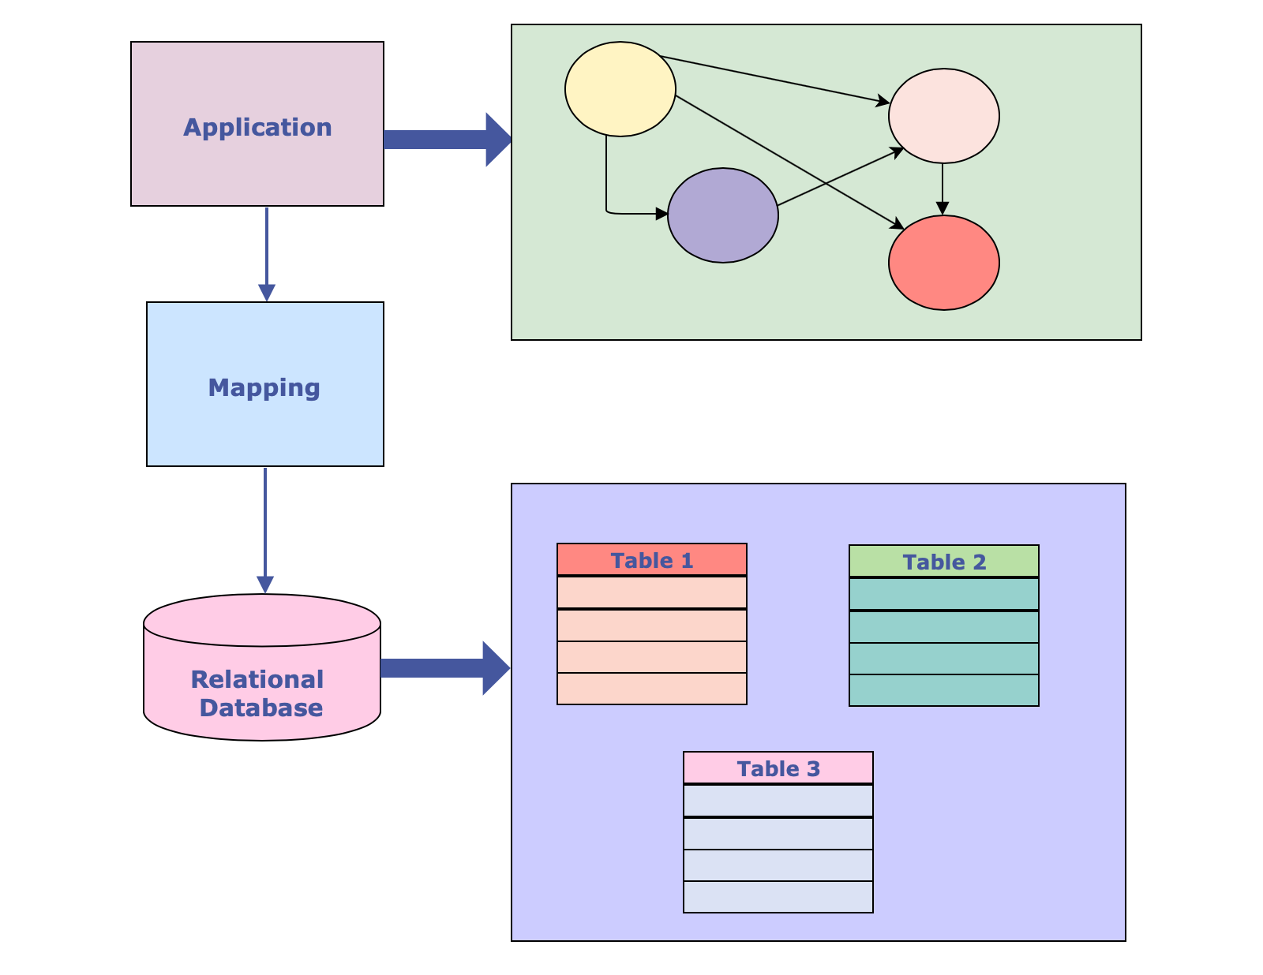Objects In application memory are often saved in the form of a graph - due to the pointer paradigm. Which is different from the tabular form that data is saved in, in relational databases.

So why exactly is this an issue?

Since these modifications to the database are quite literally a part of the application itself, it takes a long time to extend and maintain these databases. Applications and systems today have a demand for 24/7 availability, which means that there is no longer time to turn these systems off for weekend updates and maintenance. Application users also demand rapid response times, so, the front-end can’t afford to slow down while the datastore itself is updating itself.

Another problem is that relational databases are not cluster-oriented. When you try to have replicas, the writes will have to also be replicated across all nodes; since consistency is a core feature via the transaction system, this makes writes an extremely expensive operation. Think about it, if you Facebook used relational databases, you creating a profile in Singapore would mean that every single replica on earth would have to freeze whatever your create profile transaction is interacting with to write at the same time before it can unfreeze. This is ridiculous and highly unscalable. Relational database replicas affect performance exponentially.

The ability to manage data dynamically, go to production quickly, and to develop software using agile methodologies all require more flexibility than relational databases can provide.

This brings us neatly to the solution, NoSQL. Adhering to internet tradition, the origin of NoSQL as a term is seemingly random. It originated as a Twitter hashtag for a meet-up back in 2009. It is sometimes translated as an acronym for Not Only SQL or shorthand for No SQL.

This term is actually really loose and doesn’t specifically refer to one thing. It is used to cover a wide range of databases that try to tackle the problems that relational databases include:

* Availability
* Flexibility
* Scalability
* Performance

In doing so, these databases have sacrificed some of the good points of relational databases:

* Expressive query language
* Secondary Indexes
* Transactional Mechanisms
* Strong Consistency

Just to give you an idea of how loose the term NoSQL is, here is a list of some of the types of NoSQL:

* Key-Value
* Document
* Object
* Graph
* And many others…

Side note: there is also something called NewSQL, which tries to address the issues with relational databases. This is still relatively new so keep tabs on it.

And to give an idea on the number of NoSQL databases, here is another list.

* Apache HBASE
* Cassandra
* Hadoop
* MongoDB
* Redis
* Neo4j
* Hypertable
* CouchDB
* Riak
* And many more…

There are some common characteristics between all NoSQL databases such as:

* They usually don’t use SQL. This doesn’t mean they don’t have their own querying languages, they each have their own query languages that are similar to SQL. For example Cassandra has CQL, Couchbase has N1QL, and actually extends SQL for JSON.
* They are not relational databases (duh). This means that they do not provide predefined tables in which data should fit. NoSQL databases do not have tables (at least not in the way relational databases do) and, therefore, no relations.
* Most of them are cluster-friendly. The initial idea was to store databases on multiple machines but some NoSQL databases are Graph oriented just like many applications today (like social networks where people are nodes, and are linked to each other by relationships).
* They don’t enforce a fixed scheme as strongly as relational databases do. Hence, it is possible to add a field into “record” without first making changes to the structure itself. This is easier when compared to relational databases, where you need to know what you want to store beforehand.

All the above are common characteristics, but are by no means the definition of NoSQL. At this point, and in true internet fashion, we probably will never have an actual definition of NoSQL databases. This may be more of a feature than a bug, as NoSQL at it’s core, is freedom. What is more free than being unable to be defined?

## Types of NoSQL Databases

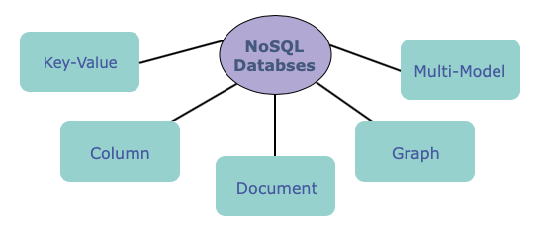NoSQL database use a different approach when it comes to storing data. There are a few types of databases in the NoSQL world:

* Key-Value Stores

It is a dictionary like associative array stored on a disk. The good thing about these databases is that they can be read very quickly, but these databases are not optimal for reverse lookups or additional analytics.

An example of this is ElasticSearch

* Column Stores

These are a subset of NoSQL databases that kept, somewhat, to the tabular form.

What does this actually mean?

Relational databases keep all their data in tabular form where every row represents one entity. Since every row is saved separately on the disk, we could say that rows align the data. So when reading this kind of database, it always reads the entire row, even if not all of the data is necessary.

Column Stores change this approach a bit: they store data in so-called columned families - in columned order.

For example:

* + First, Ids of all records are saved
  + Them, all their names, etc.

This is a big deal because it is possible to get the whole column in a more efficient manner than it was in relational databases, where you had to go through every single row, and pick out a specific value from each one. With this change, you can just pull once and get an entire column.

In essence all this means is that we can get more information from the database in a single seek. Also, these databases can be easily compressed because if you think about it, most variables in a column are the same. So lets say we have a variable of true and false Boolean values, instead of storing them all, we can simple compress them into sequences of true and false.

It however does not solve the issue of writes being very expensive.

One example of these databases is Cassandra, made by Facebook and then open sourced.

* Graph Stores

Graph stores use graph structures for queries, with nodes, edges, and properties, to represent and store data.

They are mainly used for storing a network of connections or relationships like social networks.

They are a little different from other NoSQL databases since they originated from a different problem with relational databases - They have a number of small records with a lot of relationships between them.

An example of such a database is AllegroGraph.

* Document Stores

Document stores are one of the most popular types of NoSQL databases, they revolve around the concept of a document - self describing structures that are usually similar to each other but not exactly the same.

Unlike the rows in relational databases, where every row has to follow the same schema, documents can vary from each other and still belong to the same collection.

Examples of this are MongoDB and Couchbase.

* Multi-Model Databases

Multi-model databases are designed to handle multiple data models against a single integrated backend.

These are brand-new in the NoSQL world, and there will be lots of stuff popping up around this in the future.

Just a personal opinion by the original author of this guide: These will probably become standard in the future. Having access to all store types including relational databases on a single database platform is superior in every way to the current offerings.

## Why Choose NoSQL?

There are two main reasons why you would choose NoSQL databases:

* Minimizing the Impedance Mismatch

It takes a lot of effort to map in-memory data to in-database data, saving that effort improves productivity.

Sometimes, a NoSQL database has a data model that better suits the needs of our application, and thus simplifies the interaction of the application code with the database. This way, we have less code to develop and maintain.

For example, in the MEAN stack (M for MongoDB) the whole stack simply uses JSON objects, and the interaction of application code and database is minimal.

* Large Scale Data

It is very time-consuming to store a large amount of data in relational databases (for now). There is a massive and growing need to capture and process huge volumes of data more quickly. Many NoSQL databases are designed to run on clusters, which are a better fit for this problem than relational databases.

Large scale clusters give us the ability to store larger datasets and process large amounts of analytic data. Also, NoSQL databases have different data models that may be better for processing huge amounts of data.

This does not mean relational databases are dead in the water. They are still the best choice for a large number of problems. They have the added advantage of having been around for decades, which means more tools and more available expertise in them, unlike NoSQL.

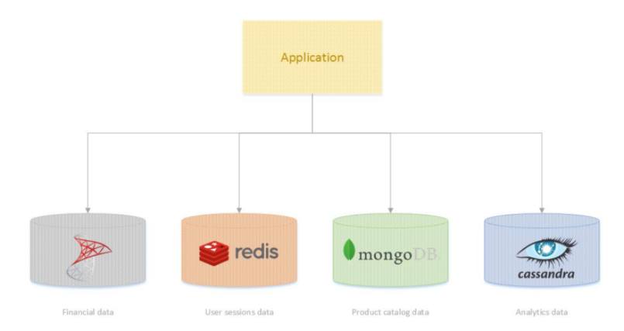All that is different now is that we have a vast array of choices for different kinds of data as can be seen in the example below, where each form of data is stored in a different database.

This way of looking at data in terms of optimal storage solutions for each type is often referred to as Polyglot Persistence.

It leads us to solutions with multiple databases for an application, each of which will be used for a different purpose. You are not shackled to a single database.

For example in the above diagram, we can use:

* SQL for financial data
* MongoDB for a products catalog
* Cassandra for large-scale analytics
* Redis for in-memory session data

Of course, there are down sides to Polyglot Persistence, since there is no simple mechanism for maintaining data consistency, the complexity increases. It is also an open question as to which database should be used in what situation.

Multi-model databases may be the holy grail that provides a solution to all our problems, but only time will tell since it is so new.

## MongoDB

For this guide we will be focusing on MongoDB. The reason for this is that Document databases are probably the closest thing to relational databases out of the NoSQL model line up.

Document databases store documents in collections, a lot like how databases store rows in tables.

MongoDB is one of the leading NoSQL databases and as such has extensive documentation and support, they even have a cloud service.

### Core Concepts

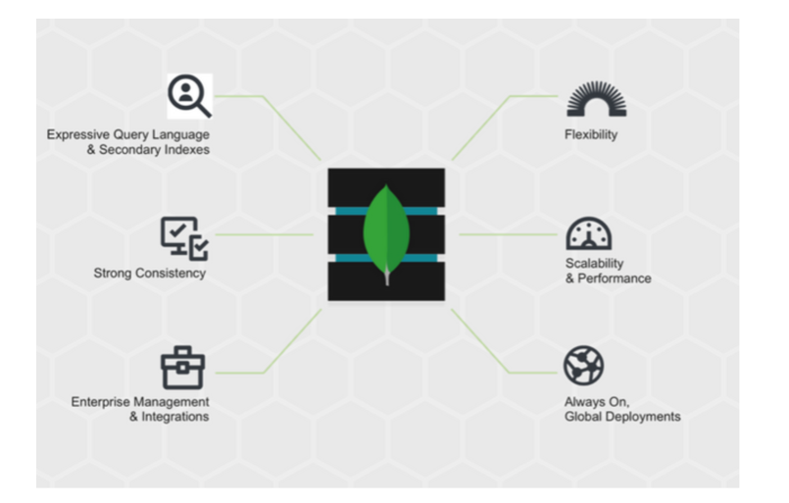The guys that developed MongoDB are very proud of what they call Nexus Architecture. This architecture gives the ability to combine proven concepts and abilities of relational databases with NoSQL innovations, a best of both worlds type claim.

#### Documents

MongoDB is a document-oriented database, I do realize this term is at this point, is entirely meaningless. So let’s start by defining it.

We have mentioned previously that Document stores have similarities to relational databases. Documents are a part of this. Instead of rows, MongoDB has documents. Unlike relational databases, where information for a given record is spread across many tables, all of the data for a given record is stored within a single document.

Under the hood, documents are BSON files, which are binary-encoded serialization of JSON files. But from a programmer point of view, MongoDB manipulates pure JSON files.

Now, I understand how this sounds. Wait a minute, are we actually just storing everything as JSON? This is madness, why and who do I beat?

The short answer is, yes we are storing everything as JSON. And the Long answer is, storing everything in JSON gives us an advantage when it comes to flexibility and searching. As stupid as it sounds when first hearing it.

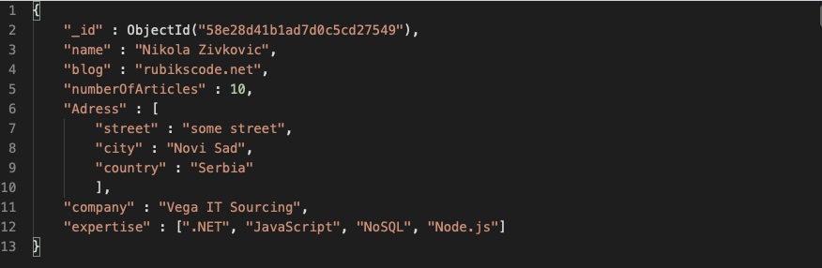For example, we can represent a user like so:

As you can see, there is an **_id** field at the beginning of this JSON document. This field is unique and is generated by MongoDB for every document in the database.

This way, MongoDB keeps one of the most important properties of relational databases - consistency

#### Collections

What are collections? Documents are stored inside of collections. They are groups of somehow related documents, but these documents do not need to have the same structure.

Here lies one of the biggest benefits of MongoDB: developers do not need to know the schema of the database beforehand but can modify the schema itself on the fly during development. This is especially great in systems where we can’t get the schema quite right in the beginning, or there are plenty of edge cases to cover.

Also, this way, the entire problem of impedance mismatch is avoided, you literally just push the json object you received on the backend to the database without needing to map it. It really doesn’t get any more streamlined than that.

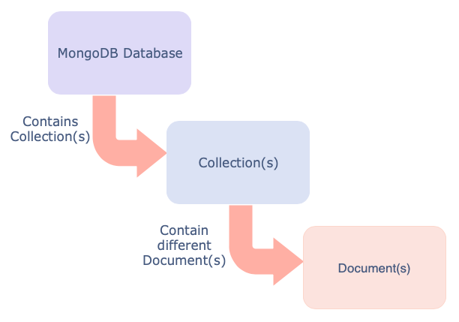A high level view of the structure so far:

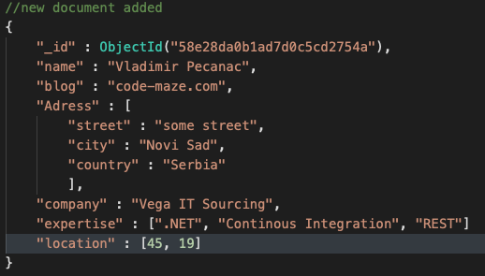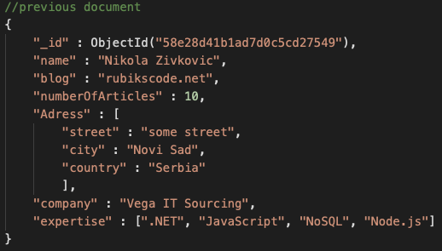So, lets say that the previous user document is stored in the collection called users; we could add another document into that collection which would contain fields that the previous documents didn’t have, or we could add a document that may not have the fields that the previous document had.

As you can see these documents are pretty similar, but not entirely the same, The new document does not contain the **numberOfArticles** field, but it does contain an additional **location** field, which the previously added document didn’t have.

Collection groups give you the ability to add indexes to these documents. Indexes are one of the concepts that MongoDB inherits from relational databases.

## MongoDB and Relational Databases

Although MongoDB is like a relational database, it is also not. It is important to emphasize some of the differences between them.

* MongoDB does not have foreign keys; but, it has a feature that looks like that - References, any object can have a reference to another object using its **id** but this is not automatically updated, and it is up to the application to keep track of these references.

This is done this way because once a foreign key is introduced in a relational database, it can be hard to unwind the database from it.

* Thanks to the document data model, and due to the fact that all information is stored for a record is stored inside one document, joins are not provided in MongoDB. There is however a similar mechanism called Lookup.
* There is no equivalent for multiple table transactions in MongoDB. Since all information for a record are in one location, there shouldn’t be a need for one.

## Command Operations

Once you have a MongoDB server up and running, you can connect to it using the Mongo shell client.

Note that all these examples can and should be done through code. However for hands on and speed purposes, we first try them out using the shell client manually.

There are a ton of commands to look at but we will just go through the basic commands needed to creating a collection and inserting a document.

Note that there are many commands that we will not cover, refer to the MongoDB documentation to find out more.

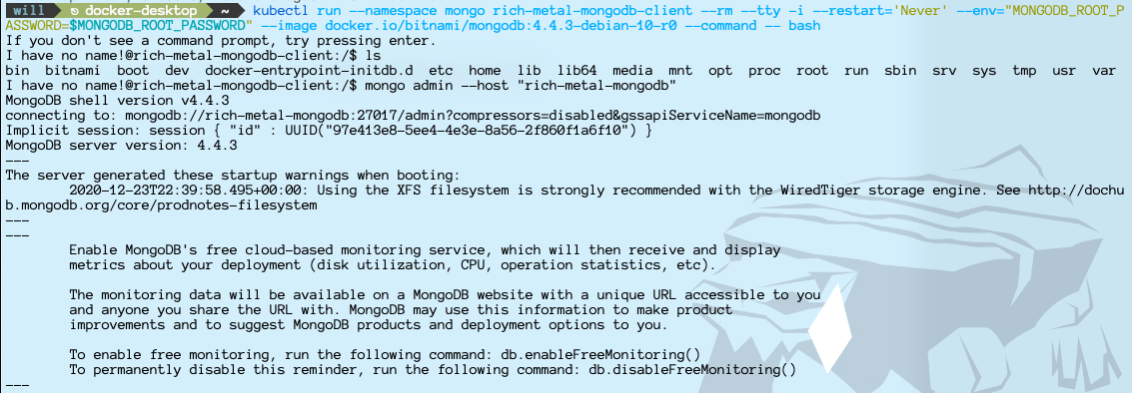This is what you will probably see when using the mongo client for the first time.

If you are wondering what are the possible commands, just type help for a full list.

### Databases

To create a database, simply type use <database_name> like so:

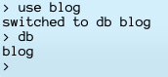

As you can see, you can use the command db to show what database you are currently using.

Once the database is created and connected to, a user can manipulate the data inside of that database. This is done by using one of the many options of the **db** entity.

All options will be displayed by typing **db.help()**.

### Collections

Now we move on to creating a collection. This is done by using the db.createCollection(<COLLECTION_NAME>, <OPTIONS>) method like so.

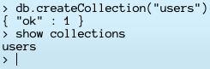

Existing collections can be removed by using the method db.<COLLECTION_NAME>.drop() like so

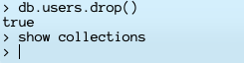

### Documents

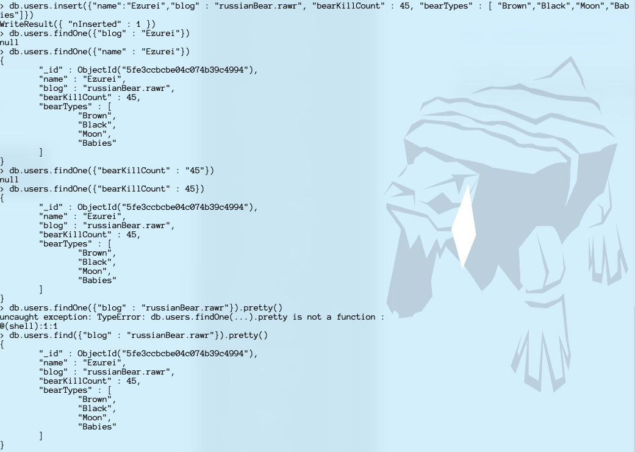For adding a document to the collection, use the db.<COLLECTION_NAME>.insert(JSON_DATA) method, you can also use the db.<COLLECTION_NAME>.save(JSON_DATA) method.

The picture above shows a few things on top of how to create a document,

It shows two methods to find documents, db.users.find() and db.users.findOne(). It also shows that the db.users.find() method has another method on top of it called pretty() which pretty prints the output.

You can update Documents via the db.<COLLECTION_NAME>.update(<SELECTIONCRITERIA>,<UPDATED_DATA>) method.

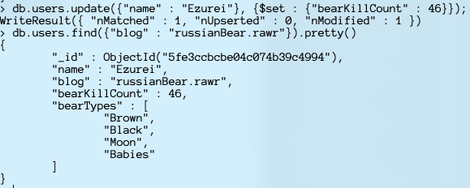We can increase the bearKillCount in our document as an example.

The additional **$set** filter was used, which helped us specify exactly which fields inside of the document should be updated.

To remove the document, use the db.<COLLECTION_NAME>.remove(<QUERY>) method.

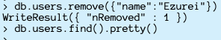

### Indexes

To achieve better performance, MongoDB provides indexes. They are not different from traditional indexes in relational databases. However, without them, MongoDB must scan every document from a collection to select those documents that match the query statement. This is obviously very inefficient when you are dealing with large volumes of data.

Indexes are data structures which store a small portion of the data that is easily accessible through MongoDB.

Index fields need to be created. To do so, we use the db.<COLLECTION_NAME>.createIndex({ <FIELD_NAME>: 1})

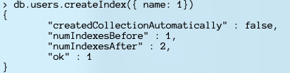

## MongoDB Compass

This is the MongoDB UI for managing a MongoDB database, this tool is designed as a connector instead of a representation of a database. Which means it is not tied to a single database. You can host this tool in a container or on your computer. And then connect it t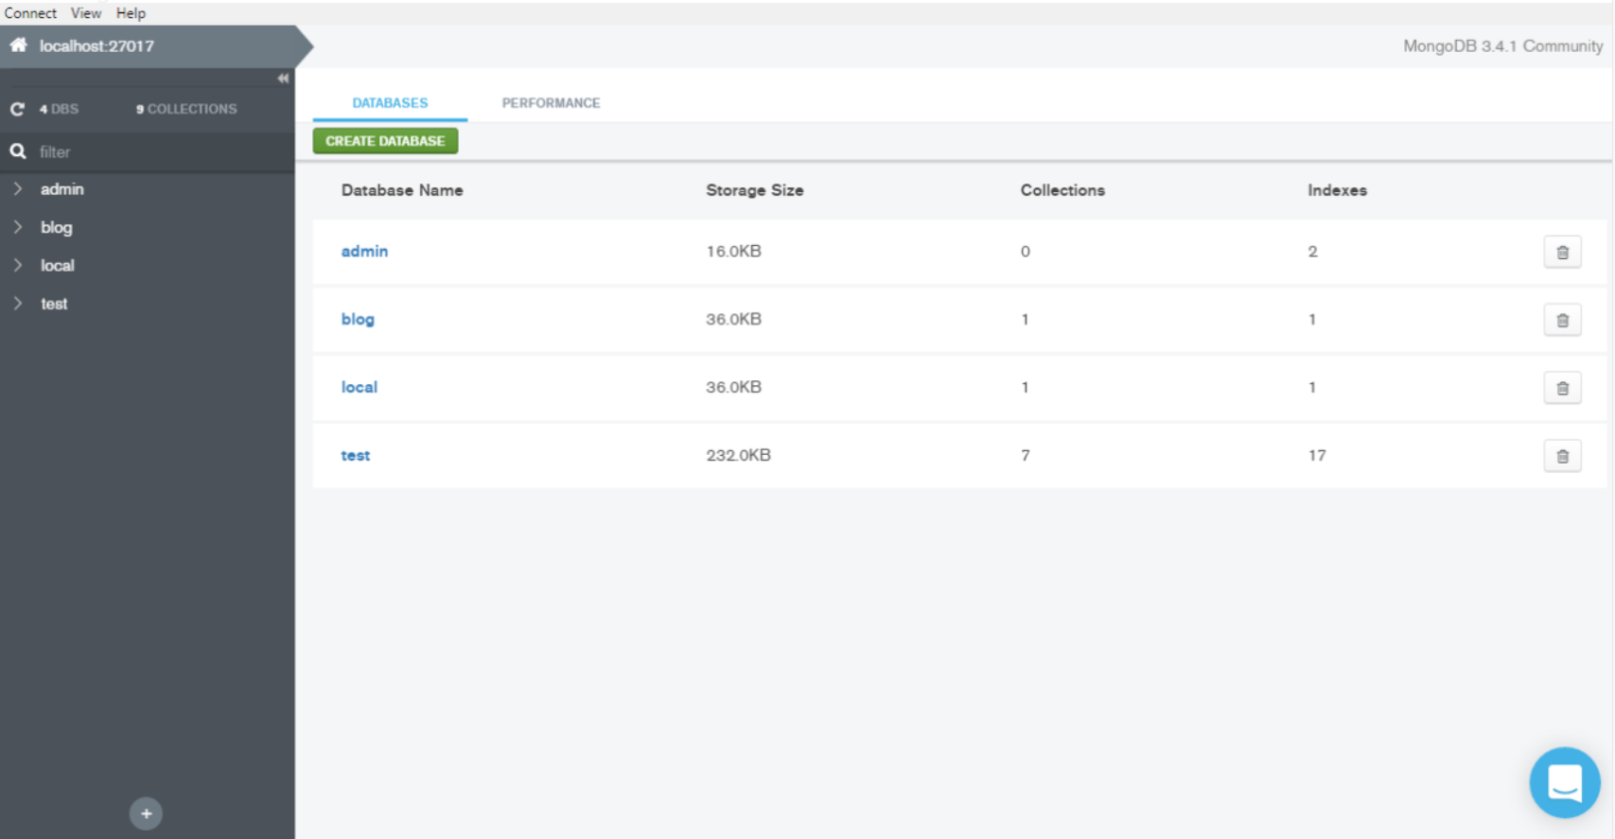o multiple databases in your cluster.

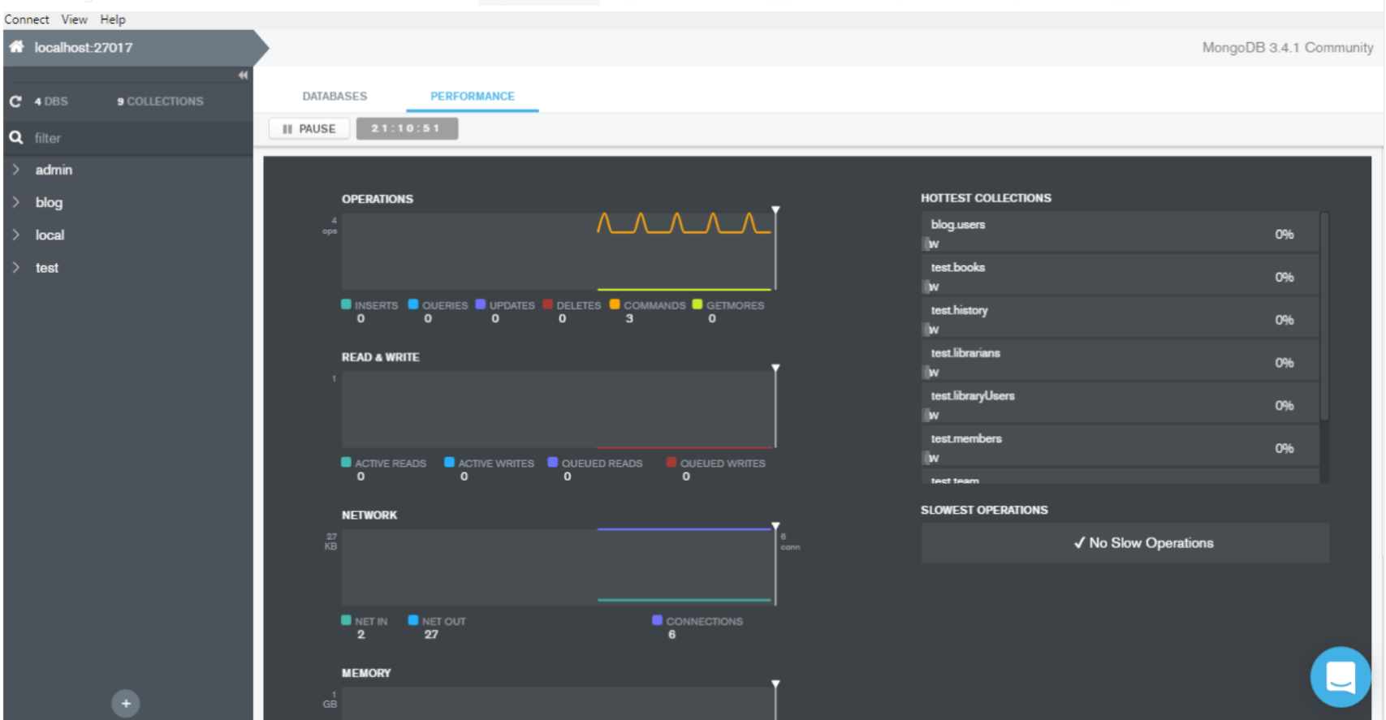One nice feature is that this is also able to show server performance

There is also another tool called Robo 3T (formerly Robomongo) that can be used for similar purposes.

# Message Queues

## Introduction

Message queues are a fundamental component to any multi service system. The concept of message queues originated from the need to communicate between internal systems in a robust and systemized way. In the age before this paradigm, programmers would have to code TCP connections between systems. Now imagine having 40 teams with 10 programmers each all writing their own TCP connections between systems, as you can probably imagine, this quickly becomes a ridiculous endeavour that cannot be maintained for long periods of time.

Message queues came about because of this, they provide a simple way to pass messages along to other systems. It is conceptually similar to a Post Office.

A Post Office will deliver whatever you need to whomever you need as long as they have an address, are reachable and your item fits inside one of their offered packages.

In the paradigm of message queues:

* Post Office = Broker
* Recipient = Consumer
* Sender = Producer

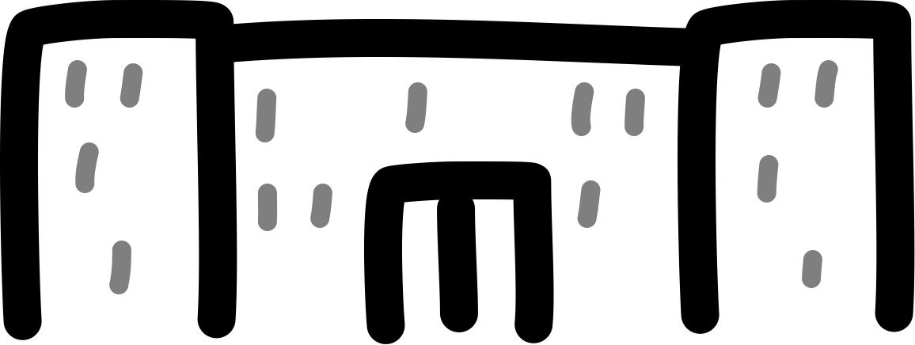

Sender

Recipient

Post Office

## Kafka

There are many message queues available. Which one you pick will depend on your requirements. Below is a list of some of them.

* ZeroMQ
* RabbitMQ
* IBM MQ
* MuleSoft Anypoint Platform
* ActiveMQ
* Apache Kafka
* Google/Azure/Amazon all have their own MQs as well

We will be focusing on Kafka because it is uniquely suited for parallel processing an enormous amount of data and has some features that are useful for disaster recovery.

### Architectural Overview

Kafka is built like a central train station, all messages flow through the Kafka Cluster and are handled by Brokers, who then send the messages to their destination based on a few factors.

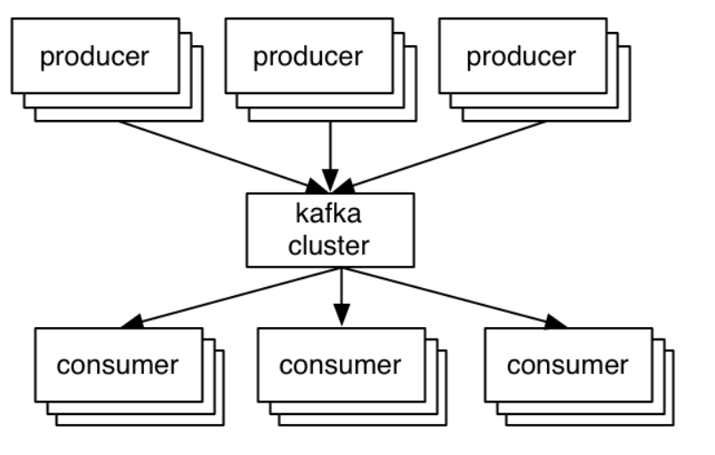

As for how it categorizes who listens and pumps data into what, it makes use of a pub/sub paradigm in the form of Topics. A consumer listens to a Topic and a producer sends data on a certain Topic.

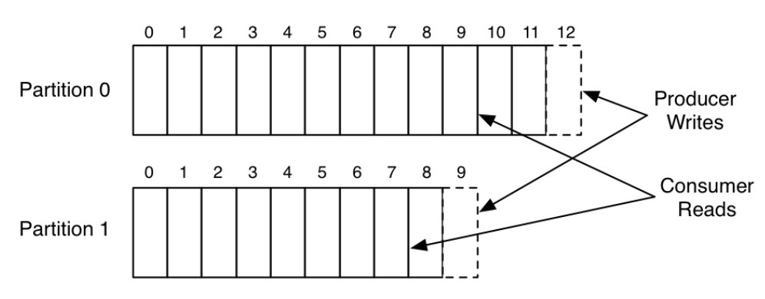Kafka stores messages as records in a sharded write-ahead log, each record is a key-value pair. The key is used for assigning the record to a log partition unless configured otherwise.

We will delve into what partitions are under the features section.

### Features

Kafka is a little different from other message queues, which gives it some interesting features.

#### Parallelism

Each Kafka Topic can be split into a user configured number of partitions. Records are inserted into a single partition based on their key value or unless configured otherwise.

The difference here is that in other message queues, a single publisher usually can only be consumed by a single consumer. Which eliminates the idea of easy scaling.

Kafka brings this one level down. A Topic can have more than 1 partition but each partition can only have a single consumer.

Now the question is, how does this allow for scaling?

Kafka will split partitions based on the number of consumers there are in a consumer group and how many partitions it has. A consumer group is used to group consumers which allows for multiple groups to access the same data stream while ensuring non overlapping parallel data consumption within each group.

Topic

Partition 1

Partition 2

Partition 3

Consumer Group A

Consumer 1

Consumer 2

Partition 4

Consumer Group B

Consumer 1

Consumer 2

Consumer 3

Consumer 4

Consumer 5

There are a two things to notice in the above diagram.

1. If you have more consumers than partitions, the excess consumers will simply not receive any messages.
2. If you have less consumers than partitions, Kafka will balance the partitions as equally as it can across the consumers.

This illustrates a key principle. To avoid wastage of resources, always have an equal or greater amount of partitions than consumers.

#### Sharding

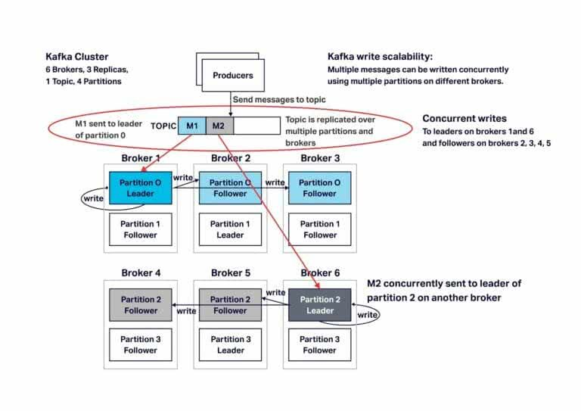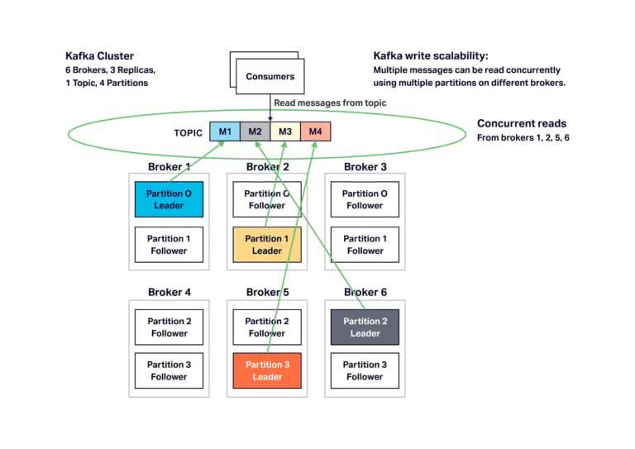Kafka is a sharded message queue, which means that it has replication, distributed writes and other features built in, the below series of diagrams illustrates how writes and reads scale. Each broker can be on different clusters or machines.

The number of followers is controlled via the Replication Factor configuration, a Replication Factor of 1 means only having leaders, a Replication Factor of 2 means there will be 1 follower, so on and so forth.

There is a CPU utilization overhead when having replication factors of more than 1 due to partition replication. The number of partitions also affects this greatly. There are a number of articles on the internet investigating the optimal ratio of replication factor to partition numbers. One such conclusion was that with a replication factor of 3, the optimal throughput was reached at 12 partitions and only significantly dropping past 100.

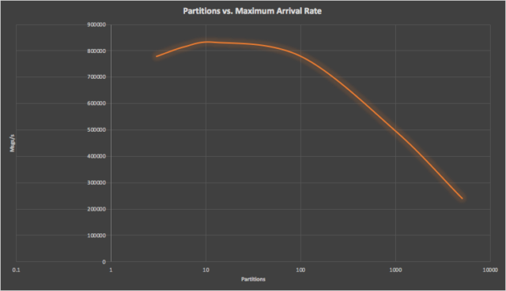

#### Retention

Kafka is unique from other message queues in that it does not delete messages immediately after they are consumed and also keeps all messages for a default of 24 hours which allows us to do some very convenient things.

1. Disaster Recovery - Lets say the worst case scenario happened, all your pods failed and aren’t doing anything while you have Gigabytes of data coming in. No problem, you have 24 hours ( default ) to get them running again and they will just start reading from where they left off as if nothing happened.
2. Down Time - Lets say you would like to update and do some maintenance on a database and have to bring it down for 7 hours. You wouldn’t even have to do anything to Kafka, simply bring down all the pods reading and writing to the database, do your maintenance and bring them up again. They will just continue reading and writing from and to where they left off
3. Isolated Consumer Operations - You can consume the same topic with a variable number of consumers groups without conflicts, this means that you can have a set stream of data you may want to analyze on a daily basis, you can use a workflow orchestrator with a workflow that consumes data from that Topic on a daily basis while not interfering with business operations that use the Topic.